1.本學科試題卷共三張六面、答案卡一張及答案卷一張。
2.本測驗共50題，共有選擇題與紙筆測驗兩部分：1-35題為選擇題，請將答案劃記於答案卡上；36-50題為紙筆測驗，請將答案作答於答案卷上。試題答錯，一律不倒扣。
3.選擇題作答時必須使用2B黑色鉛筆，將正確答案畫記在規定的答案卡上，否則不予計分；紙筆測驗部分作答時必須使用藍色或黑色原子筆作答答案卷上，並保持整齊清潔，如未保持答案卷清潔整齊以致無法辨識答案，一律不予計分。
4.本試題紙空白處，可供草稿使用，答案卡及答案卷絕對不可打草稿。
5.本學科試卷共50題，合計100分。

第一部分：聽力測驗 (20%)
一、根據敘述內容，選出正確的圖片 (5題，第1-5題，每題1分，共5分)
( ) 1. 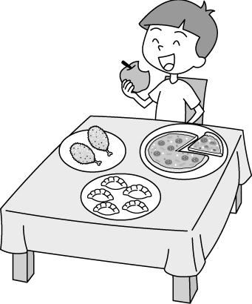 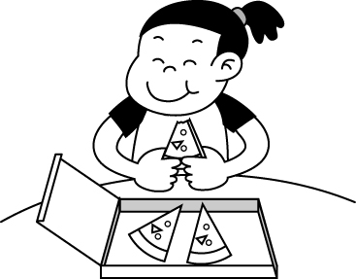 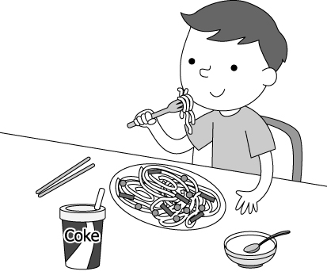 
( ) 2. 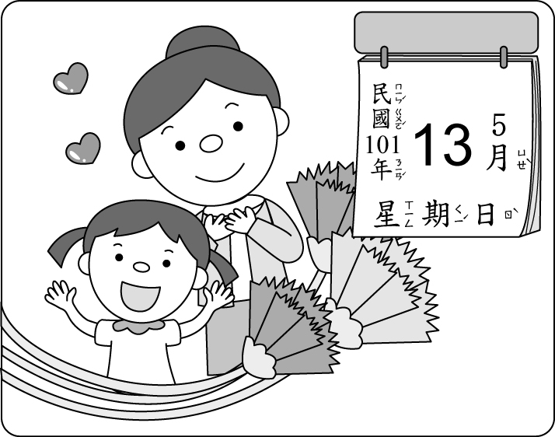 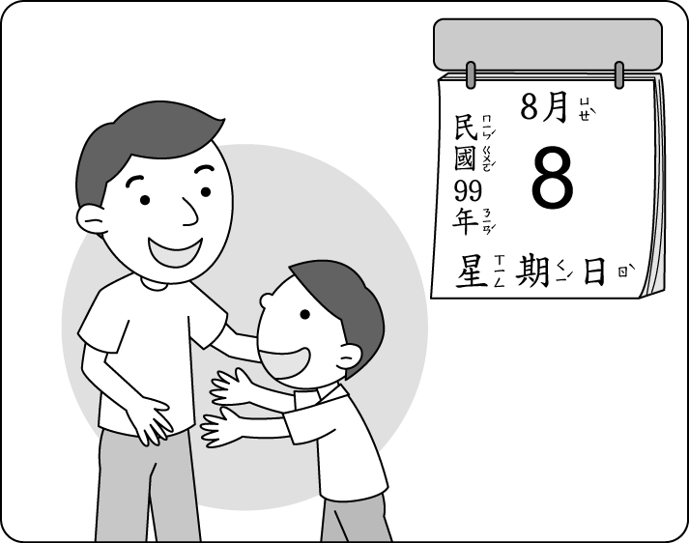 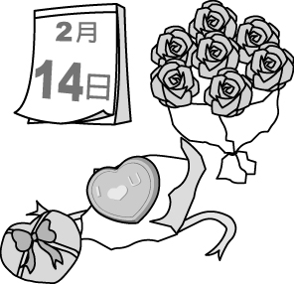 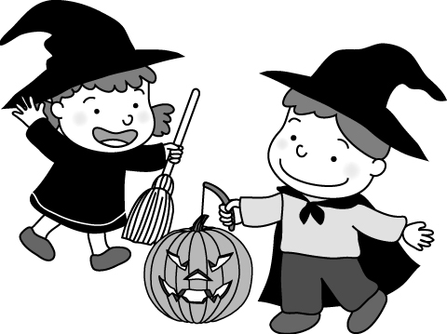
( ) 3. 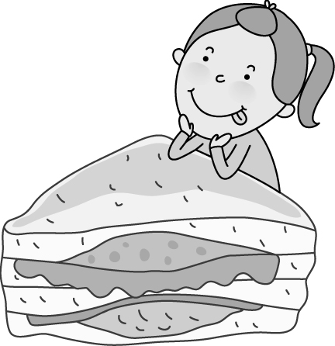   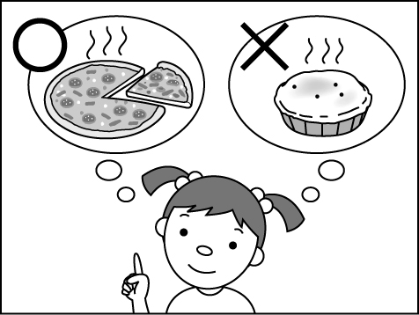
( ) 4. 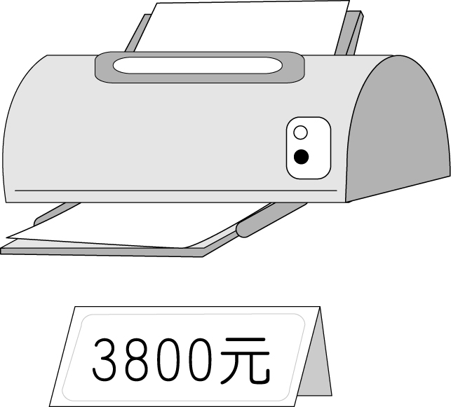 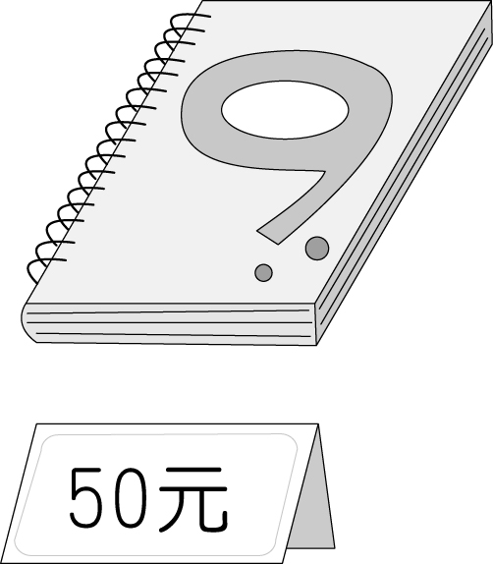 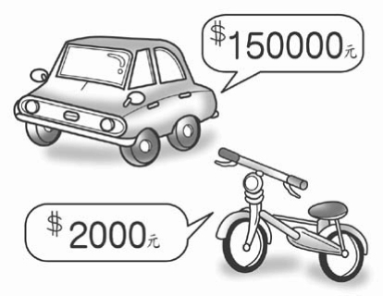 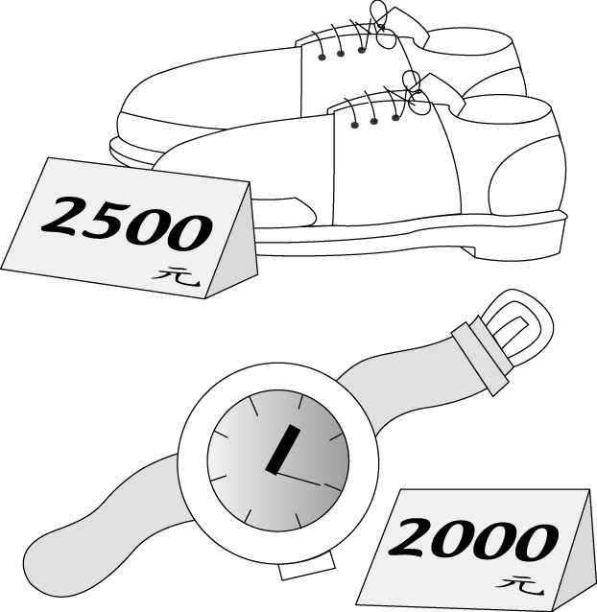
( ) 5. 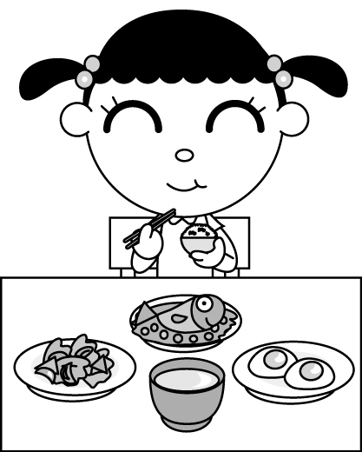 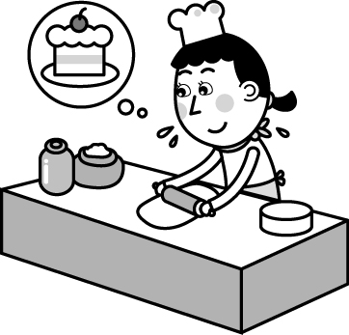 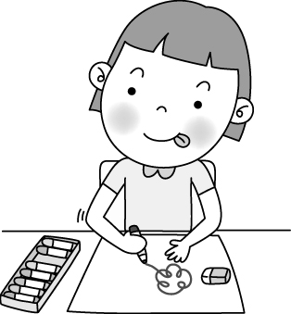 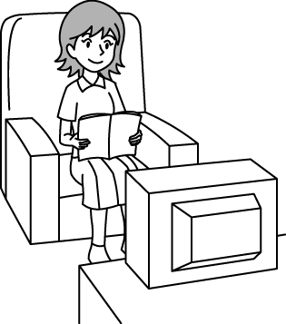

- 根據聽到的對話內容，選出正確的答案 (5題，第6-10題，每題1分，共5分)
( ) 6. The woman likes black coffee.
The man likes coffee.
The man and the woman like green tea.
The man drinks five cups of coffee every day.
背面尚有試題，請翻頁繼續作答
( ) 7. The dumplings are one hundred dollars.
The man and the woman eat soup and dumplings.
The woman needs some soup.
The dumplings are not very expensive to the man.
( ) 8. Today is the boy’s mother’s birthday.
The boy can do many things for his mother only on Mother’s Day.
The woman likes the gift from her son very much.
The boy and the woman can use the coupons together.
( ) 9. This Wednesday is the man’s birthday.
The man and the woman are talking on the Net.
The woman has no time this Wednesday.
The woman works in Fancy Kitchen.
( ) 10. The woman is cooking dinner.
The man needs eggs, fish, and rice for dinner.
The woman doesn’t have anything for the man.
The man doesn’t need any bowls or plates.

- 根據聽到的文章內容及問題，選出正確的答案 (5題，第11-15題，每題2分，共10分)
( ) 11. pie. cake. pizza. sandwiches.
( ) 12. Flour and eggs. Water and milk. Milk and juice. Bananas and oranges
( ) 13. Banana juice. Orange juice. Green tea. Flower tea.
( ) 14. At 7:20 a.m. At 7:20 p.m. At 7:30 a.m. At 7:30 p.m.
( ) 15. 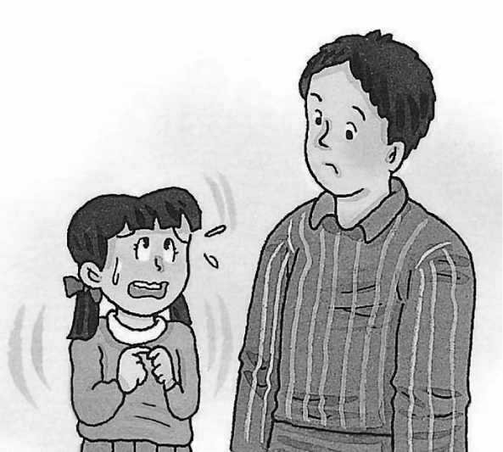 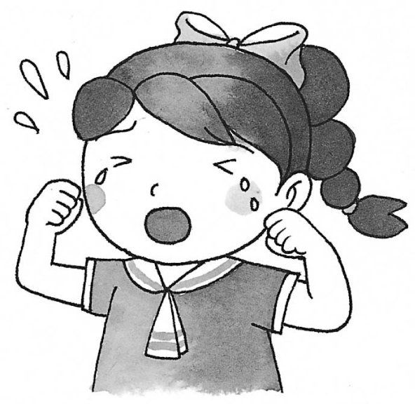  

第二部分: 讀寫測驗 (80%)
背面尚有試題，請翻頁繼續作答
四、語法測驗 (10題，第16-25題，每題2分，共20分)
( )016.0 The man is very tired. He is standing there for two hours, but there in his bowl.
aren’t any food isn’t food and water isn’t a rice isn’t a dollar
( )017.0 Mr. K: dollars are three cans of cola? Ms. W: Fifty.
How many How What How much
( )018.0 Jacob: doesn’t your brother like? Josha: He doesn’t like tennis, soccer, or dodge ball.
What balls Which What Which sports
( )019.0 Winter (冬天) in Taiwan is from to .
November; January December; February September; November March; May

( )020.0 Mitch: Greg, I’m hungry. Where is ? Greg: Some on the dining table.
the pie; are a pizza; is the food; is fried chicken; is
( )021.0 We can get some milk from the cows every morning and sell to the market near our home.
them it its their
( )022.0 Stefanie: How many monkeys are there in the national park (國家公園)?
Juno: There are only there.
three hundred one hundreds monkeys two hundrends hundred
( )023.0 Students: Sorry, I’m late. May I come in?
Teacher:
Don’t you come in time? Sure. Thank you. You are too late. Come on in.
( )024.0 Joly:
Kenson: It’s on March twelfth.
What’s the date today? When is today’s date?
When is the Christmas party? What day is today?
( )025.0 Sandy: Cindy, let’s listen to A-mei’s CD.
Cindy: I don’t need to do that. I’m going to her concert this December.
Sandy:
Leave it to me. What!
Well, well. Isn’t that A-mei? Let me see…

五、克漏字測驗 (4題，第26-29題，每題3分，共12分)
背面尚有試題，請翻頁繼續作答
(On the day before Mother’s Day)
Today is 26 , 2012. Susan is thinking about the gift for her mom. She wants to give her mother the best gift because she loves her 27 . Howerer, Susan doesn’t have much pocket money left. She only has two hundred dollars. It’s not enough to buy something 28 , like a woman’s bag or a watch. She’s thinking hard. What else can she buy for her mom?
Suddenly, she thinks of a cool Mother’s Day gift—a cute woman hat. She can use some old clothes to make the hat. It needs her about three weeks to finish it. The hat looks just beautiful. Does Susan’s mother like the hat? Of course she
29 !

 think想 best最好的 because因為 left剩下地 enough足夠的

( )026.0 May twelfth April thirteenth May ninth May thirteenth
( )027.0 every day on Mother’s Day a lot much
( )028.0 free famous little expensive
( )029.0 likes does doesn’t like doesn’t like it

六、閱讀測驗 (6題，第30-35題，每題3分，共18分)
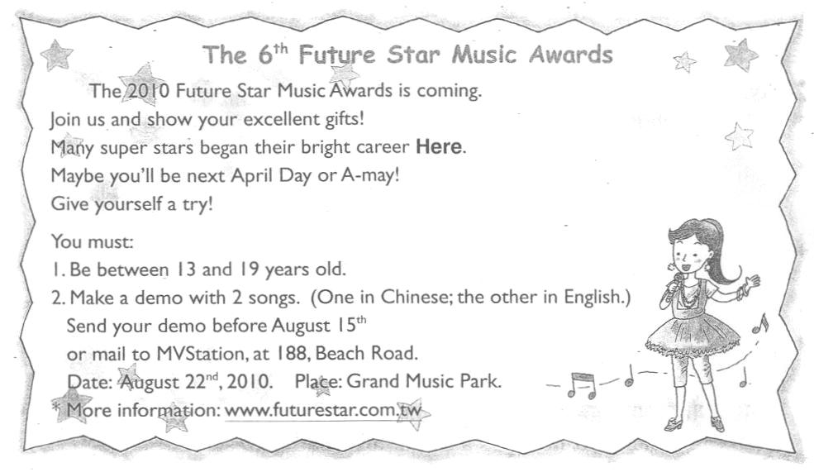
(30-32題)

 award獎 began開始(begin的過去式) career事業 demo示範帶 information資訊

( )030.0 Amy’s school has “The Future Star Music Awards” every year.
 was 是(is的過去式)
When was the first “The Future Star Music Awards”?
In 2006.
In 2005.
Before 2004.
After 2007.
( )031.0 Who can join The Future Star Music Awards?
Jeannie, an elementary school student.
 elementary school 小學
senior high school 高中
Darren. He is a music teacher with a good voice.
Hana. She studies in junior high school.
Andrew. He teaches music at a senior high school.
( )032.0 Which is NOT true?
April Day and A-may are popular singers.
You can know more about The Future Star Music Awards by getting on the Net.
You sing songs in Chinese and English at The Future Star Music Awards.
Only students can join The Future Star Music Awards.
背面尚有試題，請翻頁繼續作答
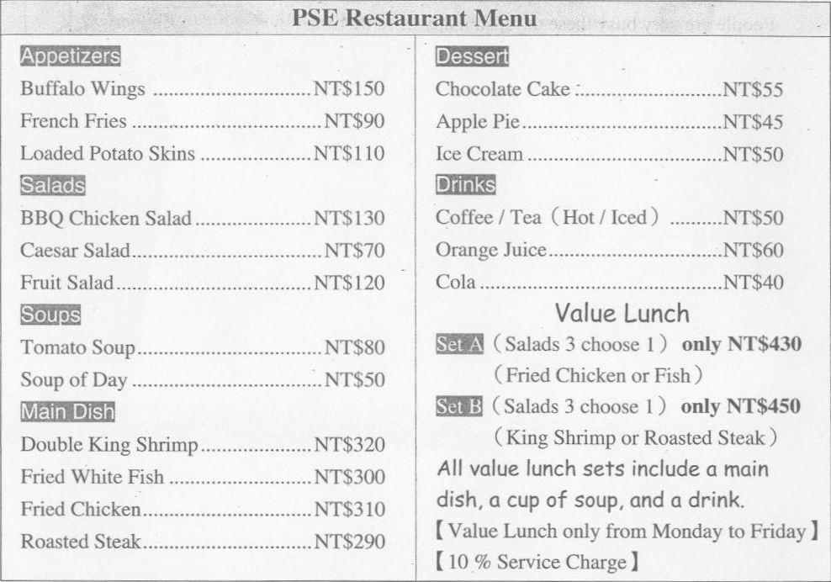
(33-35題)
背面尚有試題，請翻頁繼續作答
背面尚有試題，請翻頁繼續作答
 appetizer開胃菜 main dish主菜 include包含 set套餐 service charge服務費
背面尚有試題，請翻頁繼續作答
( )033.0 Today is Tuesday, and Edward is having lunch at PSE Restaurant. He has fruit salad, tomato soup, double king shrimp, and a cup of hot tea. How much is his lunch?
NT$450. NT$520. NT$495. NT$572.
( )034.0 Ted’s grilfriend, Rose, is going to PSE’s with him. She loves chicken, seafood, and hot drinks, but she doesn’t like dessert. What may she have at PSE’s?
Fried chicken and chocolate cake. Steak and Fried white fish.
Soup of day and tea Coffee and BBQ chicken salad
( )035.0 Which is true?
People can have value lunch every day.
All value lunch sets include drinks.
There’s no service charge at PSE’s.
A plate of roasted steak, a cup of tomato soup, and a can orange juice are $430.

七、依提示填入最適當的介系詞 (如果不需要介系詞請寫 ╳ ) (10題，第36-45題，每題1分，共10分)
36. The old prophecy (預言) says the end of the world is December, 2012.
37. Jeremy Lin plays New York Knicks basketball team this year.
38. Today is the day before New Year’s Day.
39. My sister likes to set the table dinner on Christmas Day.
40. Billy Fujiki shows his talent in singing the party.
41. Lucy is at the koala house the morning of July 17th.
42. He doesn’t study English today, so he’s worrying his grade (成績).
43. June is the sixth month the year.
44. It’s my birthday. Let’s go out lunch today.
45. Tiffany’s at her gramdma’s place this October.

八、中翻英 (5題，第46-50題，每題4分，共20分)
46. 那年輕人在新中式餐廳吃飯並在電視上看了一場才藝競賽。
47. 父親一年12個月、一天24小時照顧著我們，但我們只在每年八月八日表達我們的感謝。(數字、日期及時間請用英文表示)
48. 博物館旁邊的食物吧沒有賣美式披薩跟炸魚沙拉呀。
49. 媽媽先把好吃的火雞肉三明治跟南瓜湯放入盒子中，然後把它們包起來當早餐。
50. 順帶一提，我們三個還要兩瓶豆漿跟一盤雞肉水餃。
試題結束，請同學再次仔細檢查。

