※範圍:翰林版 BOOK 2 Unit 4~6 & Review II
※建議將聽力測驗答案先寫在此份考卷上， 等聽力全
部考完後，再將答案畫在電腦卡上，以節省時間。
第一部分、聽力測驗（共25％）
- 發音測驗 5％(第1到3題請選出三個單字中母音發音與其他選項不同者)
1.( ) 2.( ) 3.( )
(第4到5題請選出句中聽到的單字；可複選)
4. ( ) (A)need (B)want
(C)sorry (D)pumpkin
5. ( ) (A)What (B)sport (C)do (D)badminton
- 根據敘述內容，選出正確的圖片 10%
6.( ) 7.( ) 8.( ) 9.( ) 10.( )
6. (A)  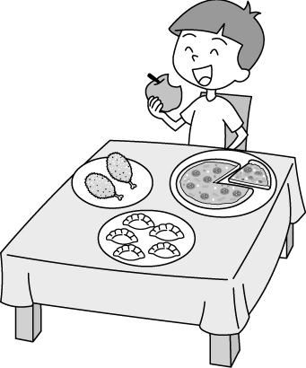 | (B)  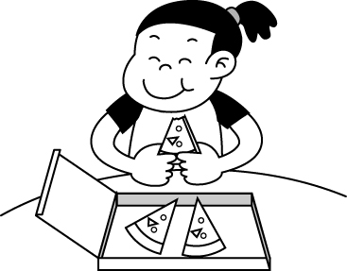 | (C)  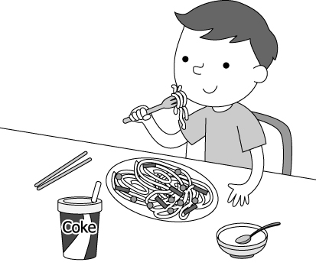
7. (A)  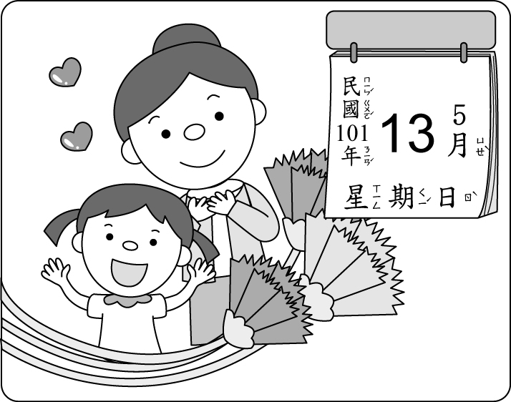 | (B)  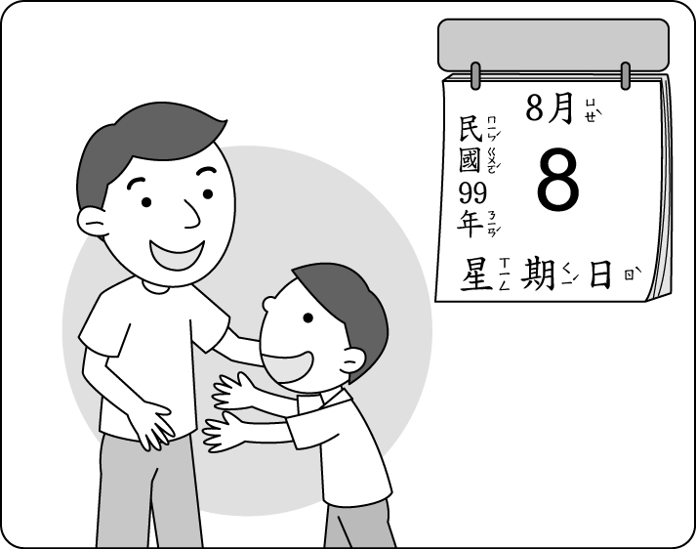 | (C)  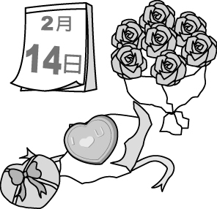
8. (A)  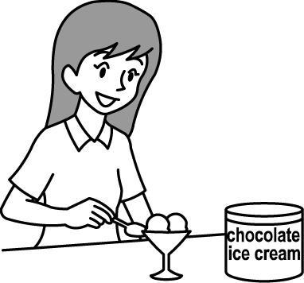 | (B)  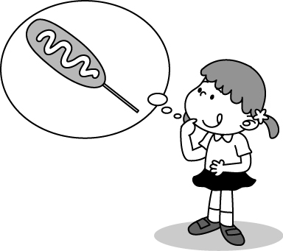 | (C)  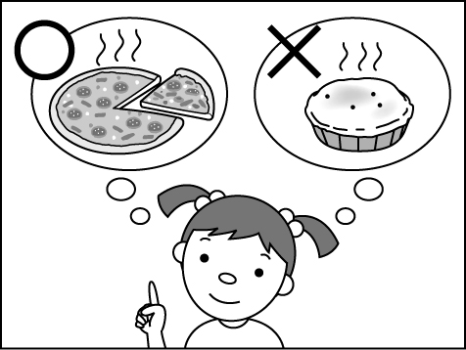
9. (A)  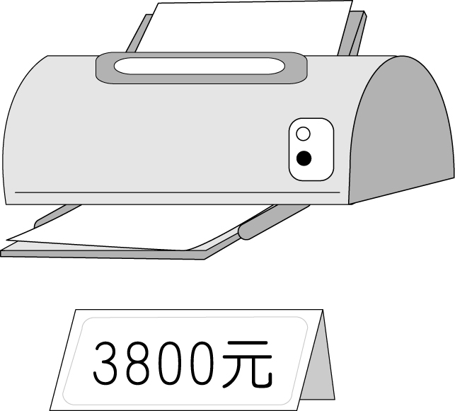 | (B)  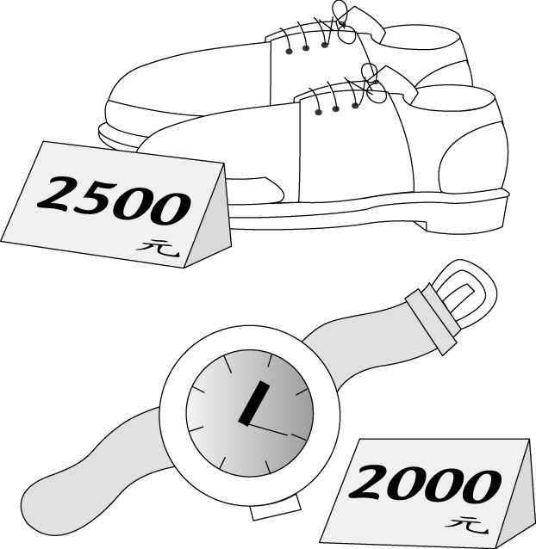 | (C)  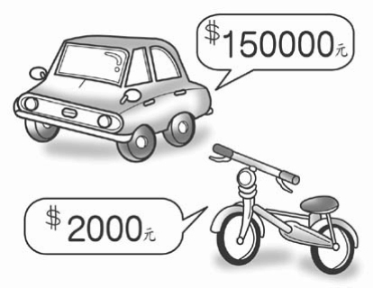
10. (A)  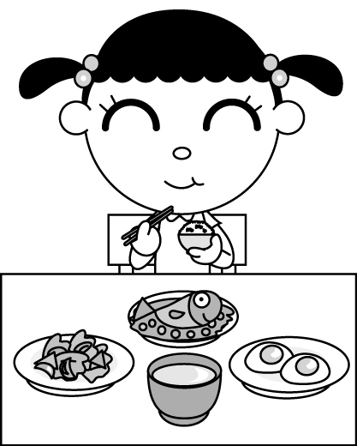 | (B)  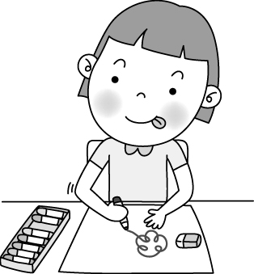 | (C)  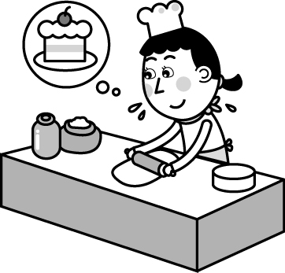

三、根據聽到的句子選出最適當的回應句 10%
11. (A) It’s Friday, my favorite day.
(B) It’s May 15.
(C) It’s five to five.
(D) It’s the last day of the month.
12. (A)Two cans of coffee, please.
(B) I also want some coffee, please.
(C) Sorry. There isn’t any coffee here.
(D)It’s NT$20.
13. (A) He doesn’t eat chocolate cookies.
(B)He can make chocolate milk.
(C)He has four boxes of chocolate cookies.
(D)He likes chocolate cookies very much.
14. (A) She likes Jeremy Lin.
(B) She likes basketball very much.
(C) Yes, Jeremy Lin is her favorite player.
(D) Yao Ming and Jeremy Lin have long
arms and long legs.
15. (A) It’s Monday today.
(B) It’s on the third Sunday of June.
(C) It’s from nine to twelve.
(D) Father’s Day is also my birthday.
※聽力測驗結束，請繼續作答以下題目!※
第二部分、綜合測驗
一、字彙與文法選擇 24%
16. The man comes from China. He’s ________.
(A) chinese (B) a Chinese (C) Chinese
(D) Chinese people
17. There are three _________ students at the gym.
(A) hundred (B) hundreds (C) hundreds of
(D) a hundred
18. Kate：________ do you like, coffee, tea or juice？
Sally：I like coffee.
(A) What (B) When (C) Which (D)Where
19. Jenny’s birthday is on __________.
(A) May (B) July eight (C) the third month
(D) October thirteenth
20. How much ________ does Patty need？
(A) sugar (B) apples (C) eggs (D) cookie
21. There are a card and a watch here. First, ________
them into the box and then wrap it.
(A)to put (B) putting (C) to putting (D)put

22. How many __________ do you have？
(A)cans of coffee (B) flour (C) pieces of rice (D) cola
23. Mike：__________ is the fried chicken？
Amy：________ ＄299.
(A) How many；It’s (B) How much；It’s
(C) How many；They’re (D) How much；They’re
24. Choose the correct（正確的） word.
(A) nineth (B) forteenth (C) twelfth (D)twenty-fiveth
25. A：Who wants two plates？
B： Kevin __________.
(A) want (B) do (C) does (D)is
26.A：When is the girl’s birthday？ B：___________
（A）It’s on August 10. （B）It’s August 10.
（C）It’s 8 o’clock. （D）It’s Wednesday.
27.There is a basketball game _____ Sunday afternoon.
（A）in （B）on （C）at （D）with

二、對話選擇 10%
28. A: I like this belt very much, but it’s too expensive.
B: A: NT$3,000. B: Wow! It really is.
(Ａ) How much is it? (Ｂ) How about the belt? (Ｃ) Which belt do you like?
(Ｄ) What do you like?
29. A: B: No, there are two bags.
(Ａ) Is there only one bag of noodles near the table?
(Ｂ) Are they your cookies and cakes?
(Ｃ) Are there two bags of flour on the table?
(Ｄ) Are those fried noodles for me?
30. A: A bowl of noodles in this store is five hundred dollars.
B: I don’t buy it.
(Ａ) Great idea. (Ｂ) Wow! Thank you.
(Ｃ)Let’s go out for it. (Ｄ)That’s too expensive.
31. A：When can you go to see a movie with me？
B：_____________
（A）OK, let’s go. （B）Thank you very much.
（C）Is this Saturday OK？ （D）Wait！
32. A: What do you do on Mother’s Day?
B:
(Ａ) It’s on the second Sunday of June.
(Ｂ) I don’t go anywhere .
(Ｃ) I make dinner for Mom.
(Ｄ)Wow！ Thanks a lot.

三、克漏字選擇 10%
1.
Susan: Wow! Your shoes are so cool. They must be very expensive.
Judy: No. They’re very cheap.
Susan: (33)
Judy: They’re only seven hundred dollars. Annie’s Shop is having a sale. I also buy a T-shirt and a skirt. They are only four hundred dollars. The (34) are two for one hundred fifty dollars. Besides, you can buy one bag and get one free.
Susan: It’s really cheap. I can’t wait to buy new skirts.
Judy: The sale is (35) December 15th (35) December 25th. Don’t miss it!
Susan: Thank you very much.
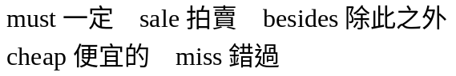
33.（A）How much is it？
（B）How much are they？
（C）How many dollars are you？
（D）How many money is it？
34.（A）bananas （B）pies （C）hats
（D）hot dogs
35.（A）between；and （B）to；from
（C）on；in （D）from；to
2.
Clerk: Welcome to Granny’s Shop. May I help you?
Jay: Yes, a turkey sandwich and an apple pie, please.
Clerk: Do you need a (36) ? Today our tea is very cheap. It’s only fifteen dollars.
Jason: No, I don’t like tea. Please give me a cup of coffee.
Clerk: What else do you need?
Jason: No, thanks. （37）
Clerk: They are eighty-five dollars.
Jason: Here’s one hundred dollars.
Clerk: Here’s your change. Thank you a lot.
cheap 便宜的 else 其他的 change 零錢
36.(Ａ) cake (Ｂ) cookie (Ｃ) drink (Ｄ) pie
37.(Ａ) Don’t worry.
(Ｂ) I have enough pocket money.
(Ｃ) How much are they？
(Ｄ) That’s too much.
四、閱讀測驗 12%
1.
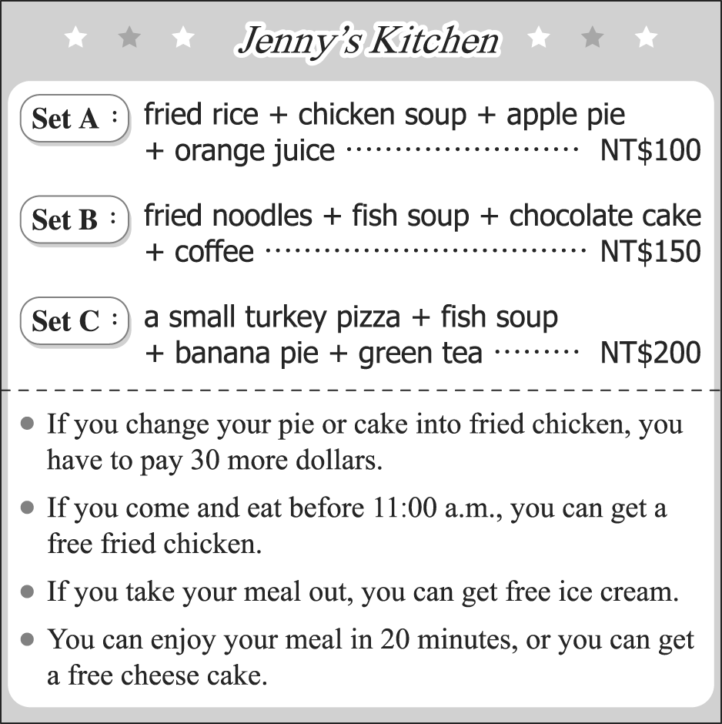
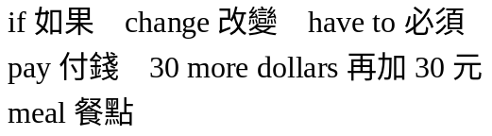
38. Jeremy goes to Jenny’s Kitchen with his brothers.
He and his brothers have a Set A and a Set B. And
they change the apple pie into fried chicken. How
much are their meals？
（A）NT$150 （B）NT$100 （C）NT$280
（D）NT$250
39. Lady Gaga wants to have lunch at Jenny’s Kitchen.
She has only $150. And she wants to take the meal
out. Which of the following（下列）is true（正確）？
（A）She can buy a meal Set C.
（B）She can get a free fried chicken.
（C）She can buy a meal Set B if she changes
chocolate cake into fried chicken.
（D）She can get free ice cream.
2.
Emily’s birthday is coming. Her friends, Joe and May, want to have a party for her. They need some things for the party and write them down.
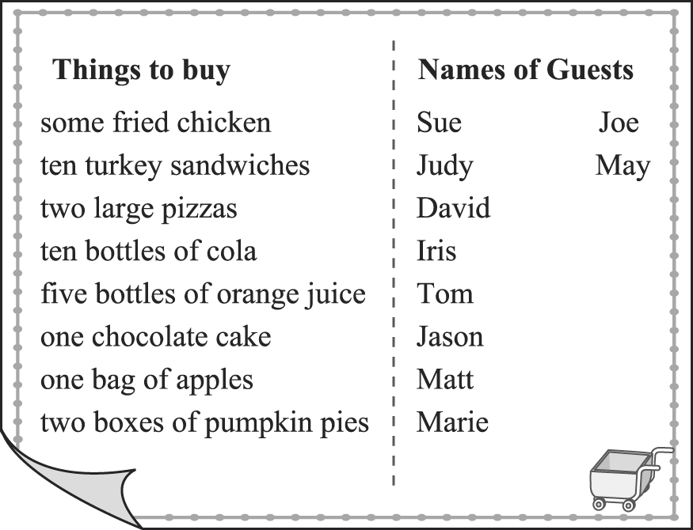
40 .There are 6 pieces of pumpkin pies in one box.
How many pieces of pumpkin pies do they buy?
(Ａ) 10. (Ｂ) 12. (Ｃ) 20. (Ｄ) 24.
41.A turkey sandwich is NT$40. Buy five and one of
them（其中之一）is free. How much are the ten turkey sandwiches?
(Ａ) NT$320. (Ｂ) NT$400. (Ｃ) NT$200.
(Ｄ) NT$160.
3.
Lots of people dream of traveling abroad. Some want to go to Europe to see castles, palaces and famous art museums. France and Spain have more visitors each year than any other countries. Others dream of traveling to Africa. They want to see the pyramids in Egypt. Or they want to go on a safari and see wild animals like elephants, lions and giraffes. If you can go to anywhere in the world, where do you want to go？
（文章出處：大家說英語雜誌2012年5月號P38）

dream of夢想 go abroad出國 Europe 歐洲 France法國
Spain西班牙 more visitors than~ 比~有較多的遊客
countries國家 Africa非洲 Egypt埃及 other其他的
42.According to（根據） the passage（段落）, what do people go to Europe to see？
（A）Animals.
（B）Pyramids
（C）Visitors.
（D）Castles.
43.Which of the following is true？
（A）France and Canada have more visitors than any
other countries.
（B）Visitors can see great castles and palaces in Europe.
（C）People want to go on a safari to see great museums.
（D）Visitors can’t see the pyramids in Egypt.
第三部分:手寫測驗 (共19分)
(一) 單字(中翻英) 每題1分 4%
44. 一月 ______________ 45. 優待券__________ 46.小吃攤 _____________ 47.果汁機 __________
(二) 翻譯 (中翻英) 每題3分 (分段計分,請盡力作答!)15%
48.5月28日星期三有一場棒球比賽。

______________________________________________

49.毎個人都喜歡這間早餐店的飯糰。

______________________________________________

50.媽媽一年365天都照顧我。

______________________________________________

51.我正在煮10個水餃給爸爸。

______________________________________________

52.你每個星期做幾杯（玻璃杯）奶昔？

______________________________________________

※試題結束，請再仔細檢查！請務必寫上班級、姓名、座號，鐘響後請將此張答案卷，連同答案卡一同交回！

