臺南市立新東國中 100學年度第二學期 一年級第二次段考 英語科試題卷

第一部份 聽力測驗 (20%)

一、聽字辨圖：每題2分，共10分
 根據聽到單字，選出正確的圖片代碼。


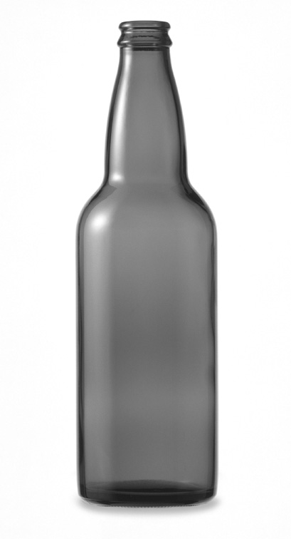
( ) 1. (A) (B) (C)

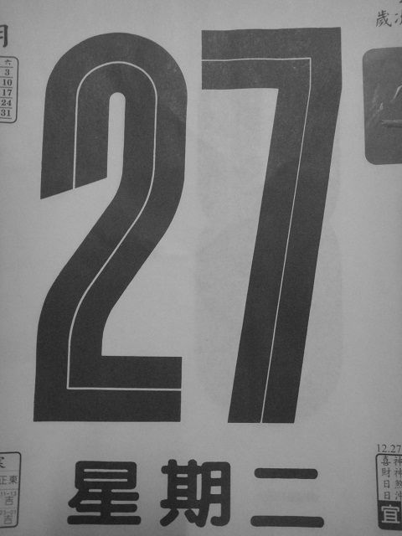

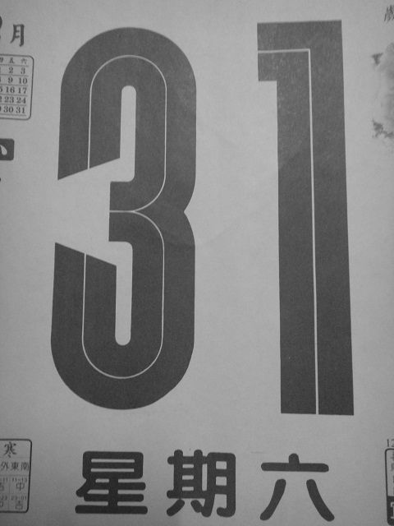
( ) 2. (A) (B) (C)

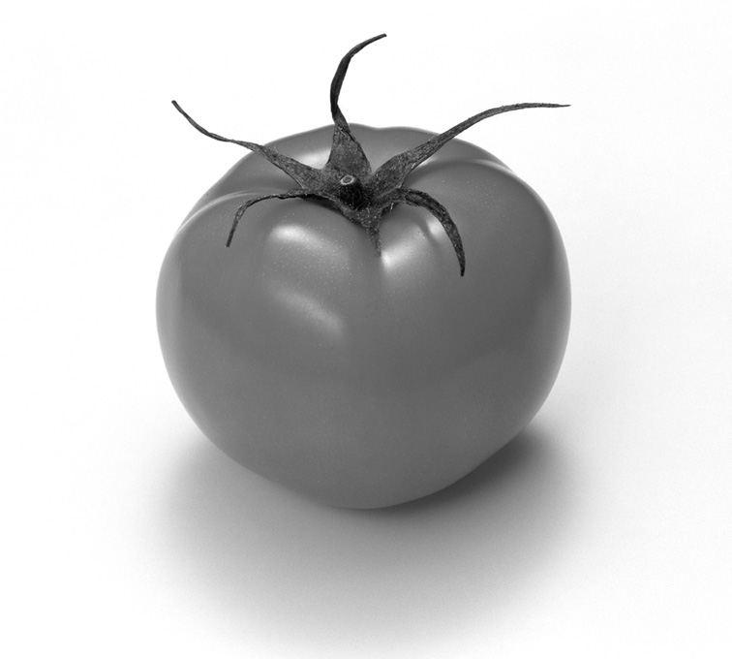
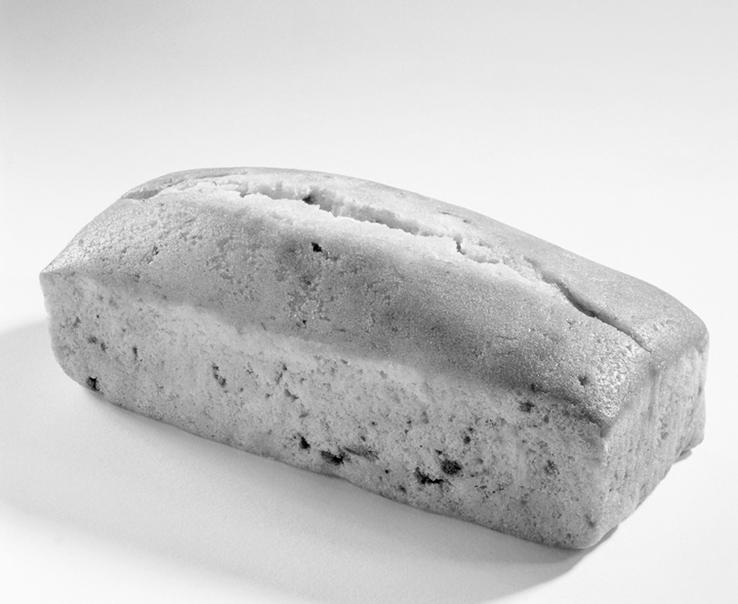
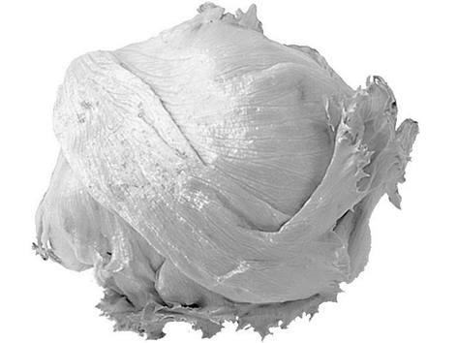
( ) 3. (A) (B) (C)

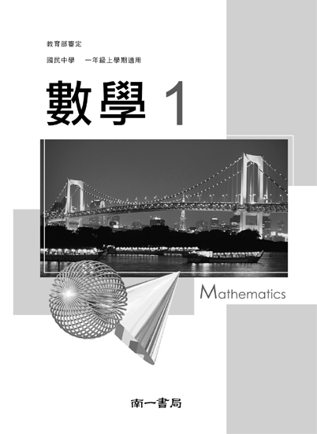

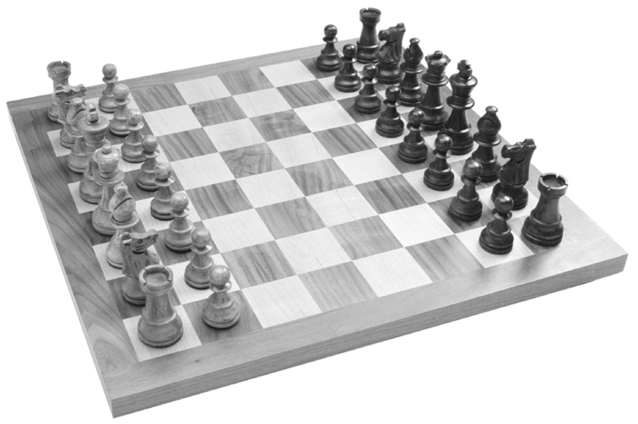
( ) 4. (A) (B) (C)

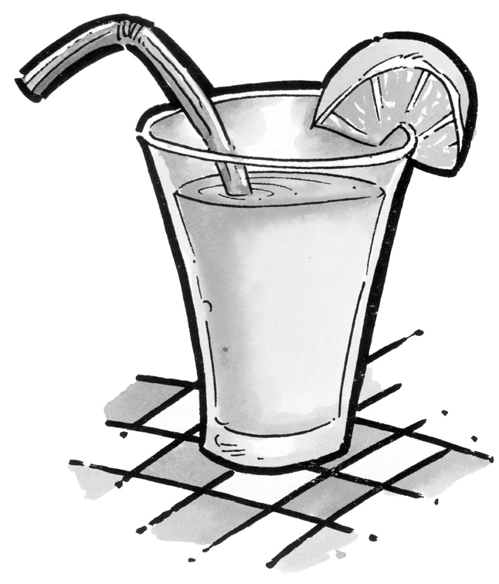
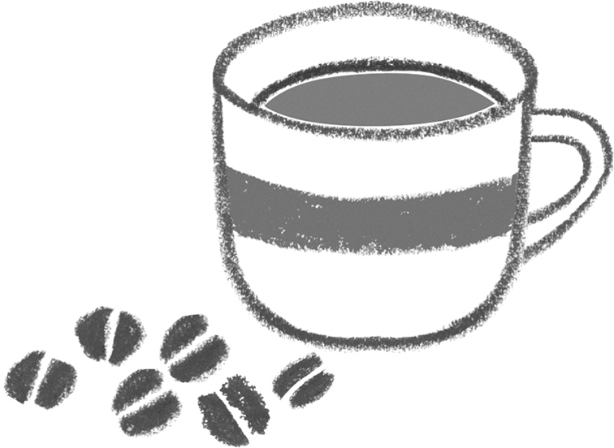

( ) 5. (A) (B) (C)

二、圖文配合：每題2分，共10分
根據圖片，聽完敘述後勾選出正確的答案。
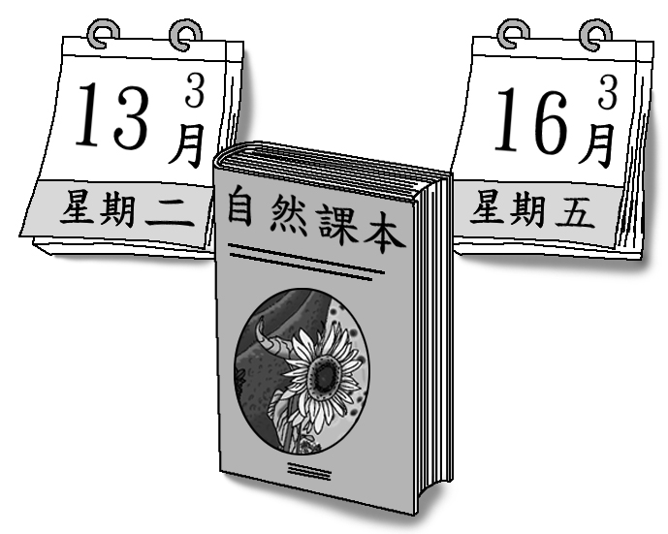
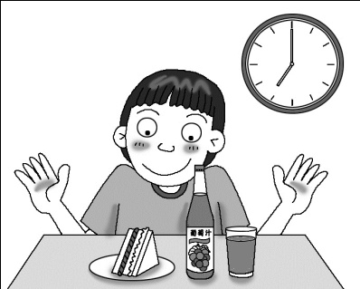
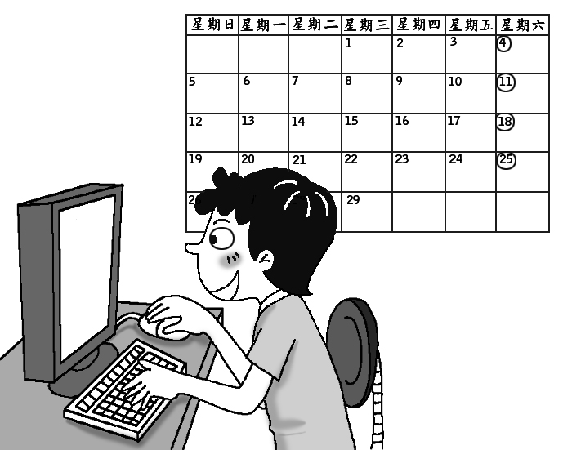
1. 2. 3.


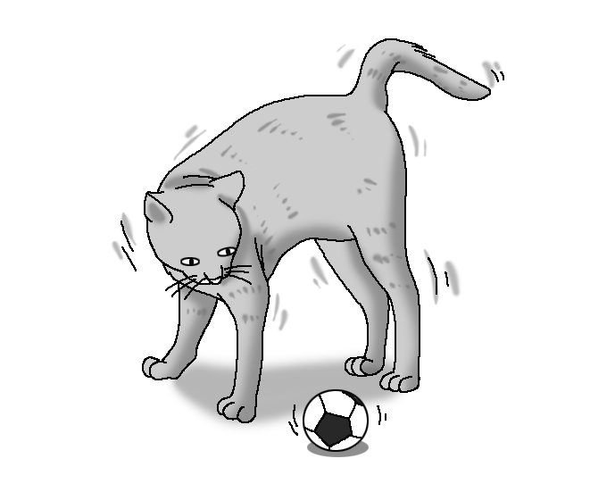
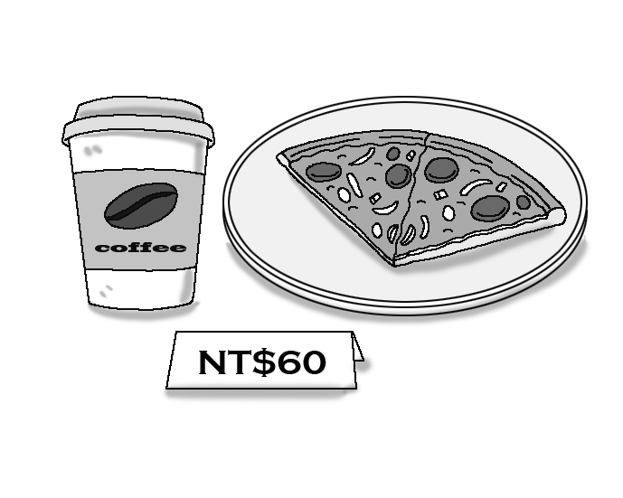
4. 5.

三、短文聽解：每題2分，共10分
根據聽到的短文，選出符合的圖片。
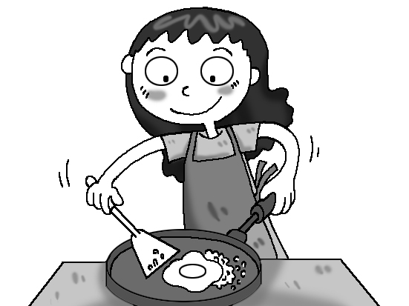

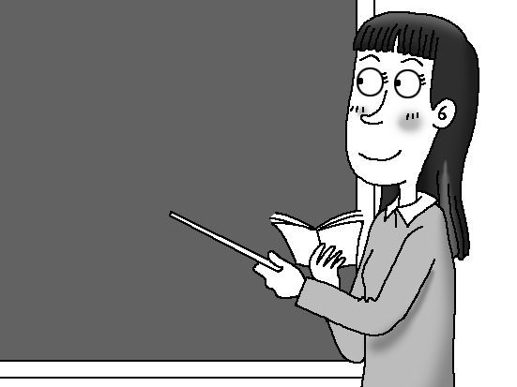
( ) 1. (A) (B) (C)


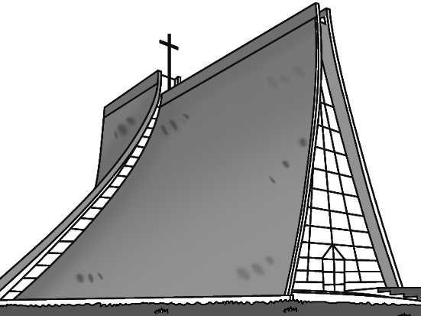
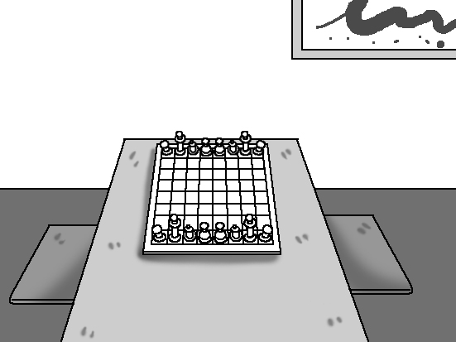
( ) 2. (A) (B) (C)

( ) 3. (A) (B) (C)
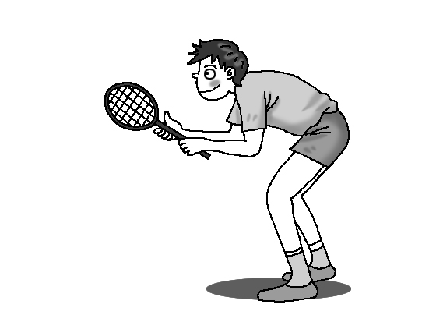
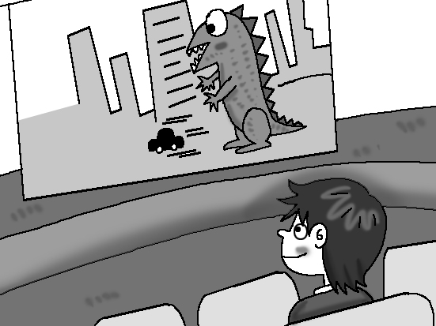
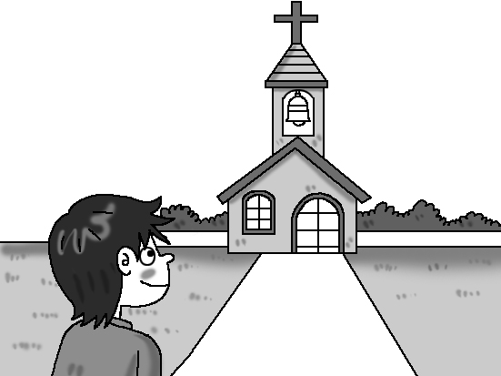

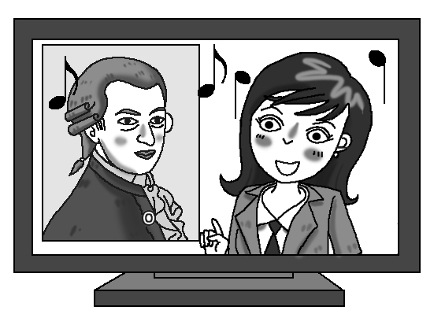
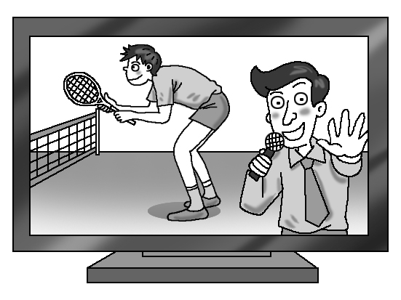
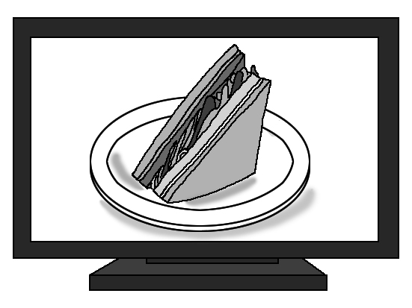
( ) 4. (A) (B) (C)

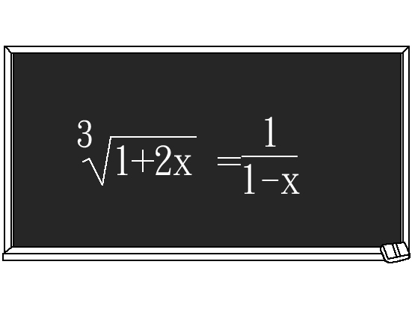

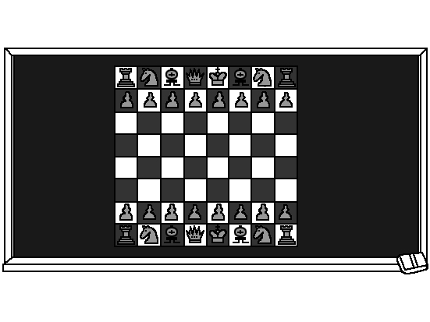
( ) 5. (A) (B) (C)

四、看圖辨義：每題2分，共10分
根據聽到的內容，敘述符合圖片者勾選 ，不符合者勾選 。
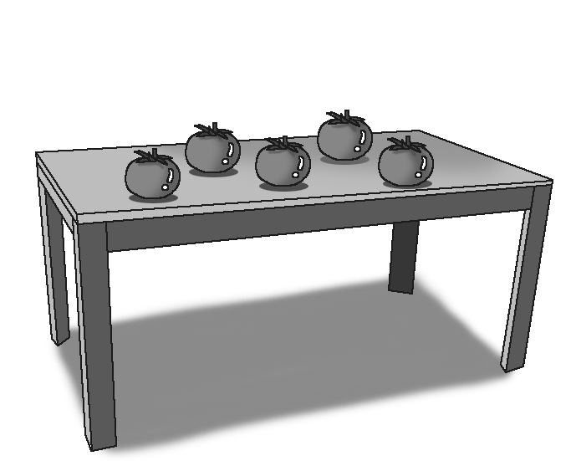
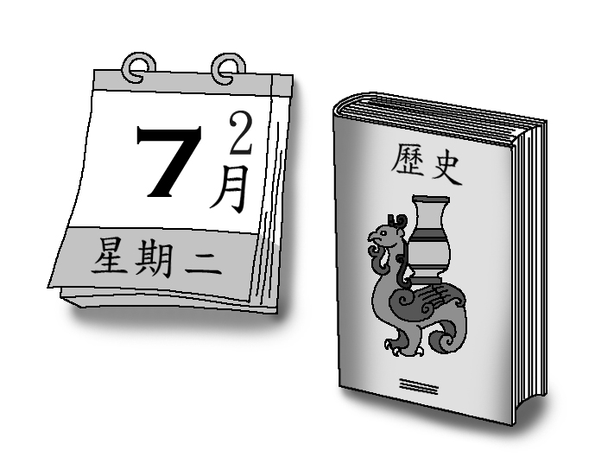
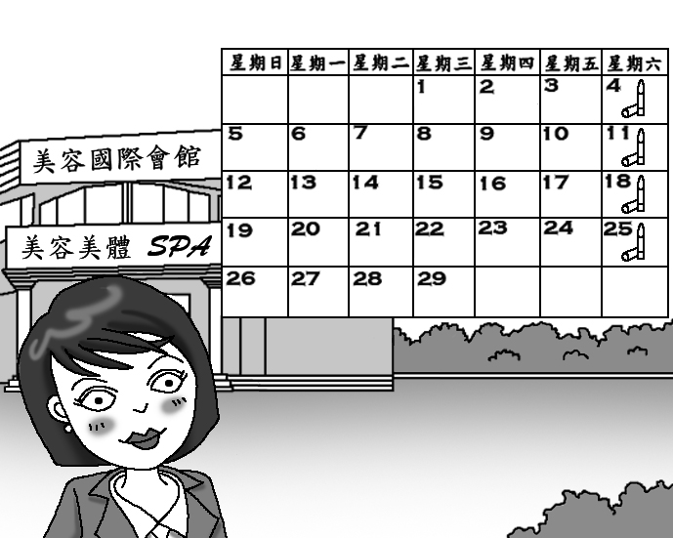
1. 2. 3.


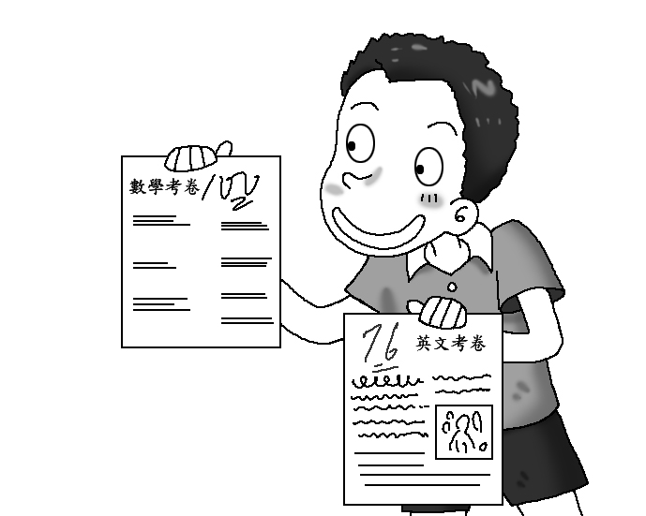
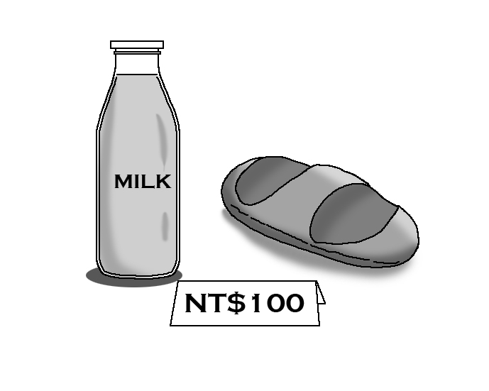
4. 5.

第二部份 讀寫部份 (80%)

一 、中翻英 (20%, 1-10題每題一分, 11-15題每題兩分)
- 牛奶 2. 商店 3. 考試 4. 星期一 5. 咬 6. 髮型 7. 報告 8. 披薩 9. 可樂 10. 有時候
11. 一片麵包 12. 兩杯水 13. 一些萵苣 14. 一個月一次 15. 一個禮拜三次

二、選出最適當答案 (20%)
- A: ______ money does the poor man have? B: He only has 5 dollars. (A) How much (B) How many (C) How often (D) When
- Jason, please go to the supermarket and buy two ______ of bread. (A) cans (B) bottles (C) loaves (D) cups
- A: ______ eggs are there in the bucket? B: There are ten eggs. (A) How much (B) How many (C) How often (D) When
- A: ______ do you have a math test? I have a math test this Monday. (A) How often (B) What time (C) What (D) When
- A: ______ we ______ go to school on Saturdays? B: Unfortunately(不幸的), Yes. (A)Does；has to (B)Does；have to (C)Do；has to (D)Do；have to
- When you have troubles(麻煩), you can always call 110 and ask ______. (A) to help (B) for help (C) for tea (D) to come
- A：______ do you do your hair? I do my hair once a year. (A) How often (B) What time (C) What (D) When
- I go swimming every Wednesday and Friday. So I go swimming ______ a week. (A) once (B) twice (C) three times (D) many
- I ______ to school at 7. (A) go usually (B) usually go (C) am usually (D) usually am
- I ______ happy. (A) am always (B) always am(C) do always (D) always do

三、故事式翻譯(請依照範例，將畫線部分翻譯成英文) (15%)
海綿寶寶( SpongeBob SquarePants)在上班途中遇到蟹老闆(Mr. Krabs)。
蟹：海綿寶寶，幾點了還在這裡。(範例)你上班已經遲到了!
海：不是這樣子的，蟹老闆！(1)今天星期幾?
蟹：星期日啊, 怎麼了嗎?
海：(2)我每個星期天早上必須去教堂，所以我是上下午的班。
蟹：我不信! 我要打電話問派大星(Patric Star)。(撥打電話中) (3)喂，派大星，我是蟹老闆。
派：呵呵呵~蟹老膽
蟹：氣死我了~我是老闆！不是老膽! 算了，我問你，你知道今天早上海綿寶寶去哪了嗎?
派：我當然知道，但我不告訴你。除非你給我美味蟹肉三明治。
蟹：氣死我了~竟敢要脅我！算了，(4)你要幾個三明治?
派：呵呵呵~你被騙了。其實，(5)我要一百罐水母果汁。(註: 水母 jellyfish)
蟹：什麼~你真是氣死我了！(這時電話被海綿寶寶搶走)
海：派大星，我們等一下去抓水母吧~
派：好啊~呵呵呵~

四、克漏字(10%)
(Part I)  A: Hey, Patric, let’s (1)______ tonight. I know a good restaurant.  B: I’m sorry. I can’t go. I have (2)______ homework to do tonight.  A: But tomorrow is Saturday. You can do it tomorrow.  B: I still have to go to school on Saturday.  A: (3)______, that’s terrible.  B: It is TERRIBLE! I don’t have time to (4)______ my life(生活).  A: I’m so sorry for you. Let me (5)_____ a good dinner for you! | (Part II)  A: Hey, Patric, do you have (6)______ cheese?  B: Yes, but why(為什麼) are you asking?  A: I want to bake(烘培) a cheese cake. (7)______ you give me some, please?  B: Sorry, I can’t. I have only two (8)______ of cheese. One is for me and (9)______ is for my dog.  A: (10)______! What are friends for! Give me your cheese, please!
- (A) eat out (B) play basketball (C) get up (D) dance  - (A) many (B) many of (C) a lot (D) a lot of  - (A) Hello (B) Oh my (C) Good (D) Watch out  - (A) practice (B) enjoy (C) need (D) play  - (A) show (B) clean (C) make (D) feed | - (A) any (B) no (C) many (D) not  - (A) Do (B) Can (C) What (D) How  - (A) cups (B) bottles (C) slices (D) loaves  - (A) others (B) other (C) the others (D) the other  - (A) Come on (B) Maybe (C) Of course (D) Wow
五、閱讀測驗(15%, 1-6題每題2分, 7-9題每題1分)
(Part I)  Sandy is planning to save $1,000,000 in ten years. She will save money according to the list below. Read it and answer the questions.  the plans for saving money  Words: plan 計畫 will (表未來)將according to 根據 amount總額 over超過 become 變成 millionaire百萬富翁 billionaire 億萬富翁  - How much does Sandy plan to save each year?  (A) $100,000 (B) $ 200,000 (C) $ 300,000 (D) $ 400,000  - When will Sandy have over $800,000? (A) one year later (B) four years later (C) six years later (D) eight years later  - After ten years, what will Sandy become? (A) a poor woman (B) a billionaire (C) a millionaire (D) a businesswoman | (Part II)  There are 40 students in Sandy’s class. What kind of movie do they like?  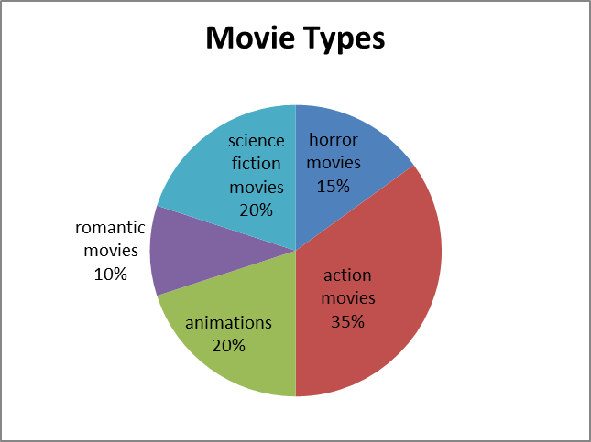  Words: horror 恐怖 fiction 虛幻 romantic 浪漫的 animation 動畫 least 最少 which 哪個  - How many students like to watch animations? (A) 4 (B) 6 (C) 8 (D) 14  - What kind of movie do the least students like? (A) romantic movies (B) science fiction movies (C) horror movies (D) action movies  - Which two kinds of movies do half of the sutdents in Sandy’s class like? (A) science ficiton movies and animations (B) action movies and horror movies (C) animations and horror movies (D) science fiction movies and aciton movies
  Year Money | Amount of savings
  2008 | 100,000
  2009 | 200,000
  2010 | 300,000
  2011 | 400,000
  2012 | 500,000
  2013 | 600,000
  2014 | 700,000
  2015 | 800,000
  2016 | 900,000
  2017 | 1,000,000

(Part III)  Dear John Letter  John was a college student in America. One day, he got a letter from his girlfriend in Taiwan. The letter said:  Dear John,  I’m sorry, but it’s time to say goodbye. I have a new boyfriend. Would you please send my pictures back? I want to give them to my new boyfriend.  Mary  Words: was (is的過去式) got(get的過去式)獲得 send 寄 back 回來 asked (ask的過去式) sent (send的過去式) yourself你自己 ask for +東西… 要…東西 | John was very angry. He asked his classmates for women’s pictures (their aunts, mothers, or grandmothers). He put these pictures into a box and then sent it to his girlfriend. In the box, he also put a letter. The letter said:  Dear Mary,  Sorry, I have too many girlfriends. Please find your picture by yourself.  John  - Who was Mary? (A) John’s mother (B) John’s girlfriend (C) John’s grandmother (D) John’s aunt  - How did John feel after he got the letter? (A) afraid (B) happy (C) angry (D) sad  - Which is true? (A) John has many girlfriends. (B) John still loves Mary. (C) Mary has many boyfriends. (D) Mary is going to get photos of other girls.

臺南市立新東國中 100學年度第二學期 一年級第二次段考 英語科答案卷
班級: 座號: 姓名:

第一部份 聽力測驗 (20%)
一、聽字辨圖：每題2分，共10分
二、圖文配合：每題2分，共10分
三、短文聽解：每題2分，共10分
四、看圖辨義：每題2分，共10分

第二部份 讀寫部份 (80%)
一 、中翻英 (20%, 1-10題每題一分, 11-15題每題兩分)
1. | 2. | 3 | 4. | 5.
6. | 7. | 8. | 9. | 10.
11. | 12. | 13. | 14. | 15.
二、選出最適當答案 (20%)
1. | 2. | 3 | 4. | 5.
6. | 7. | 8. | 9. | 10.
三、故事式翻譯(請依照範例，將畫線部分翻譯成英文) (15%)
(範例) You are already late for work!
- __________________________________________________________________________________
- __________________________________________________________________________________
- __________________________________________________________________________________
- __________________________________________________________________________________
- __________________________________________________________________________________
四、克漏字(10%)
1. | 2. | 3 | 4. | 5.
6. | 7. | 8. | 9. | 10.
五、閱讀測驗(15%) (1-6每題2分, 7-9題每題1分)
1. | 2. | 3 | 4. | 5.
6. | 7. | 8. | 9.

臺南市立新東國中 100學年度第二學期 一年級第二次段考 英語科答案卷
班級: 座號: 姓名:

第一部份 聽力測驗 (20%)
一、每題2分
B | B | A | B | A
二、每題2分
A | C | B | C | C
三、每題2分
C | A | B | C | C
四、每題2分

第二部份 讀寫部份 (80%)
一 、中翻英 (20%, 1-10題每題一分, 11-15題每題兩分並分段給分)
- milk | 2. shop | 3. test | 4. Monday | 5. bite
6. hairstyle | 7. report | 8. pizza | 9. cola/coke | 10. sometimes
11.  a/one slice/piece of bread | 12.  two glasses/cups of water | 13.  some lettuce | 14.  once a month | 15.  three times  a week
二、選出最適當答案 (20%)
1. A | 2. C | 3. B | 4. D | 5. D
6. B | 7. A | 8. B | 9. B | 10. A
三、故事式翻譯(請依照範例，將畫線部分翻譯成英文) (15%)
(範例) You are already late for work!
- What day is it? / What day is today? What is the day today? (2)
- I have to go to church every Sunday morning. (3)
- Hello, Patric Star, this is Mr. Krab. (3)
- How many sandwiches do you want? (3)
- I want one hundred cans/bottles of jellyfish juice. (4)

四、克漏字(10%)
1. A | 2. D | 3. B | 4. B | 5. C
6. A | 7. B | 8. C | 9. D | 10. A
五、閱讀測驗(15%) (1-6每題2分, 7-9題每題1分)
1. A | 2. D | 3. C | 4. C | 5. A
6. B | 7. B | 8. C | 9. D

