1.本學科試題三張五面，答案卡一張。
2.本測驗選擇題共50題:第一至第六大題每題都有A、B、C、D四個選項，其中只有一個選項是正確的。請將正確答案填入答案卡。試題答錯，一律不倒扣。
3.作答時必須使用2B黑色鉛筆，將正確答案畫記在規定的答案卡上，否則不予計分。
4.本試題紙空白處，可供草稿使用，答案卡絕對不可打草稿。
5.本學科試卷共50題，合計100分。

第一部分：聽力測驗 (30%)

一、Choose. 選出聽到單字的音標 (5題，第1-5題，每題2分，共10分)
( )01.
( )02.
( )03.
( )04.
( )05.

二、Choose. 選出聽到句中所含的單字 (5題，第6-10題，每題2分，共10分)
( )06. Christmas cards Christmas turkey
Christmas stockings Christmas trees
( )07. Mondays Wednesdays Sundays Thursday
( )08. quiet free ready quite
( )09. study room snack bar gift shop library
( )010. minutes weeks days hours

三、Choose. 根據聽到的對話或敘述，選出最適當的圖片 (5題，第11-15題，每題2分，共10分)
( )011. 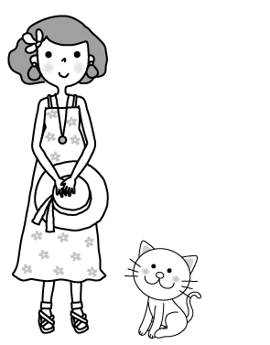 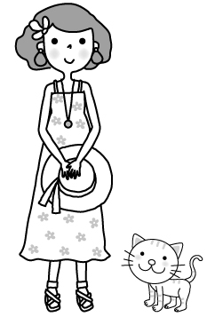 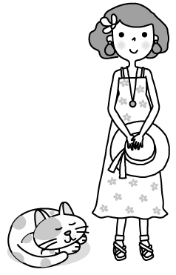 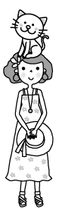
( )012. 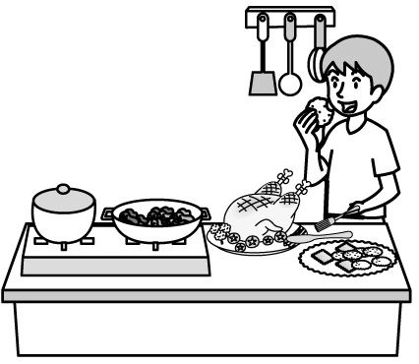 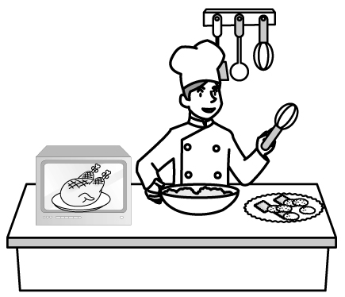 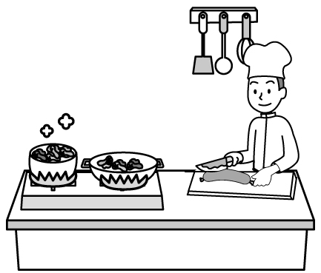 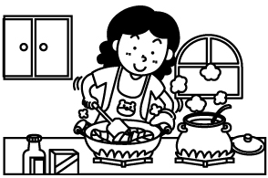

( )013. 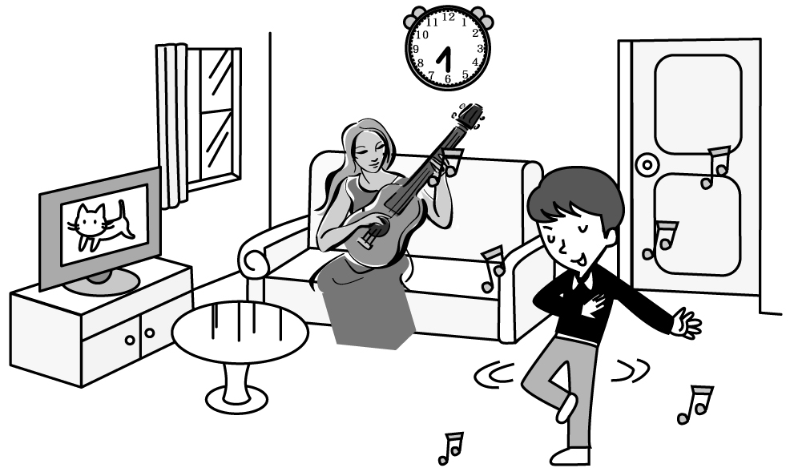 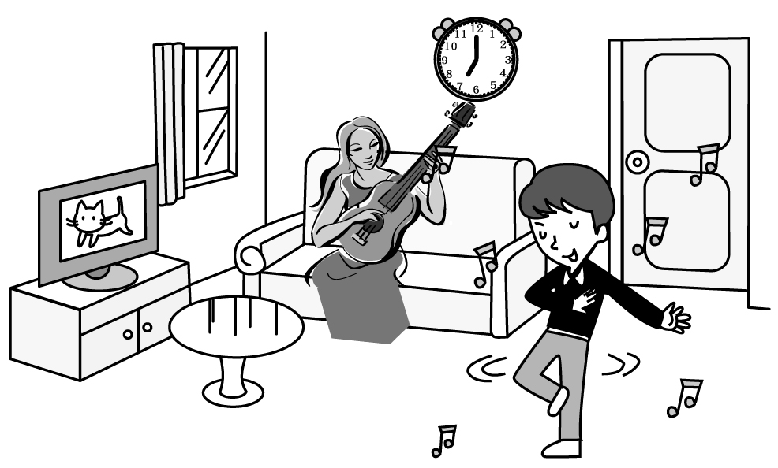
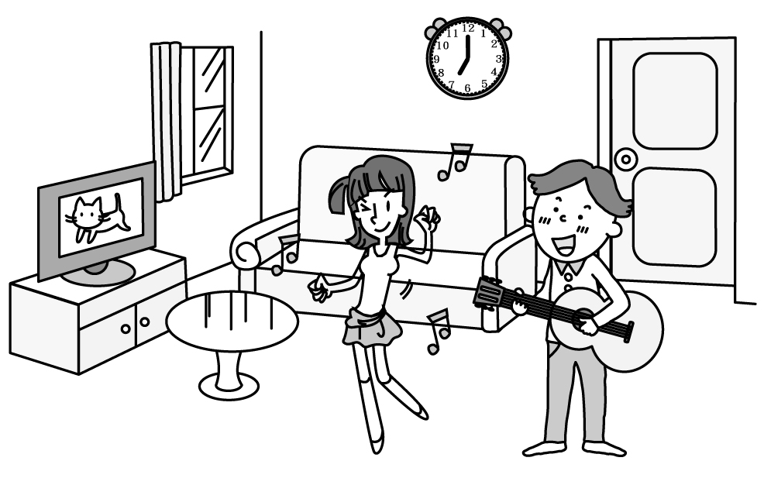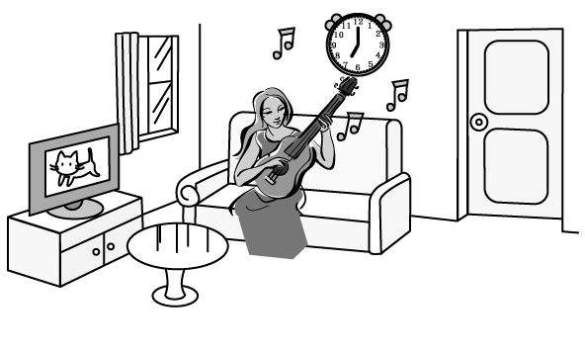
( )014. 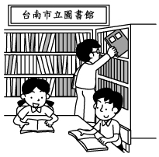 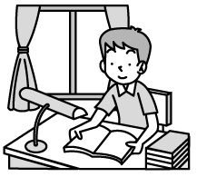  
( )015. 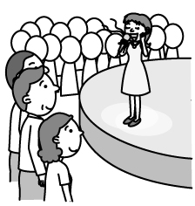 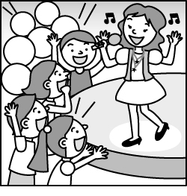 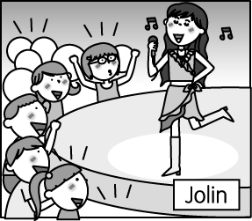

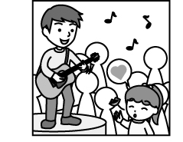
第二部分: 讀寫測驗 (70%)
背面尚有試題，請翻頁繼續作答

四、語法選擇 (20題，第16-35題，每題2分，共40分)
( )016.0 have a seat.
Please Please not Don’t please Please no
( )017.0 I am busy now. Can you give me a ?
kiss time concert hand
( )018.0 He is a bell on the Christmas tree.
having cooking hanging coming
( )019.0Where is the singer ______ ? B: He’s a Singaporean (新加坡人).
form in to from
( )020.0Ellen: What are you ? Allen: I’m singing.
singing now do doing
( )021.0 It’s Sunday today. The day after tomorrow (明天) is .
Thursday Sunday Monday Tuesday
( )022.0 Samantha is sleeping in her room, not .
singing study is watching TV talks
( )023.0Sophia, ______ a good mother.
is are Be be
( )024.0 There seven days a week.
is, in is, on are, in are, on
( )025.0 Lily is smiling and her hands.
wave waves waved waving
( )026.0Joan: Is the party Thursday night? Jose: No, it is on Friday.
on in x at
( )027.0 Mr. Wang is very tall, his wife isn’t.
X or so but
( )028.0 Be quiet. Dad is talking the cellphone..
with in for on
( )029.0 Don’t in the classroom.
little litter later letter
( )030.0Alex: What time is the basketball game? Andrew: .
It’s good It’s in the evening At seven thirty On Friday morning
( )031.0Sarah: Look at the glasses on the table. So pretty! Maggie:
What are you looking at? What is it for?
Is it for me? What are they for?
( )032.0It’s time _______. Let’s go to the park now.
go home for dinner to play baseball to doing my homework
( )033.0Henry: Hi, there. I’m Henry. _______________ Jessica: Cherry. Nice to meet you, Henry.
What’s your name? How is she? Who’s that girl? Nice to see you.
( )034.0Ava: See you at the dancing party tonight. Mia: Ok. _______________
背面尚有試題，請翻頁繼續作答
Nice to see you. See you later. Come on. Great to see you here.
( )035.0 Steve: What is your mother ? Jane: She is talking my teacher.
do, to do, about doing, with doing, next

五、克漏字選擇 (10題，第36-45題，每題2分，共20分)

(36-40題)
Debby: Mrs. Lu, can I talk (36) you for a few minutes?
Mrs. Lu: Sure. (37) a seat, please. What’s wrong, Debby? You don’t look well.
Debby: My best friend, Cindy, doesn’t talk to me now.
Mrs. Lu: Really? (38) ?
Debby: Because I used her cellphone without her permission.
Mrs. Lu: Well, it’s not polite to do that even if she is your best friend.
Debby: I know. What should I do?
Mrs. Lu: (39) sorry to her. She will forgive you.
Debby: Can you go with me, Mrs. Lu?
Mrs. Lu: No problem. (40) go.
best 最好的
because 因為
permission 同意
polite 有禮貌的
forgive 原諒
even if 即使

( )036.0 at in on to
( )037. have Have Having Do
( )038. Why Which What When
( )039. Say Be saying To say Says
( )040. Let me You and me Let Let’s

(41-45題)

Tomorrow（明天）is Christmas. Many friends (４１) to my house and having dinner together. There (４２) many people, so we have to buy much food. Mom is roasting a turkey now, and Dad (４３) the table. Grandpa is making cookies. I (４４) cookies very much. We always have a good (４５) on Christmas.
relative 親戚 prepare 準備

( )041. comes is coming are coming come
( )042. have has is are
( )043. sets is setting are setting set
( )044. liking likes like is liking
( )045. table bye time hand

背面尚有試題，請翻頁繼續作答
六、閱讀測驗 (5題，第46-50題，每題2分，共10分)

(46-48題)

Mark: Grandma’s birthday is next Sunday. What gifts do you buy?
William: A cellphone.
Mark: But she already has one, doesn’t she?
William: Yes, she does. But I think that one is hard to use for her. The screen and buttons are too small.
Mark: That’s true. I hope Grandma likes it. But a cellphone is expensive. Can you afford it?
William: I can not, so I ask Mom and Dad for help. They say they will help me but I have to do some housework. I
have to clean the living room and my room.
Mark: Cool. Maybe you can clean my room, too.
already 已經 hard 困難的 screen 螢幕
expensive 昂貴的 button 按鈕 afford 買得起

( )046. What is the relationship（關係）between Mark and William?
Cousins. Brothers. Classmates. Father and son.
( )047. Why does William buy a cellphone for his grandma?.
Because his grandma doesn’t have a cellphone.
Because her cellphone is broken (損壞的).
Because his grandmother doesn’t like it.
Because the screen and buttons of her cellphone are too small.
( )048. Which one is right?
William can afford the cellphone.
Mark buys a cellphone for his grandma.
William has to do some housework for buying the gift.
William has to clean Mark’s room.

(49-50題)

Jose: Are you two ready for the basketball game? It’s a game between the two teams from America. It will be an
exciting game.
Alexis: Yes, you are right. We can’t miss it. What time is the game?
Jose: It’s at five p.m.
Alexis: What time is it now?
Jose: It’s four p.m. We’re going to be late! Where is the game? How can we get there in an hour? What can we
do?
Alexis: It’s at the City Gym. We can take Bus No. 513 there. But let’s take a taxi now. It’s faster.
James: Hey you two. Calm down. What day is the game?
Jose: It’s on Saturday.
James: What day is today?
Jose: Oops! Today is Friday.

( )049. When is the basketball game?
At five p.m. on Friday. At four p.m. on Saturday.
At four p.m. on Friday. At five p.m. on Saturday.
( )050. Which is right?
Jose, Alexis and James are going to a basketball game today.
Alexis and James are ready for the basketball game.
Jose, Alexis, and James are going to take a taxi.
Jose, Alexis, and James can take bus to the City Gym to watch the game.

