1. 本學科試題一共五頁。答案卡與答案紙一併繳交。

2. 答案卡必須使用2B鉛筆，將正確答案畫記在規定的答案卡上，否則不予計分。

3. 非選擇題請用藍筆或黑筆書寫工整。

4. 本試題紙空白處，可供草稿使用，答案卡絕對不可打草稿。

5. 本學科試卷分成兩部分：I、選擇題65%；II、書寫測驗35%，共45題，合計100分。

I、選擇題65%

一、聽力測驗：(共15題，1~5題每題1分，6~15題每題2分，共計25分。)

(一)、請根據聽到的內容，圈選出正確的圖片。
1.
2.
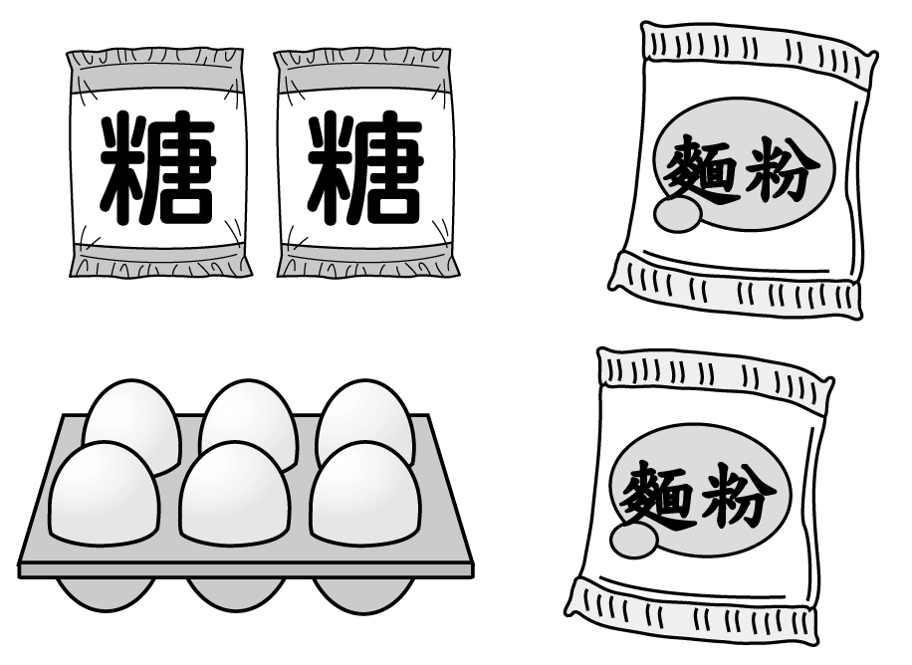 | 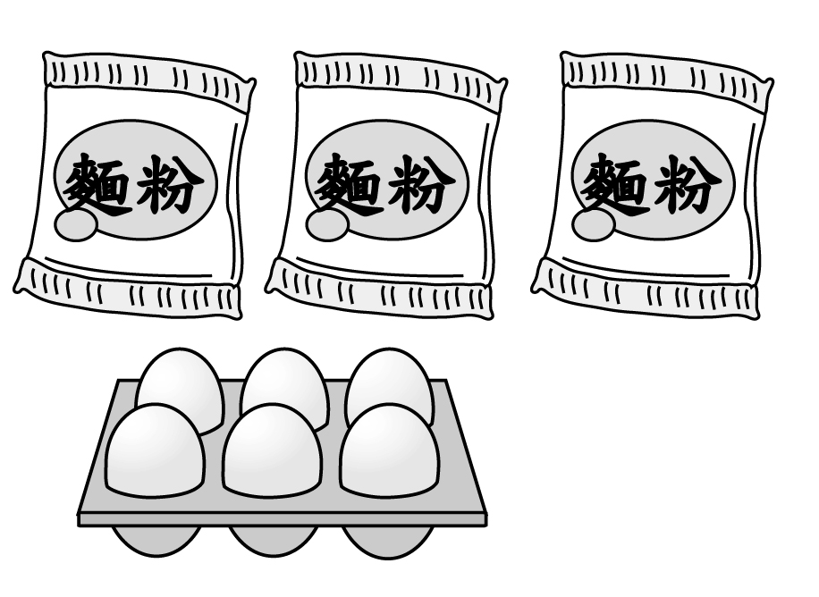 | 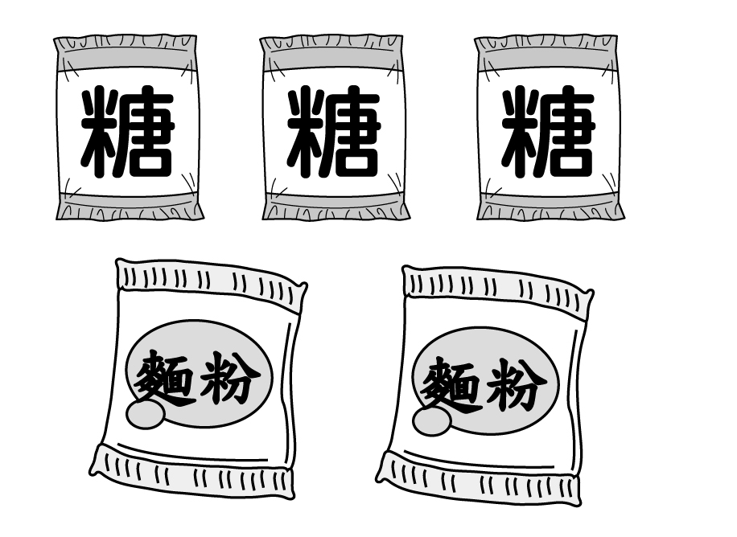
A（ ） | B（ ） | C（ ）
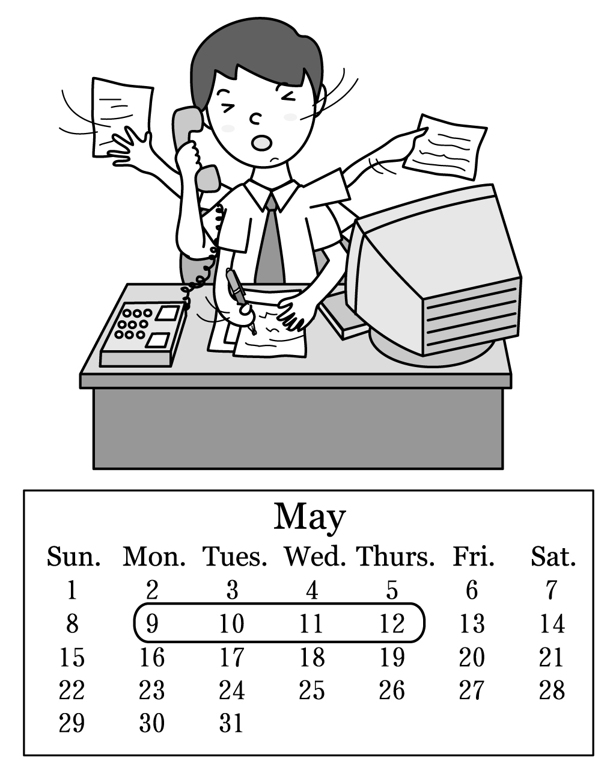 | 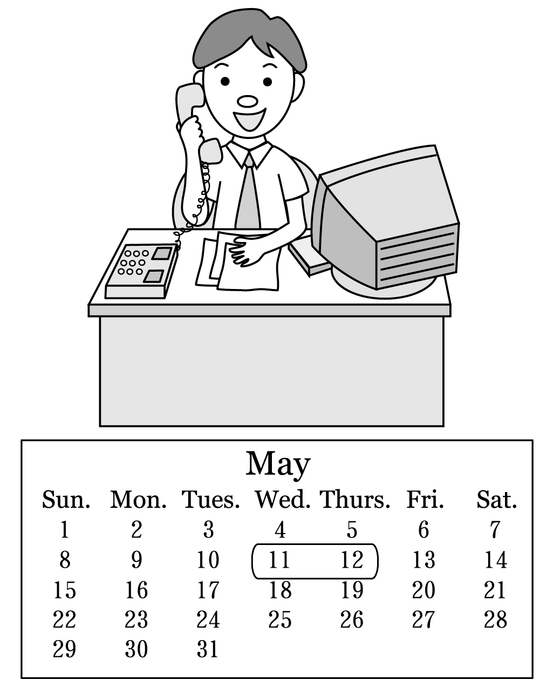 | 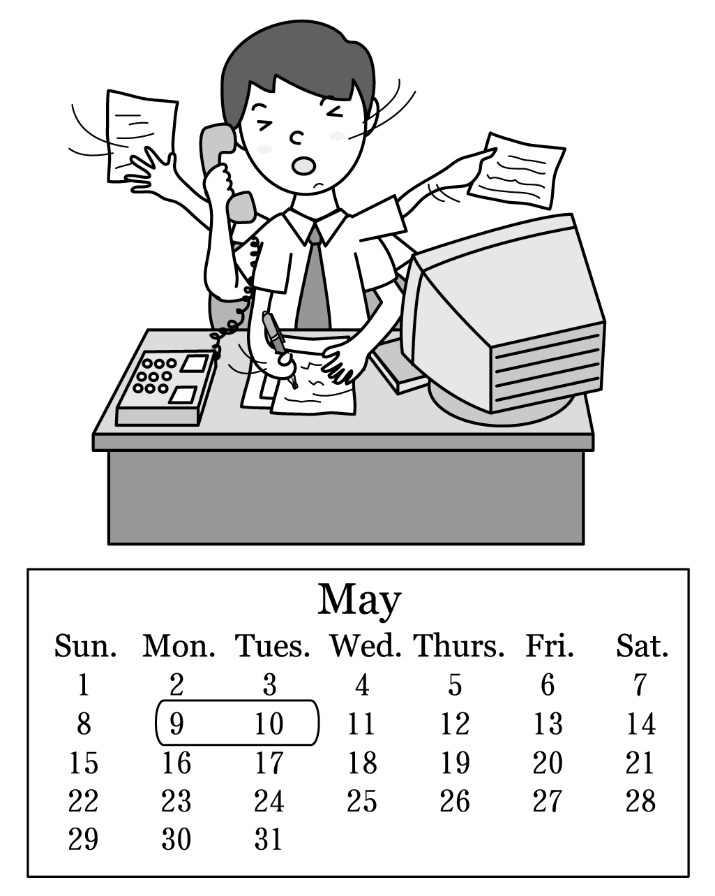
A（ ） | B（ ） | C（ ）

3.
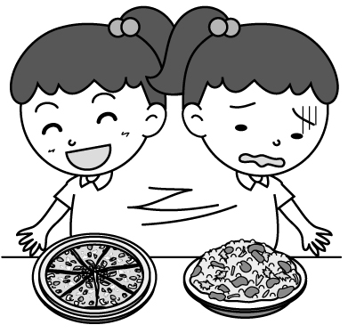 | 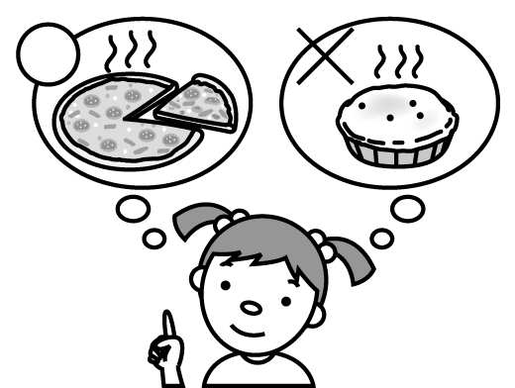 | 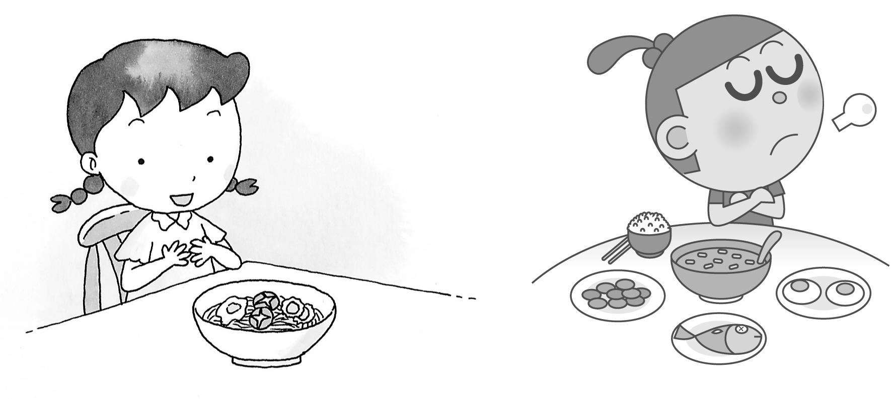
A（ ） | B（ ） | C（ ）

背面尚有試題，請翻頁繼續作答

4.
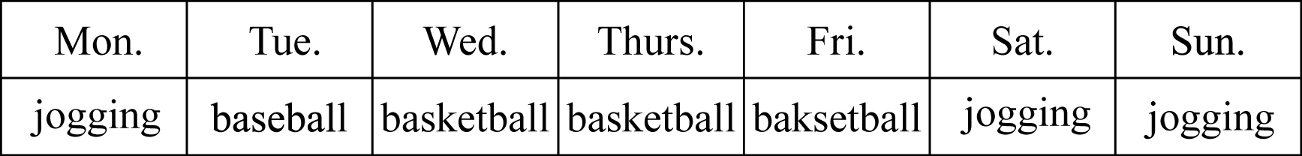 | 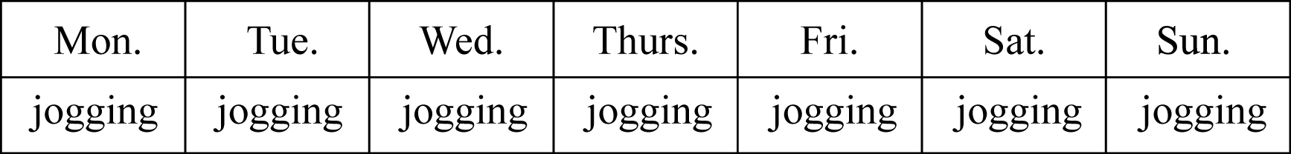 | 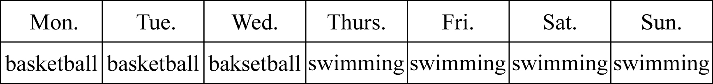
A（ ） | B（ ） | C（ ）
5.
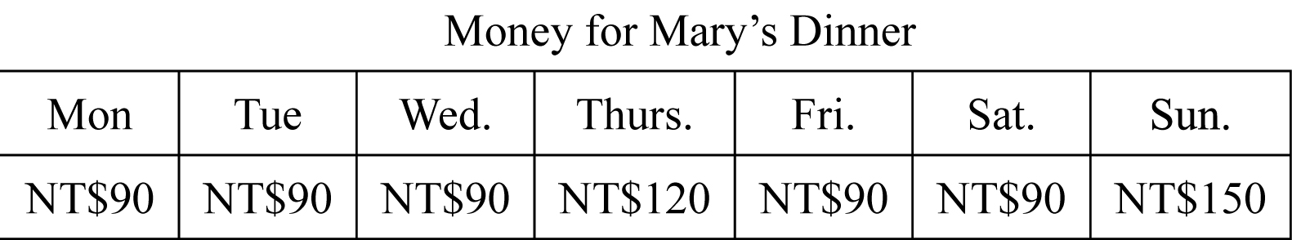 | 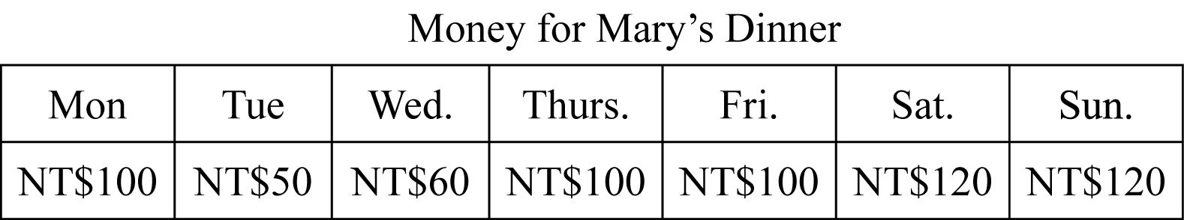 | 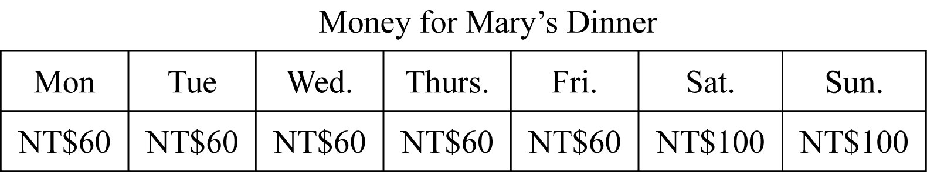
A（ ） | B（ ） | C（ ）

(二)、根據聽到的對話內容，選出正確的答案。

( ) 6 . (A) The woman likes hot dogs.

(B) The woman likes noodles and apple juice.

(C) The man and the woman like apple juice.

( ) 7. (A) The man buys one bottle of milk and some bananas.

(B) One banana is twenty-five dollars.

(C) The woman buys a bottle of milk.

( ) 8. (A) The man cleans the room once a week.

(B) The woman cleans the man’s room every day.

(C) The man’s mother cleans his room every day.

( ) 9. (A) Mary never studies after school.

(B) Mary is usually very busy after school.

(C) Mary is an early bird.

( ) 10. (A) The woman’s favorite drink is green tea.

(B) The man likes coffee, not tea.

(C) The woman wants some coffee.
(三)﹑根據聽到的文章內容及問題，正確的選A，錯誤的選B。
11. (A) ( ) (B) ( )
12. (A) ( ) (B) ( )
13. (A) ( ) (B) ( )
14. (A) ( ) (B) ( )
15. (A) ( ) (B) ( )

二、文法選擇：(共10題，每題2分，共計20分。)

( ) 16. _______ chicken in this restaurant is really delicious.

(A) A (B) The (C) These (D) Those

( ) 17. A: Why _______ Peter always late for school? B: He _______ gets up late.

(A) is; sometimes (B) is; often (C) does; never (D) do; usually
( ) 18. ______ your sister busy every weekend?

(A)Do (B) Does (C)Are (D) Is

( ) 19. _______ do you like, orange juice, pizza _______ fried chicken?

(A) Which; and (B) When; or (C) What; and (D) Which; or

( ) 20. Blend the milk and the chocolate ice cream _______ about one minute.

(A) on (B) about (C) for (D) from

( ) 21. A:How _______ cans of juice do they have? B: They have thirty-three.

(A) often (B) old (C) many (D) much
( ) 22. Those stray dogs（流浪狗）are very poor. Let’s .
(A)nice to they (B) are nice of them (C)do nice to it (D) be nice to them

( ) 23. How often do you go to Tainan?

(A) For three weeks. (B) Three times. (C) Every three weeks. (D) Twice in a week.

( ) 24. A:_______ _______ a plate of fried noodles? B: Seventy dollars.

(A) How many; is (B) How much; is (C) How many; are (D) How much; are

( ) 25. 選出正確的句子
(A) Sometimes I and Kanti play in front of our tree.
(B) How many times a day do you brush your teeth?
(C) The food there are very cheap. They cost only forty dollars.
(D) A:Are there any eggs in the kitchen? B: Yes, a lot of.

三、閱讀測驗：(共5題，每題4分，共計20分。)
背面尚有試題，請翻頁繼續作答
Dear Mom,
I know you are not happy about the poor grades on my tests. I’m sorry for that. I will study hard. So Mom, please let me study at home. I don’t want to go to the cram school every night. It’s not helpful. I will not watch too much TV and play so many computer games. I will make good use of my time and do my homework every day. Let me try, Mom.
Your son,
Jim

( ) 26. Why does Jim write this letter to his mom?
（A）He doesn’t like his teachers at school. （B）He doesn’t want to go to the cram school.
（C）He wants to surf the Net in his free time. （D）He hopes his mom can take good care of him.
( ) 27. What does that mean?
（A）Jim doesn’t get good grades. （B）Jim doesn’t use his time well.
hand in 繳交
（C）Jim writes this letter. （D）Jim doesn’t hand in his homework.
Here’s an easy cookbook for you to read. In the book are many kinds of food, like hot dogs, sandwiches, hamburgers and salad. There are also some drinks, like green tea, juice and coffee. You can make delicious food by following steps. Be careful with the knives or forks when cooking. Clean the kitchens after making dishes. You may have the new ideas and create your own cookbooks. Do it right now! Maybe you will be a great cook someday!
Super Beef Sandwich
Ingredients
★ 2 slices of bread
★ 4 slices of beef
★ 2 slices of cheese
★ 2 spoons of butter
★ 1 tomato ( cut up )
★ 1 onion ( cut up )
First, put the butter on a slice of bread.
Then, cut up a tomato and an onion. Add these to the sandwich.
Next, put the beef slices on the sandwich. Put the cheese slices on the beef.
Finally, put the other slice of bread on top.

like像是,step 步驟, when 當, after在…之後, create創造,
will將, ingredient 材料, the other另一個,slice切片 top頂端

( ) 28. What does “add” mean?

(A) To cut something. (B) To put something. (C) To drink something. (D) To clean something.

( ) 29.Which is true for you to make “Super Beef Sandwich”?
(A) You don’t have to cut up the tomato.
(B) You don’t need any cheese for the sandwich.
(C) You have to put two slices of beef on the bread.
have to 必須
(D) You need the other slice of bread on top.

( ) 30. What do children have to do after cooking?
(A) They have to be careful about the knives.
(B) They have to clean the kitchen.
(C) They have to be a great cook.
(D) They have to work with their parents.
II、書寫測驗35%

四、字 彙：(共8題，每題2分，共計16分。)

31. __________ We have e h chairs for everyone. Don’t worry!

32. __________ She lives on the s d floor.

33. __________ He likes swimmig. He swims e n in winter.

34. __________ Don’t do that a n !

35. __________ The toy is too e e for me. I don’t have that much money.

36. __________ He is a h d worker. He works 12 hours a day.

37. __________ A: Where are my socks? B: I put it in the left-hand d r.

38. __________ Grandpa is s l living in the country.

五、依提示作答：(共2題，每題2分，共計4分。)

39. A: Does Annie get up early? B: No, she doesn’t. (在問句中加入「常常」，在答句中加入「很少」。)

40. How often does Julian go to Japan? (用「每年一次」回答。)

六、翻譯：(共5題，每題3分，共計15分。)

41. 我爸爸總是在母親節前一天買一些花並將它們放在桌上。

42. 在電影結束時，每個人都哭了。 (現在式)

43. 每週二和周三，這間商店的每樣東西都很便宜。
44. Maggie 通常在她空閒的時候做什麼?
45. Patric不曾在十二點以前就寢。
本學科試題結束。

