台南市新東國中99學年度下學期國一英語第二次段考試題 B2 L4-L6
Part 1 Listening Comprehension
I 聽CD，選出所聽到的字詞：5 %
1. (A) Sundays (B) shopping (C) can
2. (A) work (B) recorder (C) hot
3. (A) someone (B) class (C) sleeping
4. (A) today (B) Tim (C) practices
5. (A) have (B) which (C) nails

II 聽CD，若符合圖意或表格內容的選 A，否則選 B：5 %
1. (A) True (B) False

2. (A) True (B) False
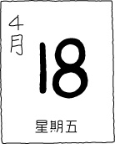
3. (A) True (B) False
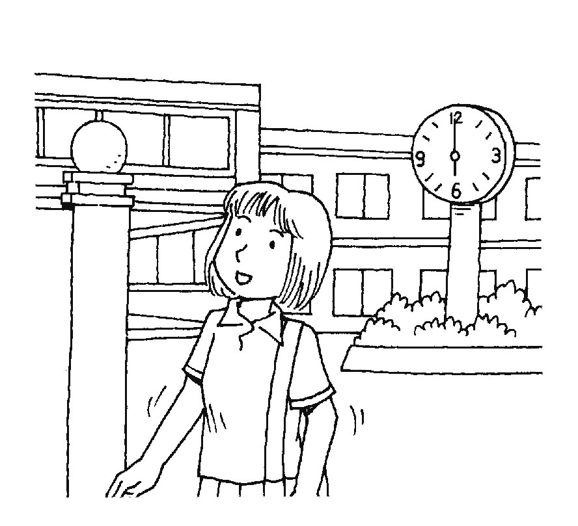
4. (A) True (B) False
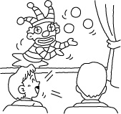
5. (A) True (B) False
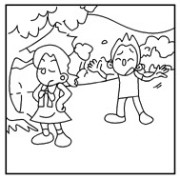
III 聽CD，選出最適當的答案：10 %
1. (A) She plays basketball.
(B) She is a reporter.
(C) She’s fine. And you?
2. (A) They are like their fathers..
(B) They don’t like dogs.
(C) They like hand puppets.
3. (A) Baseball is not a sport.
(B) Yes, I like baseball.
(C) No, baseball is interesting.
4. (A) Mr. Wang does.
(B) Mr. Wang can.
(C) No, Mr. Wang can’t speak English.
5. (A) They go to work at 7:00.
(B) They go to work at 7:10.
(C) They go to work at 7:30.
6. (A) They play witches.
(B) They play vampires.
(C) They play ghosts.
7. (A) He has to meet his friend, James.
(B) He has to watch the “Super Sunday Show.”
(C) He has to meet the girl.
8. (A) Magic club.
(B) Tennis club.
(C) Badminton club.
9. (A) On Thursdays.
(B) On Wednesdays.
(C) On Fridays.
10. (A) She can dance.
(B) She can paint.
(C) She can sing.

Part 2 Reading ＆ Writing
I.單字＆文意字彙 20 %
1地圖 2 星期三 3手指 4也許( p開頭) 5字典
6 The teacher writes the words on the blackboard with c k.
7 My ruler is l g, but his ruler is short.
8 Students in Taiwan don’t go to school on S ys and Sundays.
9 He is good at tennis, so he is on his school t m.
10 Children like to wear ghost m ks on Halloween.
II. 文法選擇 30%
1 A: _____ do you go to school? B: At 7:00.
(A) What days (B) What time (C) How (D) What
2 A: _____ do they feed their dogs? B: Every day.
(A) What days (B) What time (C) How (D) What
3 ____ he busy every morning?
(A) Is (B) Does (C) Are (D) Do
4 A: What does Billy do? B: He _____ a teacher.
(A) is (B) does (C) are (D) do
5 Let’s go to the movie _____ this Sunday afternoon.
(A) on (B) in (C) at (D) X
6 A: What day is today? B: It’s _____ Monday.
(A) on (B) in (C) at (D) X
7 I play _____ every afternoon.
(A) the tennis (B) soccers (C) the violin (D) piano
8 A: Who _____ you like? B: I like Eric.
(A) do (B) does (C) is (D) are
9 A: Who plays the witch? B: Tina _____.
(A) plays (B) do (C) does (D) is
10 We have _____ home early.
(A) go to (B) to go (C) going to (D) go
11 Sarah and Lisa _____ to the chess club.
(A) both goes (B) goes both (C) both go (D) go both
12 How about _____ the lessons together?
(A) review (B) reviewing (C) to review (D) reviews
13 My brother practices _____ early in the morning.
(A) swim (B) swimming (C) to swim (D) swims
14 This is _____ own house.
(A) I (B) me (C) my (D) the
15 I watch TV _____ 6:30 to 7:30 every day.
(A) at (B) in (C) on (D) from

III. 閱讀測驗 10 %
A Dear Peter,
How are you in America? Do you like your new school? Are your teachers and classmates nice? Do you make new friends there? Tina, Susan, Tom, and I miss you so much. Without you, our class is not interesting. We hope you can come back to Taiwan soon.
Sally
1. Where is Peter?
(A) In Taiwan. (B) In the USA. (C) At school. (D) At home.
2. Who is Sally?
(A) Peter’s sister.(B) Peter’s cousin. (C) Peter’s classmate. (D) Peter’s teacher.
B This is Mary’s class schedule.
 | Mon | Tue | Wed | Thurs | Fri
8:10  9:10  10:10  11:10 | English  Math  Science  Chinese | English  Math  Math  History | Art  Math  Chinese  History | Chinese  Chinese  Science  History | Chinese  Math  Art  History
13:10  14:10  15:10 | Health&PE | Science  Chinese  Art | Health&PE  History |  | English
3 Mary’s first class begins at ______.
(A) 8:10 (B) 9:10 (C) 10:10 (D) 13:10
4 Mary has two classes on Tuesday morning.
(A) Health & PE (B) math (C) Chinese (D) history
5 Which is true?
(A) Mary has art class on Friday afternoon.
(B) Mary has Health & PE class on Tuesdays and Thursdays.
(C) Mary has English class at 9：10 on Mondays.
(D) Mary has no classes on Thursday afternoons.

IV. 依提示作答 8 % (全對才給分)
1 Ray has science class today.（改成否定句）
2 I feed my puppy every evening.（依畫線部分造原問句）
3 He goes home.
He doesn’t say goodbye. (用without 合併句子)
4 What does Ms. Li teach at school? (以English詳答)

V. 中翻英 12% (分段給分)
1她有時放學後和Mary去逛街購物。
2 Judy每個週末打鼓兩小時。
3她正在認真地讀書。請別製造噪音!
4 那個鬼有奇怪的鼻子和黑黑的牙齒。

