桃園縣立建國國中99學年度第二學期第二次定期考查一年級英文科試卷
班 級 | 座 號 | 姓 名 | 版 本 | 範 圍 | 得 分
 |  |  | 何嘉仁 | Book 2 Unit 3 ~ Review 2

注意: 請務必在第三面上填上班級、座號、姓名，並在答案欄上作答。

一、聽力測驗：20%
第一大題：依錄音內容，選出句中所缺的字。
( ) 1. Andy’s T-shirt is __________.
(A) black (B) brown (C) blue (D) gray
( ) 2. The white __________ are too small.
(A) shirts (B) jackets (C) sweaters (D) shorts
( ) 3. Today is __________.
(A) Thursday (B) Wednesday
(C) Tuesday (D) Monday
( ) 4. They __________ every Tuesday.
(A) play basketball (B) practice karate
(C) play games (D) practice baseball
( ) 5. The students are __________ next to the bus.
(A) waiting (B) playing (C) standing (D) talking

第二大題：依錄音內容，選出正確的圖片。


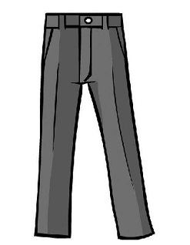

( ) 6. (A) (B) (C) (D)

( ) 7. (A) (B) (C) (D)
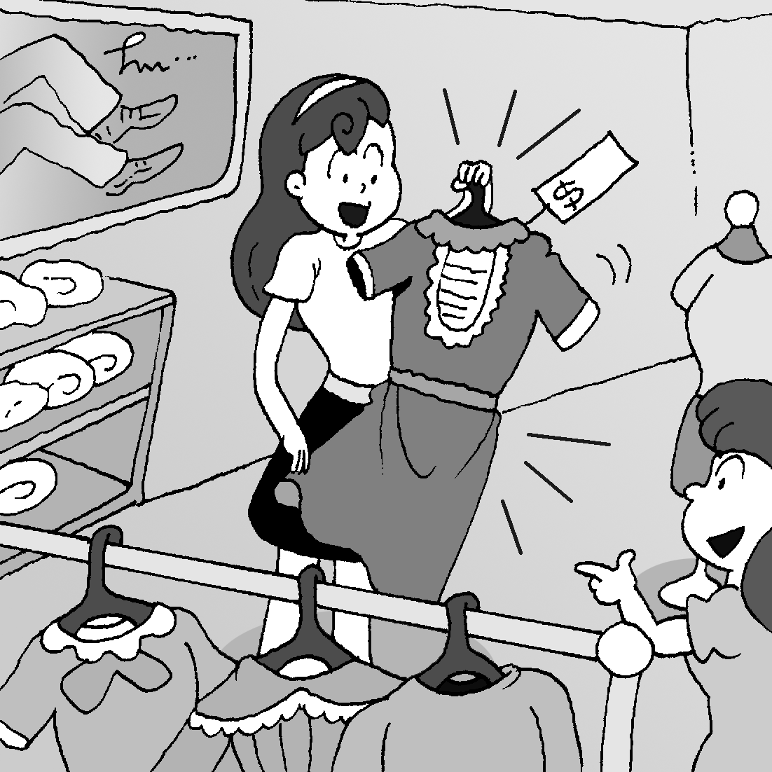
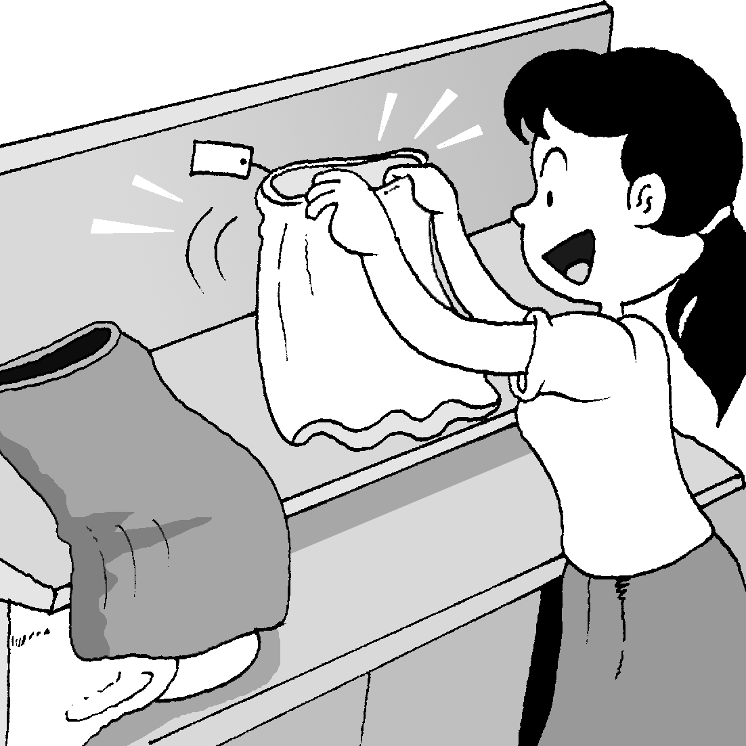
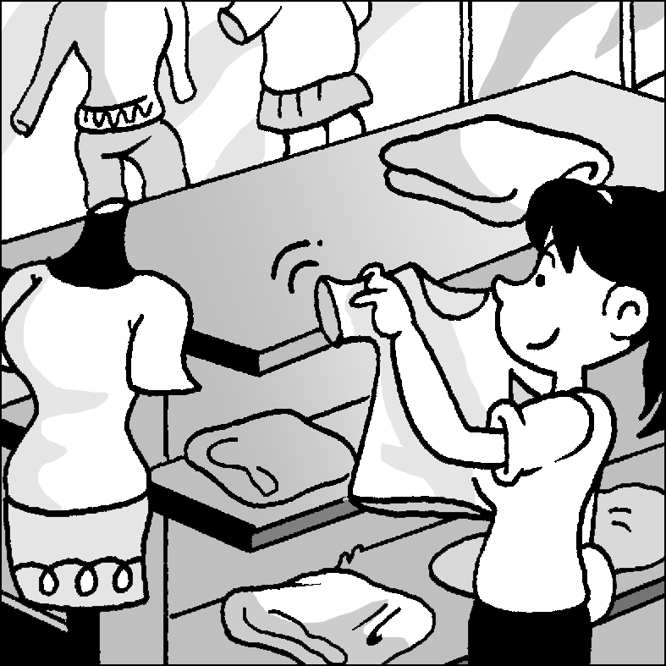
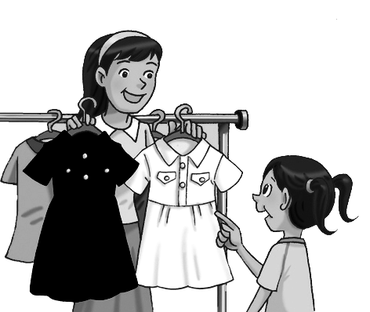

( ) 8. (A) (B) (C) (D)

( )9. (A) (B) (C) (D)

( )10. (A) (B) (C) (D)
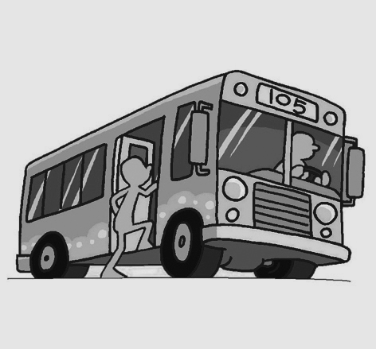
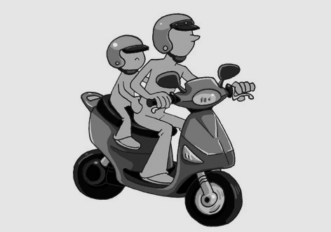
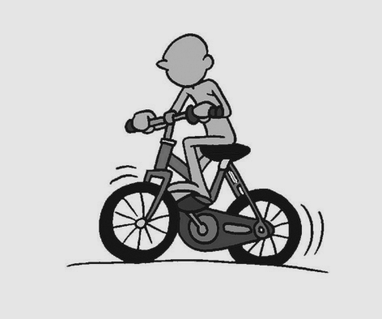
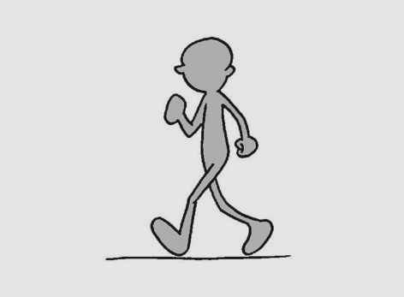

第三大題：依錄音內容，選出可對應的句子。
( ) 11. (A) In the park. (B) At school.
(C) On the second floor. (D) In the zoo.
( ) 12. (A) Yes, they do. (B) No, they aren’t on sale.
(C) Yes, they are free.
(D) No, they aren’t. They are shoes.
( ) 13. (A) He studies on Monday evenings.
(B) He goes out with his family on Sunday.
(C) He likes math, music and Chinese.
(D) He is going to the gym with his classmates.

( ) 14. (A) He is listening to music.
(B) Yes, he is buying CDs.
(C) He rides his scooter.
(D) No, he can’t drive a car.
( ) 15. (A) Yes. He rides a scooter there.
(B) Yes. It’s by his house.
(C) No. He goes there on foot.
(D) No. He is not a student.

第四大題：依錄音內容，選出正確的答案。
( ) 16. How much is the shirt now?
(A) $400. (B) $200. (C) $100. (D) $50.
( ) 17. Which is true?（何者為真？）
(A) The shoes are free.
(B) The man wants the shoes.
(C) The man doesn’t want the socks.
(D) The woman buys the socks and gets the free
shoes.
( ) 18. When（何時）do the students have a test?
(A) Friday. (B) Monday. (C) Tuesday.
(D) Wednesday.
( ) 19. Which is true?（何者為真？）
(A) The girl doesn’t like the class.
(B) Mr. Brown is a math teacher.
(C) The tests are easy for the boy and the girl.
(D) The math class is easy for the girl.
( ) 20. How does the girl go to school on Wednesday?
(A) By MRT. (B) By car. (C) By bus. (D) On foot.

二、文意字彙：20%
1.______ You look great in w e T-shirt and blue j ns.
______
2.______ My f __ e singer is JJ. He is talented in music.
3.______ My grandma is a big fan of ‘Night Market
Life’. She watches it at 8:00 on w ys.
4.______ Our school fair(園遊會) is on Sa y.
5.______ Please be quiet! Here is l y.
6.______ We can donate(捐贈) our m y to help the
victims(災民) in Japan.
7.______ A: How many love letters do you w e to
your girlfriend? B: About twenty–seven.
8.______ My family and I will take the t n to Sun
Moon Lake in Nantou(南投) this Summer.
9.______ These shoes are too small. They are not very
c e to wear.

三、文法選擇：10%
1.( ) A: Do you need a computer? B: Yes, I _______.
- do (B) need (C) can (D) am
2.( ) ________ car does Dad like, the blue one or the red one?
- What (B) Which one (C) Which (D) How many
3.( ) We like the new classmate, but William ______.
- do (B) does (C) don’t (D) doesn’t
4.( ) Mom is __________ the room. Let’s ______ her.
- clean; help (B) clean; helping
(C) cleaning; help (D) cleaning; helping
5.( ) Choose the right sentence.(選出正確的句子)
(A) He goes to school by the bus.
(B) She takes the scooter to school.
(C) My mother drive me to school.
(D) I take the MRT home.

四、對話選擇：10%
1.( ) A: _______________
B: The purple shirt.
- Do you like the shirt?
- What color is the shirt?
- Which shirt do you want?
- How many shirts do you want?
2.( ) A: What does Amy do on Monday night?
B: _______________
- She can watch TV.
- She is shopping in the supermarket.
- She do love the white dress.
- She goes out with her friend.
3.( ) A: Can you help me with tomorrow’s math test?
B: _______________
- Forget it.
- No problem.
- Write me.
- Take care.
4.( ) A: How do you go to school every day?
B: _______________
- I go to school with my friends.
- Most students walk to school.
- My Dad gives me a ride.
- I study at school every day.
5.( ) A: _______________
B: It wastes(浪費) time in traffic jams(塞車).
(A) Why do you buy a new car?
(B) How do you go to the office?
(C) What time do you go to the office?
(D) Why don’t you drive more?

五、完成句子，請依句意做適當變化。5%
- _______ Does Ella _______ (do) her homework on
Sunday?
- _______ SpongeBob(海綿寶寶) _______ (go) to
Krab’s(蟹老闆) restaurant every day.
- _______ Is the baby _______ (sleep) in the bedroom?
- _______ I can’t carry the heavy box. Can you
_______ (help) me?
- _______ Jason and her friends _______ (study) math
together every Wednesday.

六、填入適當的介系詞，如不需介系詞則打Ｘ。5%
1._______ My father jogs in the park _____ Sunday night.
2._______ Sandy can break boards _____ her hands.
3._______ I usually (經常) walk _____ home with my best friend.
4._______ My parents are busy, so I go to school _____ bike every day.
5._______ Wait _____ me! I’ll go with you guys.

七、閱讀測驗：18%
Ⅰ.
J’S CLOTHING STORE
MOTHER’S DAY
WEEKEND SALE
10% OFF
DRESSES JACKETS
20% OFF
SKIRTS SHORTS
25% OFF
FOR ANYONE WITH A
YELLOW CARNATION

SUNDAY 10:00~18:00
Kelly’s clothing shop
Mother’s Day
GREAT SALE

15% OFF EVERYTHING

Free Kelly bag
with any purchase!

Free Kelly scarf
spend $ 700
& above!
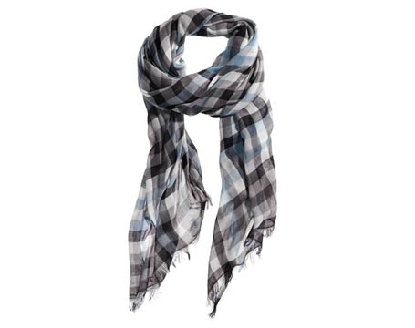SAT 01:00 p.m.~10:00 p.m.
below以下 carnation康乃馨 purchase購買 above以上

- ( ) Nana spent $ 1200 in Kelly’s clothing shop.
What can she get?
(A) A yellow carnation. (B) A bag. (C) A scarf.
(D) Both(兩者都) a bag and a scarf.
2. ( ) Nana wants a one-thousand-dollar skirt in J’s
clothing shop. If she brings(帶著) a yellow
carnation, how much is the skirt?
(A) $ 900 (B) $ 850 (C) $ 800 (D) $ 750

桃園縣立建國國中99學年度第二學期第二次定期考查一年級英文科試卷
班 級 | 座 號 | 姓 名 | 版 本 | 範 圍 | 得 分
 |  |  | 何嘉仁 | Book 2 Unit 3 ~ Review 2

3. ( ) When (何時) can Nana buy a cheaper(便宜的)
clothing for her mom?
(A) At 10:00 p.m. on Sunday.
(B) At 10:00 a.m. on Saturday.
(C) On Sunday morning.
(D) On Saturday morning.
Ⅱ.
Dear Dad and Mom,
How are you these days? I’m fine in America. My homestay Dad and Mom are nice. I make many friends here. I join our school’s cooking club and have a lot of fun.
America’s culture is not the same as Taiwan’s. Teenagers here are independent. Without parents’ help, I need to make a living on my own. I have several part-time jobs. I do the dishes at school’s restaurant, 15 dollars a week. Every Sunday, I wash cars and get 5 dollars. I take care of neighbor’s little boy, 10 dollars a week.
I miss you so much! Take care.
Your son, Stanley

homestay 寄宿家庭 culture 文化 same 相同的independent 獨立的 neighbor 鄰居

4. ( ) What may(可能) Stanley do in school’s club?
(A) do the dishes (B) make cookies
(C) teach Chinese (D) wash cars
5. ( ) How much can Stanley earn(賺) for two weeks?
(A) $ 30 (B) $ 45 (C) $60 (D) $75
6. ( ) What does make a living mean(意思是)?
(A) earn money (B) clean the room
(C) do the dishes (D) be a baby sitter(保姆)

八、翻譯式填空：12% (請直接寫於下方空格上)

- 他步行到辦公室。這對他的健康有益。
He goes to the office _ _ _ _. It’s good for his .

- 學生們以許多不同的方式上學。
Students go to school _ many
.

答案欄
一、聽力測驗：20%
1. | 2. | 3. | 4. | 5.
6. | 7. | 8. | 9. | 10.
11. | 12. | 13. | 14. | 15.
16. | 17. | 18. | 19. | 20.

二、文意字彙：20%
1-1. | 1-2.
2. | 3.
4. | 5.
6. | 7.
8. | 9.

三、文法選擇：10%
1. | 2. | 3. | 4. | 5.

四、對話選擇：10%
1. | 2. | 3. | 4. | 5.

五、完成句子，請依句意做適當變化。5%
1. | 2. | 3. | 4. | 5.

六、填入適當的介系詞，如不需介系詞則打Ｘ。5%
1. | 2. | 3. | 4. | 5.

七、閱讀測驗：18%
1. | 2. | 3. | 4. | 5. | 6.

桃園縣立建國國中99學年度第二學期第二次定期考查一年級英文科試卷
班 級 | 座 號 | 姓 名 | 版 本 | 範 圍 | 得 分
 |  |  | 何嘉仁 | Book 2 Unit 3 ~ Review 2

3. ( ) When (何時) can Nana buy a cheaper(便宜的)
clothing for her mom?
(A) At 10:00 p.m. on Sunday.
(B) At 10:00 a.m. on Saturday.
(C) On Sunday morning.
(D) On Saturday morning.

Ⅱ.
Dear Dad and Mom,
How are you these days? I’m fine in America. My homestay Dad and Mom are nice. I make many friends here. I join our school’s cooking club and have a lot of fun.
America’s culture is not the same as Taiwan’s. Teenagers here are independent. Without parents’ help, I need to make a living on my own. I have several part-time jobs. I do the dishes at school’s restaurant, 15 dollars a week. Every Sunday, I wash cars and get 5 dollars. I take care of neighbor’s little boy, 10 dollars a week.
I miss you so much! Take care.
Your son, Stanley

homestay 寄宿家庭 culture 文化 same 相同的independent 獨立的 neighbor 鄰居

4. ( ) What may(可能) Stanley do in school’s club?
(A) do the dishes (B) make cookies
(C) teach Chinese (D) wash cars
5. ( ) How much can Stanley earn(賺) for two weeks?
(A) $ 30 (B) $ 45 (C) $60 (D) $75
6. ( ) What does make a living mean(意思是)?
(A) earn money (B) clean the room
(C) do the dishes (D) be a baby sitter(保姆)

八、翻譯式填空：12% (少加S給一分)

1. 他步行到辦公室。這對他的健康有益。
He goes to the office _on_ _foot_. It’s good for his health .

- 學生們以許多不同的方式上學。
Students go to school in_ many different
ways .

答案欄
一、聽力測驗：20%
1. A | 2. D | 3. C | 4. D | 5. A
6. A | 7. B | 8. A | 9. D | 10. B
11. C | 12. B | 13. B | 14. C | 15. B
16. B | 17. B | 18. D | 19. B | 20. D

二、文意字彙：20% (少加S給一分)
1-1.  white | 1-2.  jeans
2.  favorite | 3.  weekdays
4.  Saturday | 5.  library
6.  money | 7.  write
8.  train | 9.  comfortable

三、文法選擇：10%
1.  A | 2.  C | 3.  D | 4.  C | 5.  D

四、對話選擇：10%
1.  C | 2.  D | 3.  B | 4.  C | 5.  D

五、完成句子，請依句意做適當變化。5%
1.  do | 2.  goes | 3.  sleeping | 4.  help | 5.  study

六、填入適當的介系詞，如不需介系詞則打Ｘ。5%
1.  on | 2.  with | 3.  X | 4.  by | 5.  for

七、閱讀測驗：18%
1.  D | 2.  D | 3.  C | 4.  B | 5.  C | 6.  A

