台南市立新東國民中學第二學期第一次段考二年級英語科解答

一、聽CD，選出所聽到的字詞。：
1. 《腳本區》
Helen and I went to the same senior high school.
《題目區》
(A) elementary
(B) junior
(C) senior
《答案區》
C
2. 《腳本區》
My pet is a dog. It’s very cute.
《題目區》
(A) pet
(B) pen
(C) pig
《答案區》
A
3. 《腳本區》
Can you speak louder? I can’t hear you.
《題目區》
(A) here
(B) hear
(C) heard
《答案區》
B
4. 《腳本區》
Daniel is wearing a new pair of glasses to school.
《題目區》
(A) grass
(B) glasses
(C) grades
《答案區》
B
5. 《腳本區》
Lily’s dog is barking very loudly.
《題目區》
(A) parking
(B) barking
(C) drawing
《答案區》
B
二、聽CD，若符合圖意或表格內容的選 A，否則選 B。：
1. 《腳本區》
Ben is taller than Jim.
《題目區》
(A) True (B) False
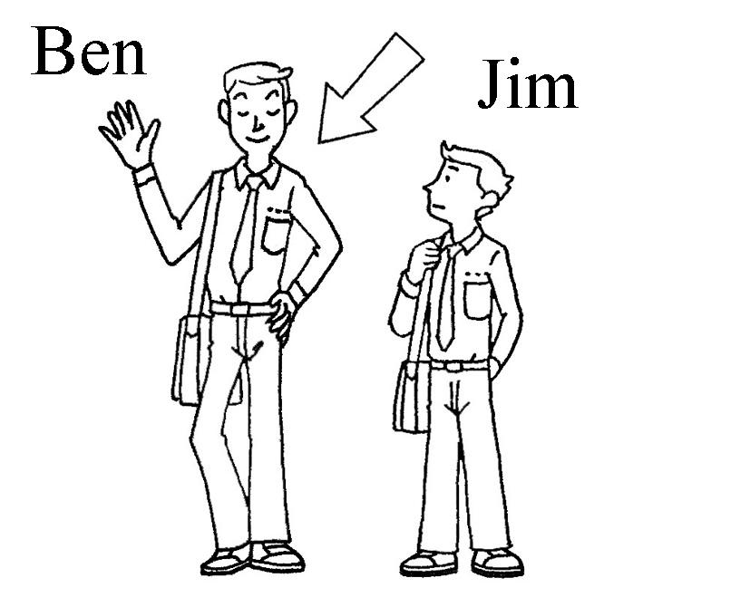
《答案區》
A
2. 《腳本區》
Mabel is strong enough to move the TV.
《題目區》
(A) True (B) False
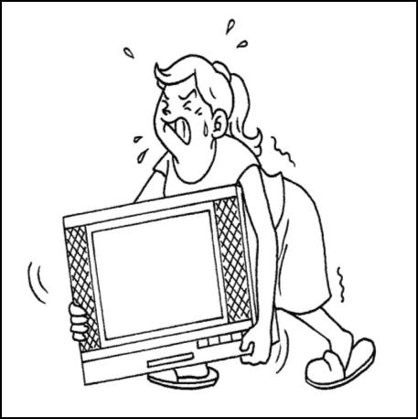
《答案區》
B
3. 《腳本區》
Johnny always studies hard. He never fails any tests.
《題目區》
(A) True (B) False
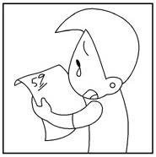
《答案區》
B
4. 《腳本區》
Josh is playing happily in the garden.
《題目區》
(A) True (B) False
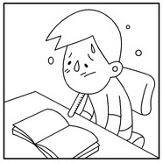
《答案區》
B
5. 《腳本區》
The hamster is the cutest pet for the girl.
《題目區》
(A) True (B) False
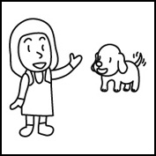
《答案區》
B
三、聽CD，選出適當的回應句。：
1. 《腳本區》
Who is the smartest student in your class?
《題目區》
(A) I think so.
(B) Jason is.
(C) I agree.
《答案區》
B
2. 《腳本區》
How about keeping a pet at home?
《題目區》
(A) You’re right!
(B) Never mind.
(C) I agree.
《答案區》
C
3. 《腳本區》
Is it raining outside?
《題目區》
(A) Take it easy. It’s not the end of the world.
(B) I don’t know. But the ground is wet.
(C) You should walk slowly.
《答案區》
B
4. 《腳本區》
What is inside the pot?
《題目區》
(A) There is nothing in it.
(B) Please walk slowly.
(C) That’s funny.
《答案區》
A
5. 《腳本區》
Is Sophia fatter than her sister?
《題目區》
(A) Yes, she is very slim.
(B) Yes, she is very hard-working.
(C) Yes, she always eats a lot and seldom exercises.
《答案區》
C
四、聽CD中的對話，選出適當的答案。：
1. 《腳本區》
Man: Is Jenny your neighbor in Taitung?
Woman: Yes. We went to the same elementary school before.
Question: Who is Jenny?【習作】
《題目區》
(A) The man’s sister.
(B) The woman’s teacher.
(C) The man’s classmate.
(D) The woman’s neighbor.
《答案區》
D
2. 《腳本區》
Man: Did you wash my shirt carefully?
Woman: Yes, I did. What’s wrong with the shirt?
Man: My shirt is smaller than before. I can’t wear it now.
Woman: It’s because you are fatter than before, my dear.
Question: What does the woman mean?
《題目區》
(A) The shirt is too expensive.
(B) The woman didn’t do the laundry carefully.
(C) The man is heavier than before.
《答案區》
C
3. 《腳本區》
Boy: My grandma had her eightieth birthday last week.
Girl: But she looks much younger than eighty. How does she do it?
Boy: Well, she sleeps and eats well.
Question: Why does the boy’s grandma look younger?【習作】
《題目區》
(A) She is old.
(B) She is 80 years old.
(C) She doesn’t eat much.
(D) She sleeps and eats well.
《答案區》
D
4. 《腳本區》
Girl: Easter is coming.
Boy: I don’t like Easter at all.
Girl: Why? Easter is full of fun.
Boy: I don’t think so. It’s boring to me.
Question: What are they talking about?
《題目區》
(A) They are talking about painting Easter eggs.
(B) They are talking about Easter.
(C) They are talking about their pets.
《答案區》
B
5. 《腳本區》
Woman: Hi, I’m the cook of the restaurant. Do you like our new meal here?
Man: Yes. It is more delicious than before.
Woman: Thank you.
Man: Urr… but it’s also more expensive than before.
Question: What does the man mean?
《題目區》
(A) The food is not delicious.
(B) He doesn’t like the cook.
(C) The food is great but expensive.
《答案區》
C

Part one: 一、聽CD，選出所聽到的字詞。
1.C | 2.A | 3.B | 4.B | 5.B
二、聽CD，若符合圖意或表格內容的選 A，否則選 B。
1.A | 2.B | 3.B | 4.B | 5.B
三、聽CD，選出適當的回應句。
1.B | 2.C | 3.B | 4.A | 5.C
四、聽CD中的對話，選出適當的答案。
1.D | 2.C | 3.D | 4.B | 5.C

Part two: 一、單字 10％
1.duck | 2.genius | 3.decorate | 4.successful | 5.senior high school
6.hard-working | 7.mice | 8.expensive | 9.bridge |  | 10.pond
二、填入適當的字詞 14%
1.polite; politely | 2. worse |  | 3. the taller | 4. hotter | 5.the most beautiful
6. busy |  | 7.more carefully
三、選擇 30％
1. D | 2. C | 3. B | 4. A | 5. B
6. C | 7. C | 8. B | 9. C | 10. D
11. D | 12. A | 13. A | 14. D | 15. D
四、克漏字與閱讀測驗 10％
1.B | 2.D | 3.D | 4.C | 5.D

五、依提示作答 10％
1. The student went to school late today.
2. Jenny’s English is better than Lisa’s.
3. Jenny wore the most beautiful clothes at the party.
4. The Teddy Bear is cuter than these two dolls.
5. Jeremy Lin is a good basketball player.

六、翻譯 6％
1. The spider may bite you,X1 so it is the most dangerous pet in the shop.X1
2. At the same moment,X1 Allen had pain in his leg at home.X1
3. Some children paint their eggs in different colors,X1 and some draw funny pictures on theirs.X1

