第一部分：聽力測驗(每題2分)

一. 根據圖片, 回答下列問題

1. 2.
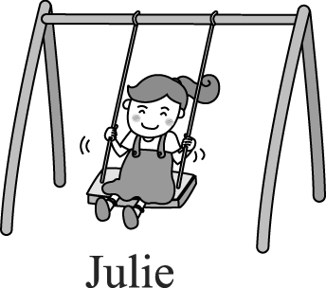
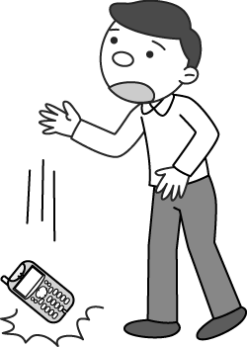

3. 4.
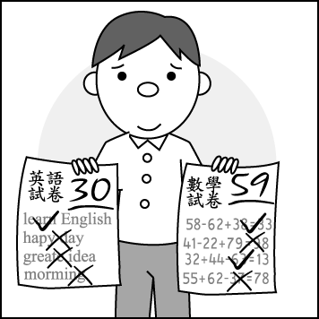
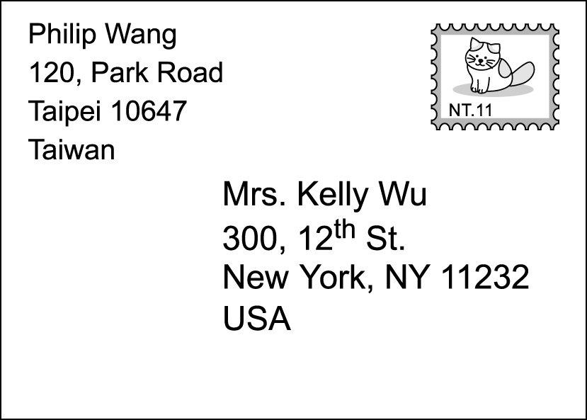

1. (A) She is crying sadly
(B) She is playing on the swing.
(C) No, she hates to swing.
(D) Yes, she likes to swing.
2. (A) He was looking for his cell phone.
(B) He couldn’t find his cell phone.
(C) He dropped his cell phone.
(D) This cell phone is the smallest.
3. (A) Yes, it was.
(B) No, it wasn’t.
(C) Yes, it’s his favorite subject.
(D) No, English is more difficult for him.
4. (A) Philip.
(B) Taipei.
(C) New York.
(D) Kelly.

二.根據下列圖表,回答下列問題

 | Amy | Judy | Lily | Karen
height | 162cm | 170cm | 158 cm | 165cm
weight | 48kg | 66kg | 80kg | 40kg
age | 23 | 18 | 34 | 29
pet | 2 | 0 | 3 | 1
comic book | zero | many | a few | two or three
cellphone | Yes | No | Yes | Yes
MP3 player | No | Yes | No | Yes
5. (Ａ)Amy. (Ｂ) Judy. (Ｃ) Lily. (Ｄ) Amy and Judy.
6. (Ａ) Karen. (Ｂ) Judy. (Ｃ) Amy. (Ｄ) Amy and Karen.
7. (Ａ) Amy. (Ｂ) Judy. (Ｃ) Lily. (Ｄ) Karen.
三、根據聽到的內容，選出最適當的回應句

8. (A) Here you are. Thank you and have a nice day.
(B) The black one is NT$160, and the red one is
NT$180.
(C) Of course. We sell many kinds of shoes.
(D) Sure. Here you go. The black one is prettier .
9. (A) I’d like to buy the black one.
(B) The white one is mine.
(C) The black one is better than the white one.
(D) The white one is cheaper than the black one.
10. (A) Yes, she did. She played it beautifully.
(B) No, she didn’t. She played it well.
(C) Yes, she did. She played it poorly.
(D) No, she didn’t like to play the piano.

第二部份：讀寫測驗(每題2分)
- 字彙及文意選擇:根據上下文，選出最適合的答案

11. Mary is a doctor. She is as ______ as a bee.
(A) busier (B) busily (C) busy (D) busiest
12.0Mr. Lin just moved in, so Betty showed him ______.
(Ａ) around (Ｂ) playground
(Ｃ) supermarket (Ｄ) friendly
13. The novel is NT$150. The comic book is NT$200. The price of the novel is _______ than that of the comic book.
(A) more expensive (B) cheaper
(C) higher (D) lower
14. Taiwan is ______ for its fruit and friendliness.(友善)
(Ａ) bad (Ｂ) successful
(Ｃ) famous (Ｄ) convenient
15. Sandy didn't walk _____ because she had eggs in her
hands.
(Ａ) fast (Ｂ) carefully (Ｃ) slowly (Ｄ) careful
16. ______ said than ______.
(A) Easily, do (B) Easy, done
(C) Easier, done (D) Easily, done
17. Do in ______ as the ______ do.
- Romans, Rome (B) Rome, Romans
(C) Romes, Roman (D) Romes, Romans
18. Tom never practices English, so his English is ______
than other students.
(Ａ) bad (Ｂ) worse (Ｃ) better (Ｄ) best
19. Look at the picture. George is ______ .
(Ａ) taller than Nancy (Ｂ) the shortest
(Ｃ) shorter than Michael (Ｄ) the youngest
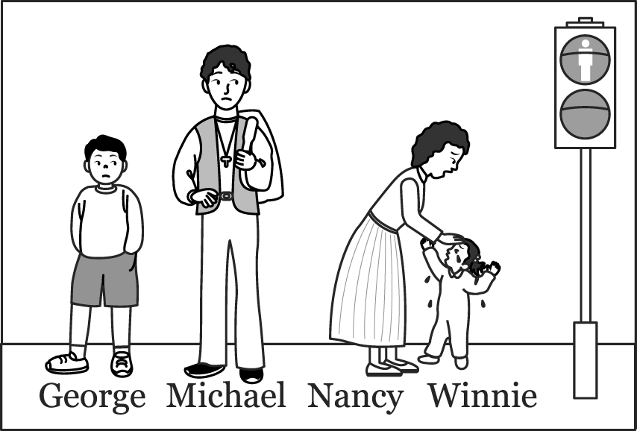

20. A: ______ B: I’d like the purple one.
(Ａ) How would you like to pay?
(Ｂ) Which one is more expensive?
(Ｃ) Which one do you want?
(Ｄ) How may I help you?

21. The children are______ .
(Ａ) happy rolling the eggs
(Ｂ) rolling the happily eggs
(Ｃ) rolling the eggs happily
(Ｄ) rolling happily the eggs
22. A friend of ______ took ______ to Hualien the day before yesterday.
(A) his; me (B) Vicky; her
(C) Tom’s; he (D) your; him
23. There are a lot of children_____ in the yard.
(Ａ) playing (Ｂ) play (Ｃ) to play (Ｄ) are playing
24. Study ______ , and you can go to a better school.
(Ａ) hardly (Ｂ) more harder
(Ｃ) much harder (Ｄ) hardest
25. A: ______ B: No, it’s not mine. It’s Peter’s.
(Ａ) Whose cellphone is it?
(Ｂ) Which cellphone is yours?
(Ｃ) Is this cellphone yours or Peter’s?
(Ｄ) Is this your cellphone?
26. A: Kobe Bryant is coming to Taiwan next year.
B: Really? ________
(Ａ) I can’t wait to see him. (Ｂ) You can say that again.
(Ｃ) Thank you. (Ｄ) I can go with him.
27. Mr. Lee couldn’t find his car key because little
Larry_____ it.
(Ａ) slid (Ｂ) hid (Ｃ) kept away (Ｄ) gave away
28. Many students in Class A are sick. have a cold, ______have a fever.
(A) Some；and others (B) Some；other
(C) Others；and some (D) Most；others
29. I think “Kung Fu Hustle” is movie this year.
(A) interesting (B) the most interesting
(C) very interesting (D) more interesting
30. Which of the following items (項目) is correct ?
(A) Who is the younger, May, Jenny, or Cindy?
(B) I have fewer homework than Pete.
(C) This is the least interesting chapter (章節) in the
book.
(D) Mary’s hair is longer than me.

- 克漏字選擇(每題2分)
(一)

Clerk：Good day. Can I help you?
Claire：Yes. 31.
Clerk：OK. What animal do you like to adopt for him?
Claire：I’m not sure. Can you give me some suggestions?
Clerk： 32. Maybe you can pick one for him.
Claire：Um... 33.
Clerk：No, it isn’t. I can also write down some directions
for you, and then you’ll know more about it.
Claire：OK. Thank you.

＊ adopt 領養 suggestion 建議

31. (A) I’d like to learn a lot about animals.
(B) I’d like to take a picture of an animal.
(C) I’d like to pick a pet animal for my son.
(D) I’d like to take care of an animal for my son.
32. (A) Boys don’t like animals.
(B) Cats are the most popular for girls.
(C) We have a lot of animals here.
(D) Dogs are the most popular here.
33. (A) Is it the cutest here?
(B) Is taking care of dogs difficult?
(C) Is taking a picture of him interesting?
(D) Is it the most expensive one here?

(二)

Kelly took her eight–year–old son, Dennis , to Taipei Zoo last Sunday. Dennis was so excited because he could see his 34 animal, the giraffe, there. Kelly bought a school bag 35 giraffe patterns on it for Dennis as an Easter gift. He was very happy and said, “This school bag is prettier than my old 36 . ” Kelly also bought some food for their lunch. She 37 what she bought at the zoo in cash. After lunch, they went home 38 . Dennis 39 go to his piano class at two p.m.
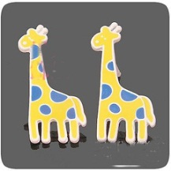

＊ pattern 圖案

34. (A) like (B) loves (C) enjoyed (D) favorite
35. (A) in (B) on (C) with (D) about
36. (A) one (B) it (C) ones (D) them
37. (A) paid (B) pays (C) spent (D) cost
38. (A) late (B) quickly (C) quick (D) lately
39. (A) has to (B) have to (C) had to (D) don’t need to

- 閱讀測驗(每題2分)
(一)

Message
To：Cathy
From：Dick, a clerk at “King Stone”
Calling time：10：30 a.m.
Phone number：(O) 02-8665-5688
✽✽Message：
We have got the book, The Lord of the Rings III, you
ordered. Please come to our store to get it back during our opening hours, 10：00 ~22：00.
If you have any problems, please call us.

Message Taker：Tony Dec. 18, 2004.

40. What kind of store “King Stone” is it?
(A) A supermarket.
(B) A school.
(C) A bookstore.
(D) A restaurant.
41. Whose telephone number is 02-8665-5688?
(A) Cathy’s.(B) Tony’s. (C) Dick’s clerk. (D)The store’s.
42. How many hours a day is the store open?
(A) Eight. (B) Ten. (C) Eleven. (D) Twelve.

(二)


Many people like to play or watch basketball games. But not many people know basketball is the only popular sport from the USA. Dr. James Naismith invented basketball in 1891. Naismith was from Canada, but lived in the USA. He was a teacher at Springfield Training School. He taught sports and found there were no interesting games to play indoors in the winter. So he thought of a game. At first, there were five men on each team. They put baskets on the wall. And all they needed to do was to get the ball into the basket. So you know how he called the game? BASKETBALL! A man had to climb a ladder and take the ball out of the basket. Luckily, only one man got the ball into the basket in the first game.

＊ invent 發明 ladder 梯子 title標題 simple 簡單的

43. Which is the best title for the reading?
(A) Basketball Today.
(B) The Start of Basketball.
(C) The Rules of Basketball.
(D) James Naismith－A PE Teacher.
44. What is true about the first game of basketball?
(A) It was in Canada.
(B) It was really terrible.
(C) It was in the USA.
(D) It had only nine players in the game.
45. Why did they call the game “basketball”?
(A) They needed a basket to put the ball in when they
played the game.
(B) The rules were very simple.
(C) There were five baskets in each game.
(D) A man called Basket invented the game.
四、依提示作答 (每題2分)
46. Michael is a good soccer player.（用副詞改寫）
47. The red cameras / cheaper / than / blue / one.
（依序造句,適當變化）
48.勿打如意算盤。 (寫出此英文諺語)
49.What does everyone have to do in the library?(詳答)
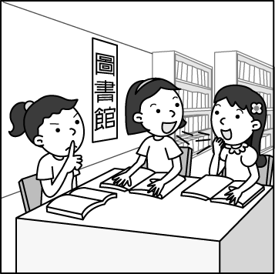

50. How does Sam sing? (用 ”可怕地” 詳答)
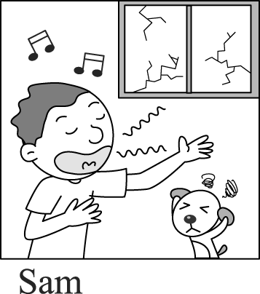

答案卷

46
47
48
49
50

※貼心提醒: 請記得用原子筆寫基本資料和答案卷,
並交答案卡和第三頁試卷

