花蓮縣自強國中99學年度第二學期八年級英語科第一次段考題目卷

Class: No: Name:
請將第1-45題的答案用2B鉛筆劃記在電腦卡上
- 聽力測驗：22%
A大題： 1-5題—選出音節數。6-10題—選出重音節的位置。每題唸兩遍。(每題1分)10%
Example: u‧su‧al‧ly (4個音節) - 答案為(D)
[ (A) 1 (B) 2 (C) 3 (D) 4 ]
com‧`put‧er game (重音節在put，選(B))
(A) (B) (C) (D)
( ) 1. | (A) 1 | (B) 2 | (C) 3 | (D) 4
( ) 2. | (A) 1 | (B) 2 | (C) 3 | (D) 4
( ) 3. | (A) 1 | (B) 2 | (C) 3 | (D) 4
( ) 4. | (A) 1 | (B) 2 | (C) 3 | (D) 4
( ) 5. | (A) 1 | (B) 2 | (C) 3 | (D) 4
( ) 6. | ac‧ti‧vi‧ty ( ) 7.  (A) (B) (C) (D) |  | wa‧ter‧me‧lon  (A) (B) (C) (D)
( ) 8. | Go a‧head. ( ) 9.  (A) (B) (C) |  | po‧pu‧lar game  (A) (B) (C) (D)
( )10. | con‧ve‧nience store  (A) (B) (C) (D)

B大題：根據錄音內容，選出正確的句子。每題唸兩遍。(每題2分)12%
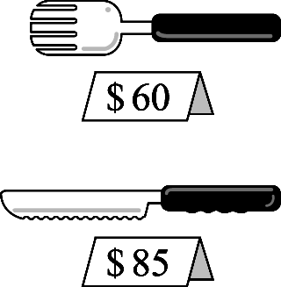 | 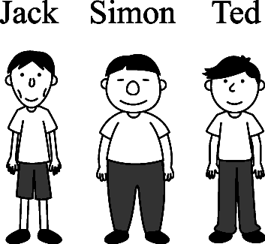 | 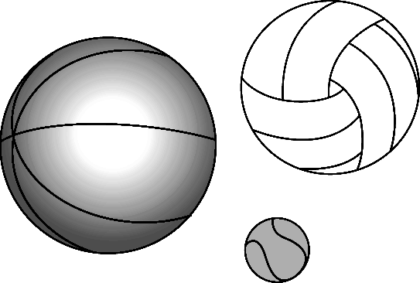 | 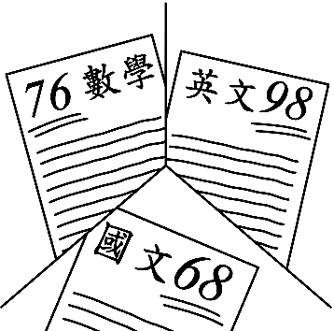 | 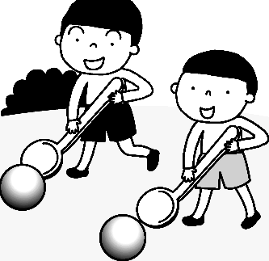 | 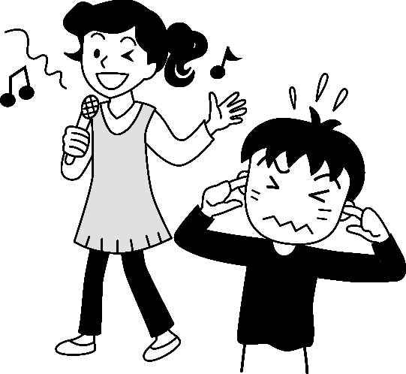
11. | 12. | 13. | 14. | 15. | 16.

- 請依文意選出一個正確或最佳的答案：48% (每題2分)
( ) 17. The clock on the wall stops. We need to change the ______.
(A) batteries | (B) tapes | (C) fans | (D) video games
( ) 18. I like to buy fruit at that ______ because the fruit there is fresher.
(A) vendor | (B) refrigerator | (C) building | (D) stand
( ) 19. You need a ______ to take pictures.
(A) knife | (B) fork | (C) spoon | (D) camera
( ) 20. Hurry up! You are as slow as ______.
(A) a mouse | (B) a bear | (C) a bee | (D) a turtle
( ) 21. My computer is newer than _____.
(A) John’s | (B) him | (C) her | (D) Sally
( ) 22. Which refrigerator is ______ of all?
(A) most expensive | (B) more expensive | (C) cheaper | (D) the cheapest
( ) 23. They are playing the Easter egg hunt ______.
(A) happier | (B) happily | (C) the happiest | (D) happy
( ) 24. A: Whose CD player is this? B: It’s ______.
(A) my | (B) her | (C) his | (D) your
( ) 25. A: How does Eric swim? B:_____.
(A) Slow | (B) Fastly | (C) Nervous | (D) Well
( ) 26. A: Mom, can I go to the movies with Eric? B: Yes, ______.
(A) go ahead | (B) go for it | (C) don’t give up | (D) give it a try
( ) 27. Everyone ______ quiet in the library.
(A) has to | (B) doesn’t have to | (C) don’t have to be | (D) has to be
( ) 28. Sammy sells ______ vegetables around here.
(A) the better | (B) well | (C) the best | (D) worst
( ) 29. Egg toss is an Easter activity. We have to throw and catch the eggs carefully without breaking ____.
(A) it | (B) them | (C) one | (D) ones
( ) 30. A: Mom, can you help me with my homework?
B: _____! Go to your dad, please. I’m as busy as a bee now.
(A) Give me a break | (B) Bravo | (C) How interesting | (D) How come
( ) 31. A: ________? B: I’d like the red one.
(A) May I take a look at the red skirt | (B) Which skirt is more expensive
(C) Which skirt do you want | (D) Would you like the blue skirt
( ) 32. Which bird is ________?
(A) the more expensive, the red one or the blue one
(B) the most expensive of the four
(C) more expensive of all
(D) the most expensive of the two
( ) 33. Kevin went to Japan with _____.
(A) a friend of his | (B) his a friend
(C) one his friend | (D) his one friend
( ) 34. A: Who is your English teacher? B: _____. (選錯誤者)
(A) The one at the door | (B) The one is standing at the door
(C) The woman over there | (D) She is the one over there
( ) 35. Children ________ during the Easter egg hunt.
(A) roll the eggs quickly to the finish line | (B) look for the eggs
(C) paint the eggs in beautiful colors | (D) give away the eggs
請翻頁繼續作答

( ) 36. Things at the yard sale are _______ things in the department store.
(A) as cheaper as | (B) more expensive
(C) much cheaper than | (D) the most expensive
( ) 37. A: What do you have to do during the test? B:_____.
(A) We have to careful | (B) We have to answer carefully
(C) We have to be successful | (D) We have to do the test terribly
( ) 38. There are two famous singers there. _____ is A-mei, and ____ is Stefanie.
(A) One; the other | (B) One; another
(C) One; one | (D) One; other
( ) 39. A: The pen is NT$75. The notebook is NT$150. We give a special discount (折扣)of 10% for cash. B: OK. I’ll have 2 notebooks and 3 pens, and I’ll pay in cash. How much is the total?
(A) NT$525 | (B) NT$600 | (C) NT$472.5 | (D) NT$540
( ) 40. 選正確者。
(A) They happily are looking at each other.
(B) Samuel is doing well his homework.
(C) It is raining heavily right now.
(D) The baby is sleeping comfortable on his bed.

- 請依據所附資料，選出一個正確或最佳的答案。10% (每題2分)
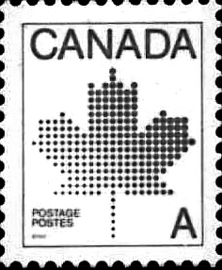
Kelvin Johnson
1350 Sherbrooke Street West,
Suite 800, Montreal,
Quebec, Canada
Mr. Andrew Smith
610 Rhode Island Street
San Francisco, CA 94107
USA

( ) 41. Which is true?
(A) Montreal is a place in the USA.
(B) Andrew Smith wrote the letter.
(C) The letter is from Canada.
(D) The writer’s address (地址) is 610 Rhode Island Street, San Francisco.
( ) 42. What is NOT mentioned(提及)?
(A) The writer’s address. | (B) The date of the letter.
(C) The recipient’s (收信人) name. | (D) The nation (國家)the letter is from.

Easter
Christians celebrate the resurrection (復活) of Jesus Christ on Easter Day or Easter Sunday. Easter is a movable feast (節日). It is celebrated on the first Sunday following the first full moon after the Spring equinox (春分). This usually occurs (發生) on March 21, which means the date of Easter can range (變動) between March 22 and April 25. Today, Christians go to church and have a special service (宗教儀式) on Easter Sunday. Many people sing and pray on Easter Sunday. They think about new life in Heaven (天堂) after death (死亡). It is a very happy day. Flowers, eggs and rabbits are all symbols (象徵) of Easter. They are all symbols of new life.
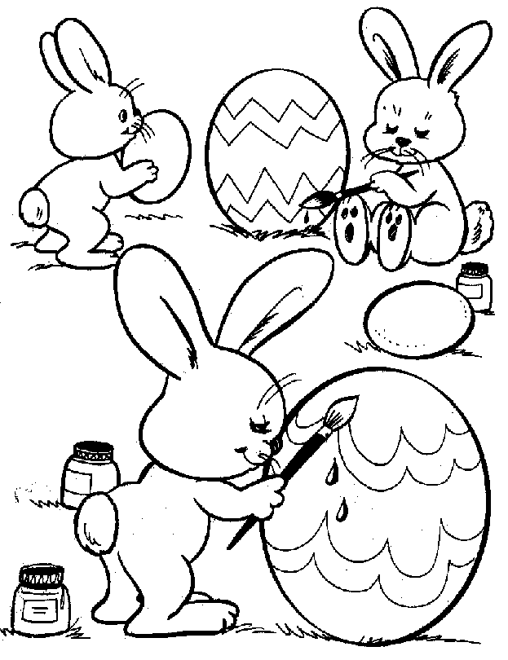
Children like the Easter Bunny. The Easter Bunny visit children and hide colored eggs that the children have to find on Easter Sunday morning. On Easter Sunday evening, children eat a big dinner with their families.

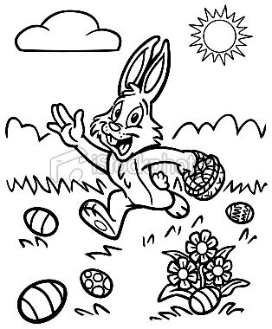
( ) 43. Look at the calendar above. Which date is the Easter Sunday?
(A) April 4th | (B) April 11th | (C) March 28th | (D) March 21st
( ) 44. What do people NOT do on Easter?
(A) They go to church. | (B) They sing and pray.
(C) They look for new life. | (D) Children find colored eggs.
( ) 45. Which is NOT true?
(A) Flowers, eggs, bunnies are symbols of new life.
(B) Children eat dinner with their families on Easter.
(C) Easter is a feast to celebrate the resurrection of Jesus Christ.
(D) Easter Sunday always falls on the same date.

46-60題為書寫題，請直接書寫在「書寫卷」上
花蓮縣自強國中99學年度第二學期八年級英語科第一次段考—書寫卷
Class: No: Name: Score:
IV. 請將下列的單字及片語寫成英文: 10% (每題一分)

46. 成人 | 47. 鄰居
48. 蹺蹺板 | 49. 溜滑梯
50. 草莓 | 51. 木瓜
52. 收音機 | 53. 洗衣機
54. 購物中心 | 55.台灣高鐵(縮寫式)

V. 依提示作答：10% (每題2分)

56. The student was nervous. (畫線部分以answer his teacher’s question代替)

57. which / be / fast / take a train / take a bus? (造句—做適當的變化)

58. she / have to / hold the egg / quick (造句—做適當的變化)

59. 鳳梨酥是台灣最好吃的點心。(翻譯成英文)

60. MP3播放器比錄音機更普遍。(翻譯成英文)

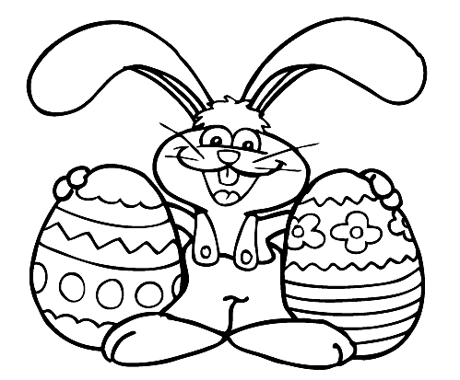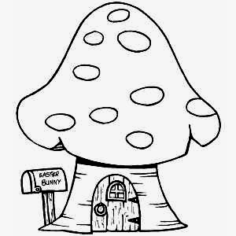
花蓮縣自強國中99學年度第二學期八年級英語科第一次段考--教師用卷

Class: No: Name:
請將第1-45題的答案用2B鉛筆劃記在電腦卡上

- 聽力測驗：22%
A大題： 1-5題—選出音節數。6-10題—選出重音節的位置。每題唸兩遍。(每題1分)10%
Example: u‧su‧al‧ly (4個音節) - 答案為(D)
[ (A) 1 (B) 2 (C) 3 (D) 4 ]
com‧`put‧er game (重音節在put，選(B))
(A) (B) (C) (D)
( B ) 1. | (A) 1 | (B) 2 | (C) 3 | (D) 4
( C ) 2. | (A) 1 | (B) 2 | (C) 3 | (D) 4
( B ) 3. | (A) 1 | (B) 2 | (C) 3 | (D) 4
( D ) 4. | (A) 1 | (B) 2 | (C) 3 | (D) 4
( C ) 5. | (A) 1 | (B) 2 | (C) 3 | (D) 4
( B ) 6. | ac‧ti‧vi‧ty ( A ) 7.  (A) (B) (C) (D) |  | wa‧ter‧me‧lon  (A) (B) (C) (D)
( C ) 8. | Go a‧head. ( D ) 9.  (A) (B) (C) |  | po‧pu‧lar game  (A) (B) (C) (D)
( B )10. | con‧ve‧nience store  (A) (B) (C) (D)

B大題：根據錄音內容，選出正確的句子。每題唸兩遍。(每題2分)12%
11. (B) | 12. (C) | 13. (C) | 14. (A) | 15. (B) | 16. (A)

- 請依文意選出一個正確或最佳的答案：48% (每題2分)
( A ) 17. The clock on the wall stops. We need to change the ______.
(A) batteries | (B) tapes | (C) fans | (D) video games
( D ) 18. I like to buy fruit at that ______ because the fruit there is fresher.
(A) vendor | (B) refrigerator | (C) building | (D) stand
( D ) 19. You need a ______ to take pictures.
(A) knife | (B) fork | (C) spoon | (D) camera
( D ) 20. Hurry up! You are as slow as ______.
(A) a mouse | (B) a bear | (C) a bee | (D) a turtle
( A ) 21. My computer is newer than _____.
(A) John’s | (B) him | (C) her | (D) Sally
( D ) 22. A: Which refrigerator is ______ of all?
(A) most expensive | (B) more expensive | (C) cheaper | (D) the cheapest
( B ) 23. They are playing the Easter egg hunt ______.
(A) happier | (B) happily | (C) the happiest | (D) happy
( C ) 24. A: Whose CD player is this? B: It’s ______.
(A) my | (B) her | (C) his | (D) your
( D ) 25. A: How does Eric swim? B:_____.
(A) Slow | (B) Fastly | (C) Nervous | (D) Well
( A ) 26. A: Mom, can I go to the movies with Eric? B: Yes, ______.
(A) go ahead | (B) go for it | (C) don’t give up | (D) give it a try
( D ) 27. Everyone ______ quiet in the library.
(A) has to | (B) doesn’t have to | (C) don’t have to be | (D) has to be
( C ) 28. Sammy sells ______ vegetables around here.
(A) the better | (B) well | (C) the best | (D) worst
( B ) 29. Egg toss is an Easter activity. We have to throw and catch the eggs carefully without breaking ____.
(A) it | (B) them | (C) one | (D) ones
( A ) 30. A: Mom, can you help me with my homework?
B: _____! Go to your dad, please. I’m as busy as a bee now.
(A) Give me a break | (B) Bravo | (C) How interesting | (D) How come
( C ) 31. A: ________? B: I’d like the red one.
(A) May I take a look at the red skirt | (B) Which skirt is more expensive
(C) Which skirt do you want | (D) Would you like the blue skirt
( B ) 32. Which bird is ________?
(A) the more expensive, the red one or the blue one
(B) the most expensive of the four
(C) more expensive of all
(D) the most expensive of the two
( A ) 33. Kevin went to Japan with _____.
(A) a friend of his | (B) his a friend
(C) one his friend | (D) his one friend
( B ) 34. A: Who is your English teacher? B: _____. (選錯誤者)
(A) The one at the door | (B) The one is standing at the door
(C) The woman over there | (D) She is the one over there
( B ) 35. Children ________ during the Easter egg hunt.
(A) roll the eggs quickly to the finish line | (B) look for the eggs
(C) paint the eggs in beautiful colors | (D) give away the eggs

( C ) 36. Things at the yard sale are _______ things in the department store.
(A) as cheaper as | (B) more expensive
(C) much cheaper than | (D) the most expensive
( B ) 37. A: What do you have to do during the test? B:_____.
(A) We have to careful | (B) We have to answer carefully
(C) We have to be successful | (D) We have to do the test terribly
( A ) 38. There are two famous singers there. _____ is A-mei, and ____ is Stefanie.
(A) One; the other | (B) One; another
(C) One; one | (D) One; other
( C ) 39. A: The pen is NT$75. The notebook is NT$150. We give a special discount (折扣) of 10% for cash. B: OK. I’ll have 2 notebooks and 3 pens, and I’ll pay in cash. How much is the total?
(A) NT$525 | (B) NT$600 | (C) NT$472.5 | (D) NT$540
( C ) 40. 選正確者。
(A) They happily are looking at each other.
(B) Samuel is doing well his homework.
(C) It is raining heavily right now.
(D) The baby is sleeping comfortable on his bed.

- 請依據所附資料，選出一個正確或最佳的答案。10% (每題2分)
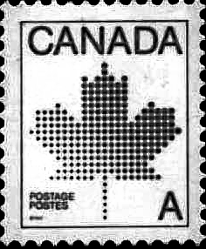
Kelvin Johnson
1350 Sherbrooke Street West,
Suite 800, Montreal,
Quebec, Canada
Mr. Andrew Smith
610 Rhode Island Street
San Francisco, CA 94107
USA

( C ) 41. Which is true?
(A) Montreal is a place in the USA.
(B) Andrew Smith wrote the letter.
(C) The letter is from Canada.
(D) The writer’s address (地址) is 610 Rhode Island Street, San Francisco.
( B ) 42. What is NOT mentioned(提及)?
(A) The writer’s address. | (B) The date of the letter.
(C) The recipient’s (收信人) name. | (D) The nation (國家)the letter is from.

Easter
Christians celebrate the resurrection (復活) of Jesus Christ on Easter Day or Easter Sunday. Easter is a movable feast (節日). It is celebrated on the first Sunday following the first full moon after the Spring equinox (春分). This usually occurs on March 21, which means the date of Easter can range (變動) between March 22 and April 25. Today, Christians go to church and have a special service (宗教儀式) on Easter Sunday. Many people sing and pray on Easter Sunday. They think about new life in Heaven (天堂) after death (死亡). It is a very happy day. Flowers, eggs and rabbits are all symbols (象徵) of Easter. They are all symbols of new life.
Children like the Easter Bunny. The Easter Bunny visit children and hide colored eggs that the children have to find on Easter Sunday morning. On Easter Sunday evening, children eat a big dinner with their families.

( A ) 43. Look at the calendar above. Which date is the Easter Sunday?
(A) April 4th | (B) April 11th | (C) March 28th | (D) March 21st
( C ) 44. What do people NOT do on Easter?
(A) They go to church. | (B) They sing and pray.
(C) They look for new life. | (D) Children find colored eggs.
( D ) 45. Which is NOT true?
(A) Flowers, eggs, bunnies are symbols of new life.
(B) Children eat dinner with their families on Easter.
(C) Easter is a feast to celebrate the resurrection of Jesus Christ.
(D) Easter Sunday always falls on the same date.

46-60題為書寫題，請直接書寫在「書寫卷」上
花蓮縣自強國中99學年度第二學期八年級英語科第一次段考—書寫卷
Class: No: Name: Score:
IV. 請將下列的單字及片語寫成英文: 10% (每題一分)

46. 成人 adult | 47. 鄰居 neighbor
48. 蹺蹺板 seesaw | 49. 溜滑梯 slide
50. 草莓 strawberry | 51. 木瓜 papaya
52. 收音機 radio | 53. 洗衣機 washing machine
54. 購物中心 shopping mall | 55.台灣高鐵(縮寫式) THSR

V. 依提示作答：10% (每題2分)
56. The student was nervous. (畫線部分以answer his teacher’s question代替)
The student answered his teacher’s question nervously.
57. which / be / fast / take a train / take a bus? (造句—做適當的變化)
Which is faster, taking a train or taking a bus?
58. she / have to / hold the egg / quick (造句—做適當的變化)
She had / has to hold the egg quickly.
59. 鳳梨酥是台灣最好吃的點心。(翻譯成英文)
(The) pineapple cakes are the most delicious snacks in Taiwan.
60. MP3播放器比錄音機更普遍。(翻譯成英文)
MP3 players are more popular / common than tape recorders.
The MP3 player is more popular / common than the tape recorder.

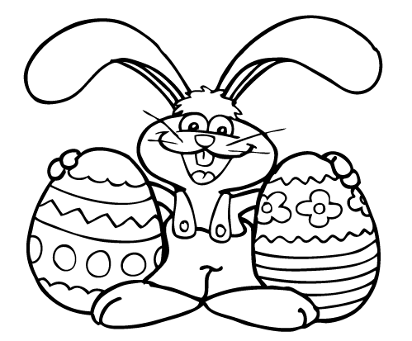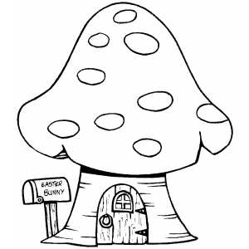

花蓮縣立自強國中八年級第一次段考英語科聽力測驗
請翻到題目卷第一大題
- 1-5題—選出音節數。6-10題—選出重音節的位置。每題唸兩遍。

Example: u‧su‧al‧ly (4個音節) - 答案為(D)
com‧`put‧er game (重音節在put，選(B))
(A) (B)(C) (D)
1. slowly 2. successful 3.quiet 4. beautifully 5.happiest
6. ac‧`ti‧vi‧ty 7.`wa‧ter‧me‧lon 8.Go a‧`head. 9. po‧pu‧lar `game
10.con‧`ve‧nience store

(B) 根據錄音內容，選出正確的句子。每題唸兩遍。
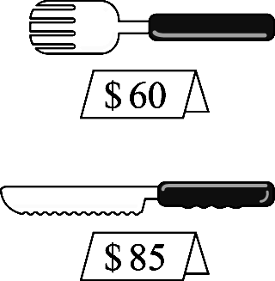 | 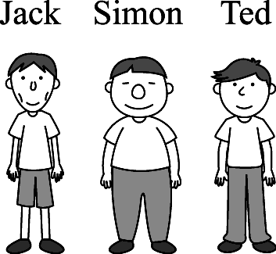 | 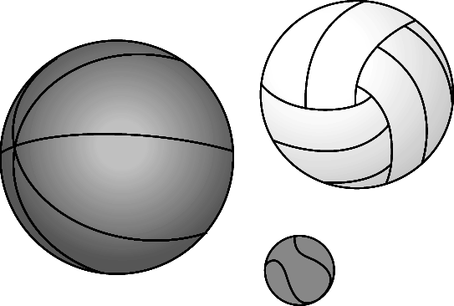 | 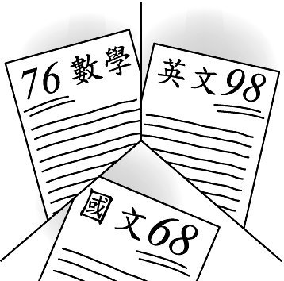 | 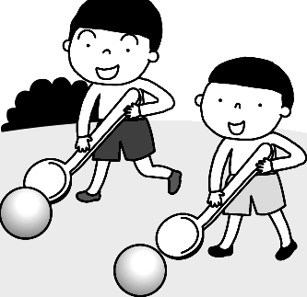 | 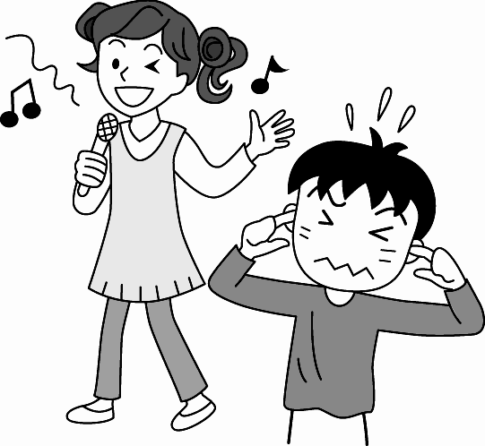
11. | 12. | 13. | 14. | 15. | 16.

( B ) | 11. | (A) The knife is cheaper than the fork.  (B) The fork is 25 dollars cheaper than the knife.  (C) The fork is more expensive than the knife.
(C ) | 12. | (A) Jack is the shortest of all.  (B) Simon is lighter than the other two boys.  (C) Simon is the heaviest of the three.
(C) | 13. | (A) The basketball is smaller than the soccer or the baseball.  (B) The soccer is smaller than the baseball or the basketball.  (C) The baseball is the smallest.
(A) | 14. | (A) Jane got the best grade in English.  (B) Jane got the worst grade in Math.  (C) Jane got better grade in Chinese than in Math.
( B ) | 15. | (A) They are rolling eggs.  (B) They are playing ball rolling.  (C) They are painting the eggs.
(A ) | 16. | (A) She is singing terribly.  (B) She sings very well.  (C) He likes her singing very much.

