台南市新東國中100學年度上學期國三英語第一次段考試題 B5L5-7
Part 1 Listening Comprehension : 20%
I 選出出現在CD句中的單字：5 %
1 (A) some (B) with (C) on (D) grow
2 (A) wait (B) young (C) waved (D) rain
3 (A) so (B) read (C) head (D) with
4 (A) mom (B) repeated (C) race (D) downstairs
5 (A) gift (B) than (C) hug (D) goose

II 聽CD的二個敘述，勾選出符合圖片的句子(答案卷上請填代號)：5 %
1 A ( ) B ( ) 2 A ( ) B ( ) 3 A ( ) B ( )
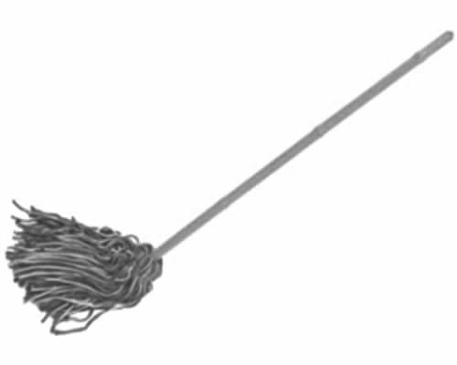
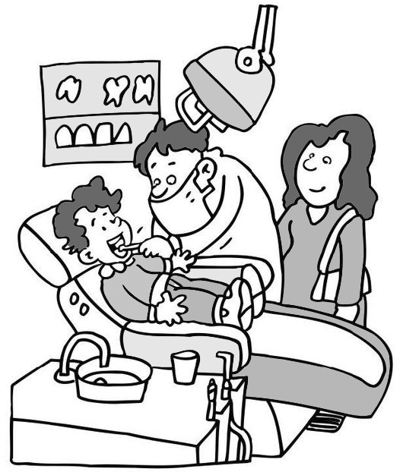
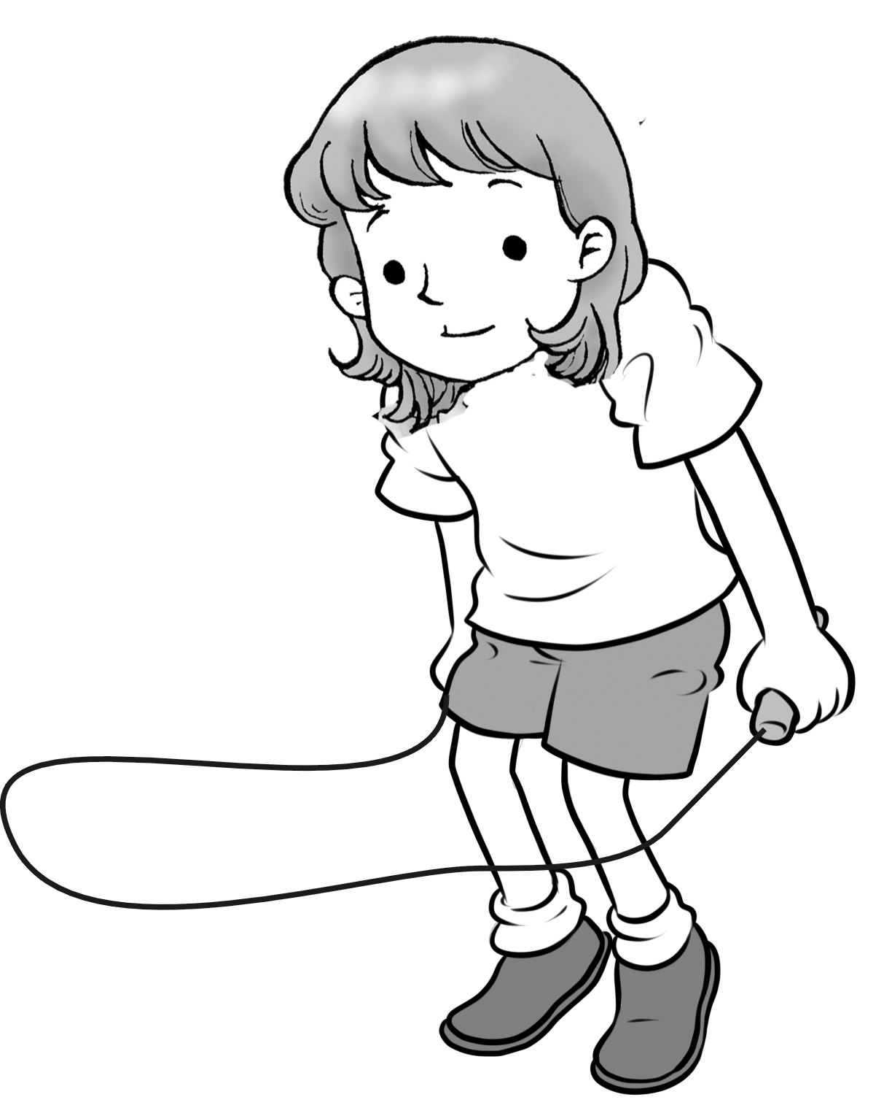

4 A ( ) B ( ) 5 A ( ) B ( )
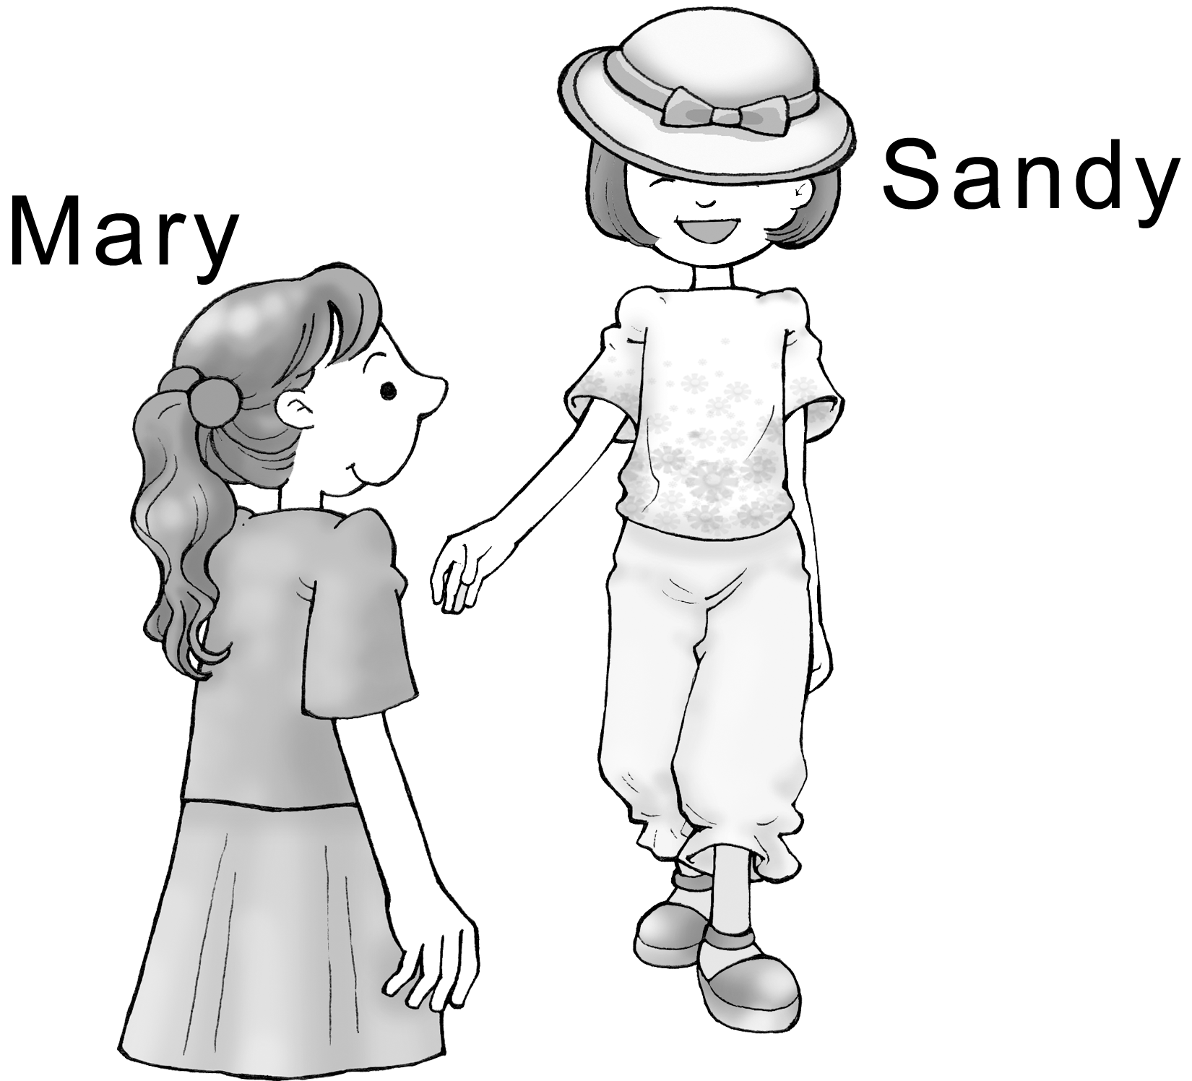
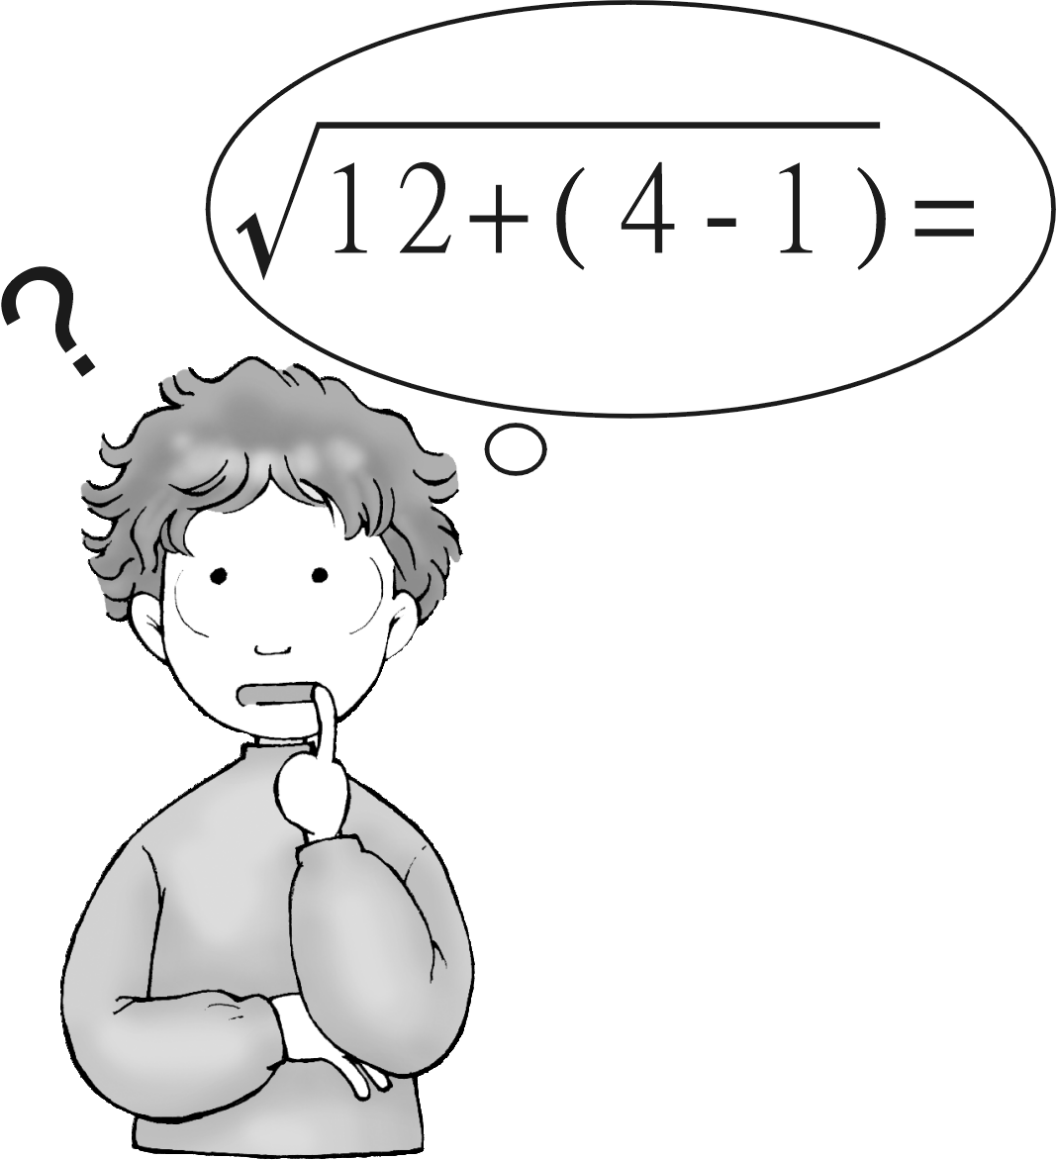

III 聽CD的對話，在正確的括號內打勾：5 %
1. ( ) A: The woman had a car accident yesterday.
( ) B: The woman was late today.

2. ( ) A: The woman bought some flowers for her brother.
( ) B: The woman got some flowers from a boy.

3. ( ) A: Sue has big eyes.
( ) B: The woman is talking to Jane.

4. ( ) A: Amy’s is a place where you can sell flowers.
( ) B: Amy’s is a flower store.

5. ( ) A: The woman’s boss will be back in 3 hours.
( ) B: The woman’s boss won’t be back until 3 o’clock.

IV 聽CD的問題，選出最適當的回應：5 %
1. (A) Yes, I bought it last night.
(B) Yes, they are.
(C) Yes, Tom bought them last night.
(D) No, I don’t like them.

2. (A) There were two rings.
(B) It was on the table.
(C) It was NT8,000.
(D) It was Lisa’s birthday gift.

3. (A) My cousin is very tall.
(B) The boy is Ben.
(C) The man who wears big glasses is my uncle.
(D) The one with a big nose.

4. (A) It won’t turn off itself.
(B) OK. I’ll tell you how to do it.
(C) Tell me which is better.
(D) Well, I don’t know how useful it is.

5. (A) I don’t know where I am.
(B) Your train will arrive soon.
(C) It’s on the fifth floor.
(D) By bus number 299.

Part 2 Reading ＆ Writing : 80%
I單字＆文意字彙 20 %
1玫瑰花 2夢 3假裝 4胃 5廣場

6 This is his second time to take the test, but he f ed again.
7 Ted made a s s mistake, so his teacher was very angry.
8 A: You look sad. What’s the m r? B: I lost my wallet.
9 Tom believes in God. He goes to c h every Sunday morning.
10 I t ly agree with you. I think we will win the game.

II. 文法選擇 30%
1 Let me show you _____ I just bought.
(A) where (B) which (C) what (D) who
2 Have you ever been to Japan, _____ I visited last month?
(A) where (B) which (C) what (D) who
3 Taichuang, _____ I was born 13 years ago, has changed a lot.
(A) where (B) which (C) what (D) who
4 _____ I want to do is make you happy.
(A) What (B) Which (C) Who (D) That
5 _____ the earth is round is true.
(A) That (B) Which (C) What (D) Who
6 I am not sure ______ he will come tonight.
(A) what (B) if (C) that (D) which
7 I am sure _____ the book is Ted’s.
(A) what (B) if (C) that (D) which
8 I believe _____ he said is true.
(A) what (B) if (C) that (D) which
9 I think _____ you should read it.
(A) what (B) if (C) that (D) which
10 Jenny baked cakes for the first time, so she didn’t know .
(A) whether to do (B) to do what (C) do what (D) what to do
11 I won’t come if it _____ tomorrow.
(A) rains (B) will rain (C) rain (D) is raining
12 Do you know the woman Mr. Jackson fell in love ?
(A) with (B) for (C) to (D) X
13 Who’s the girl a big smile in the picture?
(A) has (B) in (C) wears (D) with
14 The woman a pink skirt is the one I love.
(A) has (B) in (C) wears (D) with
15 Is that man glasses your father?
(A) has (B) in (C) wears (D) with

III. 依提示作答: 8 % (全對才給分)
1 Here comes the bus.
We are waiting for the bus. (用關係代名詞合併兩句)
2 We all like Uncle Ted.
He gave us a lot of gifts. (用關係代名詞合併兩句)
3 Who is he? (句首加入”I don’t know…”改寫)
4 I don’t know…
Did he fight with Peter? (用if合併兩句)

VI. 中翻英: 12% (分段給分)
1 那位就是你要嫁的帥哥嗎?
2 直到去年夏天他才成功地通過考試。(He …not…until…)
3 他的心再一次充滿希望與喜悅! (once…)
4 我所知道的是生命是我們最珍貴的禮物。(What…)
V. 閱讀測驗: 10 %
(A)
Dear Lady Fanny,
I’m in trouble now. My classmate, Tina, likes to talk to me in class. But I want to pay attention to my teacher carefully. I don’t know how to tell her about this without hurting her. Please help me. Sally

Dear Sally,
You must be a kind girl! It is really hard to get you out of the trouble, but you still need a try! I think your classmate wants to show that she likes you very much. So you may tell her that you like her to be quiet and hard-working in class. Then your classmate will talk less. If she won’t, you had better ask your teacher to change your seat. Lady Fanny

1 Who is a trouble to the person who wrote this letter?
(A) Sally (B) Tina (C) Fanny (D) Fanny’s classmate
2 Which is NOT the way that Lady Fanny told Sally ?
(A) Tell her classmate that she likes her very much.
(B) Change her seat.
(C) Ask her classmate to keep quiet in class.
(D) Ask her teacher to help her.

(B) There are some important things that a traveler must come to understand before
entering a new country. One thing is that every culture is unique. There are no cultures
that are exactly alike. One culture may do certain things one way, and another culture
does things another way. But it does not make one culture right and another culture wrong. For example, the Spanish and the Italians like to talk loudly on the street, but northern Europeans, like the Swedish and the Finnish, are quiet. Neither of these cultures is wrong. It is just the way the people do things.
3 According to the reading, which people like to talk loudly on the street?
(A) The Spanish (B) The Chinese (C) The Swedish (D) The Finnish
4 What may the word “unique” mean in the reading?
(A) Boring. (B) Difficult. (C) Excellent. (D) Special.

(C) Do you know the people in the West didn’t have family names at first? Why did they create their family names? That’s because often more than five men were called John in a small town. John didn’t know whether someone called him when he heard his name on the street. So he thought maybe he should give himself one more name to make sure if he was the person someone was calling. He decided to take his father’s name, Jack, and put “son” after it. Then his name became John Jackson.
5 What is the name of John’s father in this story?
(A) John (B) Johnson (C) Jack (D) Jackson

