台中市立惠文高級中學【國中部】九十八學年度第二學期 第一次定期評量
三年級英文科試題卷 範圍：第六冊 第一課~第三課 命題人員：林益守 審題人員：陳孟樺
第一部分:下列各題(題號1-21)，請依據題意選出一個正確或最佳的答案。
- The fire in the subway caused a ______. Everyone was afraid and ran out of the station at once.
(A) fever | (B) mark | (C) panic | (D) convenience
- Many parents wouldn’t ______ their kids to play computer games or watch TV because the BC test is at hand.
(A) correct | (B) allow | (C) understand | (D) believe
- I think Paul Potts is a(n) ______ singer. His singing is really great, and he won the first place in a game in England.
(A) embarrassed | (B) horrible | (C) excellent | (D) honest
- Mr. Lin: B.J, do you know the answer?
B.J.: I’m sorry, Mr. Lin. Could you please ______ the question?
(A) repeat | (B) face | (C) lie | (D) pass
- After the storm, the road was covered with branches. The garbagemen came to ______ them from the road in case any accident might happen.
(A) knock | (B) pollute | (C) tear | (D) remove
6. It is considered good ______ in some countries to leave a little food on your plate. Finishing all the food may be impolite.
(A) joy | (B) manners | (C) stranger | (D) space
- My car couldn’t move because the motor was overheating. I asked a mechanic to ______ it for me.
(A) reach | (B) relax | (C) recycle | (D) repair
- There isn’t any ______ for the shelf. The room is too crowded.
(A) lane | (B) point | (C) basket | (D) space
- After a tiring day, taking a ______ will make you feel comfortable.
(A) sunset | (B) shower | (C) peanut | (D) bedtime
- Teacher: Boys and girls, you should ______ yourselves in the museum. You can’t run or talk loudly inside.
Students: Yes, sir.
(A) behave | (B) add | (C) lead | (D) step
- We will give a present to Joan before she ______ Taiwan this afternoon.
(A) will leave | (B) left | (C) leaves | (D) leaving
- It is time to watch the news. Would you mind ______ the TV?
- me to open | - me to turn on | - my opening | - my turning on
- Alice: What is your ideal husband like?
Jessica: Well, I want a husband ______ well. I enjoy eating, but I hate kitchens.
- cooked | - that cooked | - who cooks | - to cook
- Gorge is an impolite boy because he talks to the teacher ______ his arms crossed.
- by | - with | - for | - besides
- People ______ wash clothes at the riverside, but now we do the laundry in a washing machine at home.
- were used to | - used to | - are used to | - get used to
- Joe, Sarah and May went to McDonald’s for lunch. After ______ the menu, only Joe ordered the set meal.
(A) they read | (B) reading | - read | - was reading
- My classmate writes a blog ______ pets. He loves puppies very much.
(A) which is | (B) which about | - with | - about
- Jack: Do you see the street vendor over there? He is David’s father.
Phil: Which one?
Jack: ______
(A) The one with a blue shirt. | (B) That in a black shorts.
(C) He with glasses. | (D) The one in black.
- Clerk: How would you like to pay ______ the MP3 player?
Guest: In cash.
(A) with | (B) to | (C) for | (D) on
- Which sentence is right?
- Our teacher tells us learning needs patience and passion.
- We are not sure if he comes to our party tomorrow.
- The gift we bought it in the department store is expensive.
- That why they left the country was a secret.
21. You might feel like ______ the test papers into pieces while you are taking this test. But don’t do silly things. Keep on writing.
(A) to tear | (B) tear | (C) tore | (D) tearing

第二部分:下列七個題組，共有29題(題號22-50)，請依據選文或所附圖表資料，選出

一個正確或最佳的答案。

(22-27)

Greg and Steve are watching the DVD 2012 in Greg’s house.

Greg : How do you like the movie?

Steve: I think the story is kind of stupid. It doesn’t have good logic, but the special effects are great. __22__ the floods __22__ the earthquake look real.

Greg : Forget about the poor logic of the story and the laughable dialogue. Wouldn’t it be great if the movie could inspire people to __23__ the problem of global warming?

Steve: __24__. The scientists say that our earth is getting warmer. That would make polar ice melt down and the sea level __25__.

Greg: It sounds __26__. What if the sea level rises so much as to sink Taiwan? This is a serious problem and I think scientists must __27__ now.

Steve: I guess we’ll have to live on Mars then. Anyway, the movie should be a wake-up call for all of us.

logic邏輯；special effect特效；inspire激勵；melt融化
22. | - Either…or  - Both…and |  | (B) Neither…nor  (D) Not only…but also
23. | - hear from | - think about | - call on | - keep away
24. | - What a pity. |  | - Never mind.
 | - You can say that again. |  | - Gosh! No.
25. | - rise | - rises | - rising | - risen
26. | - surprised | - exciting | - terrible | - terribly
27. | - work on it | - work it on | - try on it | - try it on
(28-38)
Joseph, a lazy person __28__ job was a writer, had trouble raising his six children because the books __29__ by him never sold well. He had no idea __30__, and nor did his wife. He was so upset that he just stayed home without __31__. His wife was not satisfied __32__ him because he was __33__.
Feeling bad and worried, he knew that he had to do something about it. __34__ money for the family, he would go out and __35__ a second job besides writing. One day, an ad on the wall caught his eyes when he was __36__. He then called the boss and was glad when he succeeded in finding a job which was to translate foreign movies into Chinese ones. He decided __37__ and stared to work hard for the family. He translated one movie for more than five thousand dollars.
Since then, he had tried to translate as many foreign movies as possible. __38__, his family lived a happy life because they never had to worry about not having enough money.
28. | (A) his | (B) whose | (C) who | (D) that
29. | (A) which wrote | (B) which written | (C) writing | (D) written
30. | (A) what to do | (B) to do what | (C) what should do | (D) how to do
31. | (A) to write | (B) writes | (C) written | (D) writing
32. | (A) by | (B) in | (C) with | (D) of
33. | (A) a such lazy man  (C) such a lazy man |  | (B) such lazy a man  (D) so a lazy man
34. | (A) To make | (B) Making | (C) Made | (D) That making
35. | (A) look up | (B) look for | (C) look after | (D) look down
36. | (A) in his way home  (C) on his way home |  | (B) in his way to home  (D) on his way to home
37. | (A) didn’t be lazy | (B) not be lazy | (C) not to be lazy | (D) to not be lazy
38. | (A) From now on | (B) In the end | (C) At first | (D) At the bottom
(39-41)

Tomorrow’s Weather Forecast for Monkey Island

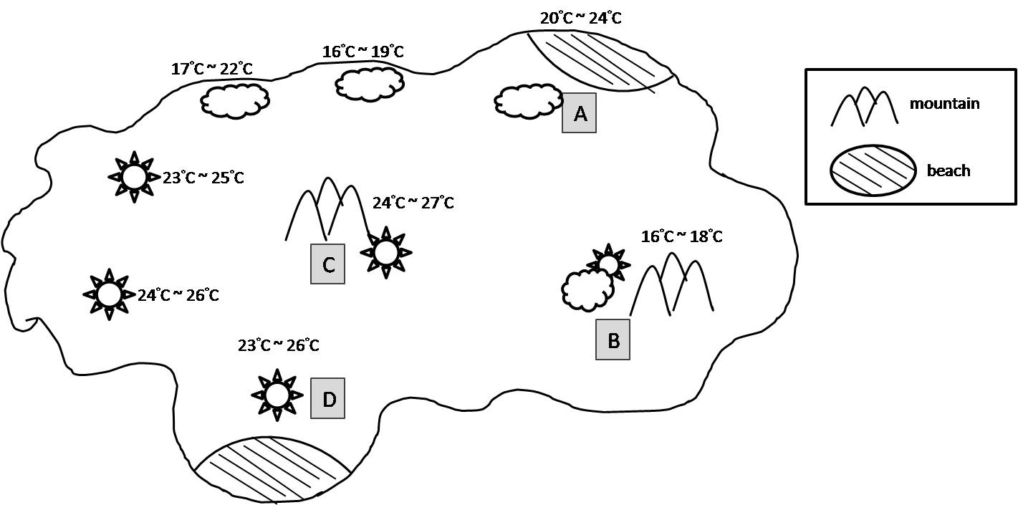
S
- How will the weather be tomorrow in the north of Monkey Island?
- It will be sunny. | - It will be rainy.
- It will be cloudy. | - It will rain.
- If Mike and his friends want to play at the beach, but they are afraid of strong sun, where should they go?
- A | - B | - C | - D
- This forecast is for Monkey Island.

Tomorrow is the first day of this year’s Kite Festival. You can fly a kite in the mountains. If it rains, you can watch different kinds of kites in the tourist center.

Which part of Monkey Island is the forecast talking about?
- A | - B | - C | - D

(42-44)

Eric’s Resume

Name: Eric Chen

Address: 128 Palm Street, Taipei City

Phone Number: (02)4129889

I’d like to apply for the job: Engineer

Experiences:

2005 ~ Apple Company.

128 Dayuan Rd, Taoyuan.

Mechanic. Fixing computers for customers.

2001 ~ 2005 Kings World Shopping Mall.

100 Museum Rd, Hsinchu.

Selling computers in the mall.

Making plans of big sales on computers.

Education:

1996 National Taiwan University

Master of Computer and Science

Personal Interests:

Amateur tennis player

Sportscar racing

apply for申請;master主修
- What did Eric do in his first job?
- He sold Kings’ clothing.
- He fixed computers.
- He sold computers.
- He played tennis.

- Which is true about Eric?
- He lives in Hsinchu now.
- His hobby is selling computers.
- He probably goes to work by train now.
- He studied art in a college in southern Taiwan.
- To which company will Eric most likely send the resume?
- Sogo Department Store
- Apple Restaurant
- Far West Cell Phone Store
- Acer Technology

(45-47)

Memories
Memories from childhood stay with us forever,
Taking us where we have been and will go,
Pieces of life that live on and will never
Let us forget we were young long ago.
Sometimes I walk back into those moments,
Quietly being who I used to be,
Bringing to life all the joys and the sorrows,
Days that can’t die because they still live in me.
Holidays stay and happy times shine;
I can see everyone happy and well.
I can still see them if I open my eyes,
Feeling each action and breathing each smell.
Life has such treasures that time’s always stealing;
Nothing can ever stay.
While you are young, you can catch each feeling;
Make all the memories you can every day.
memory回憶；sorrow悲痛；breathing (breathe)呼吸；treasure寶藏
- Who do you think the writer is?
- A poor man who has had a hard life.
- A man who is old.
- A very young boy.
- A man who can’t remember much.
- According to the poem, which is true about our memories?
- They are an important part of who we are.
- They are lost when we grow old.
- They become less clear over time.
- They don’t have to be remembered.
- What does the poet try to say?
- We can change the past by forgetting some things.
- All memories should be happy.
- We should make good use of every moment and keep it in our minds.
- We should forget the past and only think about the future.
(48-50)
Have you ever seen the movie, Charlotte’s Web? It’s a touching story between a pig and a spider. At the beginning of the story, a little girl named Fern heard that her father was going to kill one of his newly born pigs. She felt sad for that pig, so she asked her father to give it to her. He agreed with her, but he wanted Fern to take the responsibility to take care of her new pet, Wibur.
Two months later, Fern got sick, so Wibur was sold to Fern’s uncle. On the farm, Wibur didn’t have any friends until he met Charlotte, a smart and helpful spider. They became good friends, but soon they found out an amazing thing – Fern’s uncle decided to kill Wibur for Christmas meal. Charlotte thought of a good way to save Wibur. She span the words “some pig” in her web on the corner. After Fern’s uncle saw it, he believed that Wibur was an amazing pig and gave up killing him.
Wibur was thankful for Charlotte’s help, but he could do nothing for her. Charlotte made him understand that “a true friend is a friend in need.”
responsibility責任; amazing 驚人的;spin (span)結網
- Fern’s father agreed not to kill that new-born pig, Wibur, but he asked Fern to _____.
- look after that pig by herself
- take care of herself from then on
- sell it to her uncle
- sleep with the pig every day
- According to the sentence, “A true friend is a friend in need,” what is the writer trying to say?
- A true friend is a friend who can give you everything you need.
- A true friend is a friend who can help you when you’re in trouble.
- Do a good thing every day, and then you’ll be a true friend.
- Give a hand to somebody in trouble, and then he’ll be your true friend.
- Which of the following is true?
- Finally, Wibur still became a Christmas meal.
- Charlotte saved Wibur in a smart way.
- Fern’s uncle thought Wibur was so horrible that he was afraid of eating it.
- Wibur also did something special to thank Charlotte.

-------------------------------題目結束------------------------------

[Take a Break]
~~Don’t read the comics before the test ends.~~
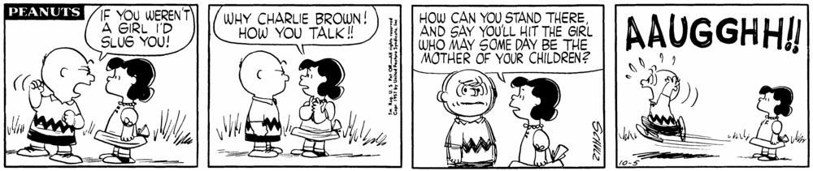
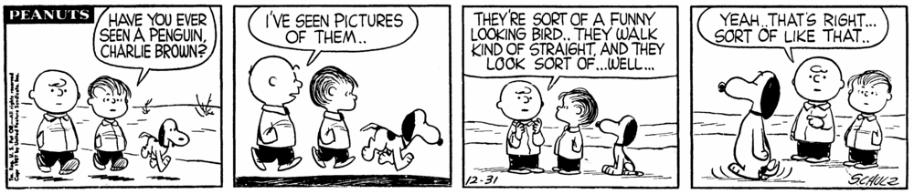
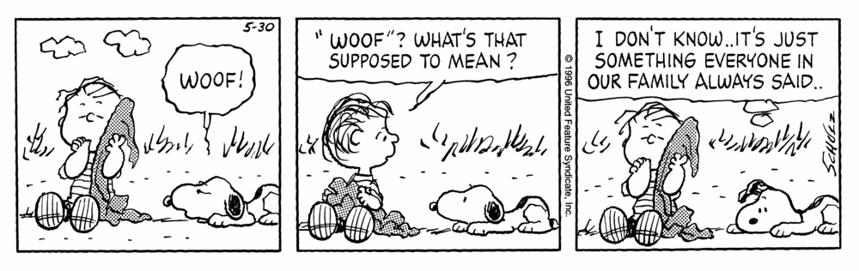

佳句節錄:
It is nice to be important but it is more important to be nice.
答案
- CBCAD BDDBA
11. CDCBB ADDCA
21. DCBCA CABDA
31. DCCAB CCBCA
41. BCCDB ACABB

