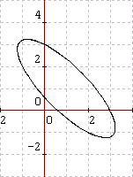
5x^2+8xy+5y^2-18x-18y+9=0(橢)
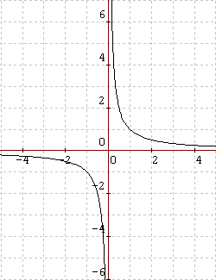
xy=1(雙)
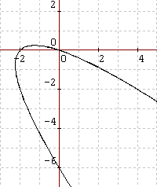
x^2+2xy+y^2+2x+6y=0(拋)
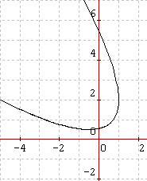
x^2+2xy+y^2-6y+3=0(拋)
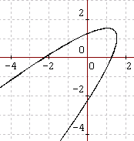
x^2-2xy+y^2+x+y-2sqrt(2)=0(拋)
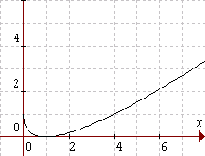
sqrt(x)+sqrt(y)=1
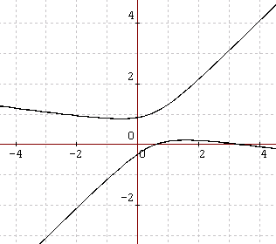
x^2+6xy-7y^2-4x+4y+2=0(雙)
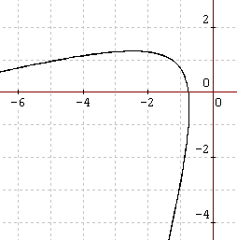
x^2-4xy+y^2+10x-2y+7=0(拋)
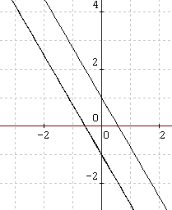
3x^2+2sqrt(3)xy+y^2=1(兩平行線)
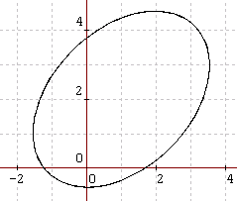
13x^2-10xy+13y^2-6x-42y-27=0(橢)
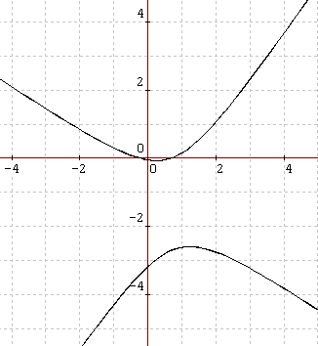
13x^2+10xy-13y^2-6x-42y-2=0(雙)
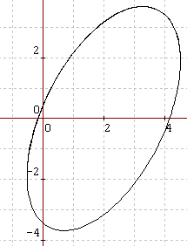
17x^2-12xy+8y^2-68x+24y-12=0(橢)
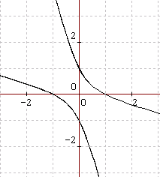
x^2+4xy+y^2=1(雙)
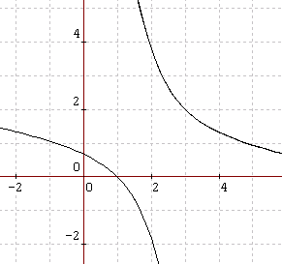
x^2+6xy+y^2-10x-14y+9=0(雙)
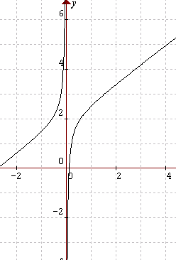
3x^2-4xy+8x-1=0(雙)
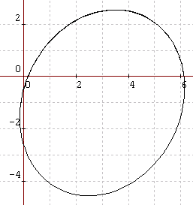
14x^2-4xy+11y^2-88x+34y+14=0(橢)
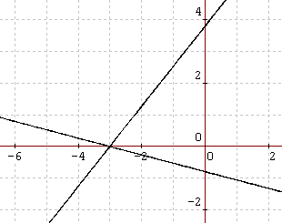
x^2+3xy-3y^2+6x+9y+9=0(兩相交直線)
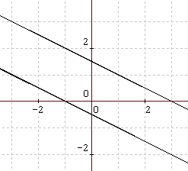
x^2+4xy+4y^2-2x-4y-3=0(兩平行線)
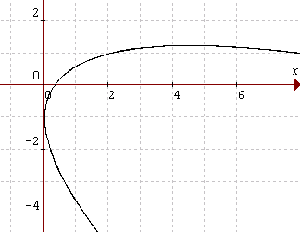
x^2+4xy+4y^2-14x+8y+5=0(拋)
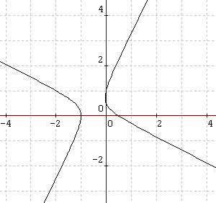
2x^2+3xy-2y^2+x+3y-1=0(雙)
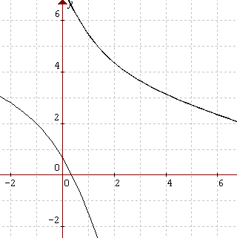
x^2+4xy+y^2-14x-8y+5=0(雙)
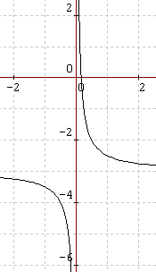
4xy+12x-2=0(雙)
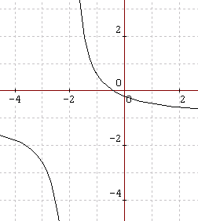
5xy+5x+10y+2=0(雙)
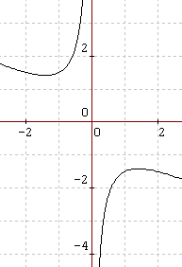
x^2+2xy+2=0(雙)
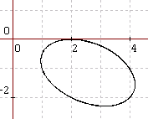
x^2+xy+2y^2-4x+2y+4=0(橢)
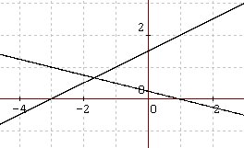
x^2+2xy-8y^2+2x+14y-3=0(兩相交直線)
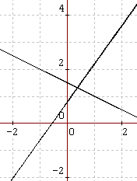
7x^2+9xy-10y^2-17x+23y-12=0(兩相交直線)
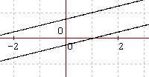
x^2-8xy+16y^2+2x-8y-3=0(兩平行線)
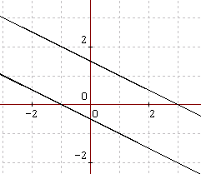
x^2+4xy+4y^2-2x-4y-3=0(兩平行線)
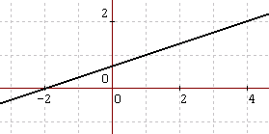
x^2-6xy+9y^2+4x-12y+4=0(兩重合直線)
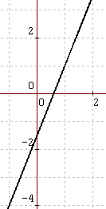
25x^2-20xy+4y^2-30x+12y+9=0(兩重合直線)

2x^2-6xy+5y^2-8x+12y+8=0(一點)
2x^2+5xy+4y^2-8x-17y+22=0(一點)
2x^2-2xy+y^2-8x+6y+10=0(一點)
x^2+xy+y^2+3y+4=0(無)
9x^2+24xy+16y^2-36x-48y+61=0(無)
x^2-6xy+9y^2+2=0(無)
5x^2+6xy+5y^2+32=0(無)
x^2+2xy+y^2-2x-2y+3=0(無)

